***Vocabulary:- Q1:***

***Choose the correct answer:***

1-This sleeve is ................ a- broken b- torn c-crashed

2-This computer a- broken b- torn c- crashed

3-It sounds like means : a- It seems to be b- without worry c-clothing

***-write the words with the correct picture:***

**Leaky pipe - cracked windshield - doorknob - dead battery**

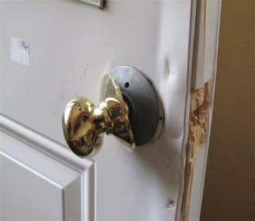 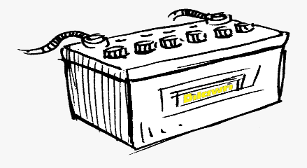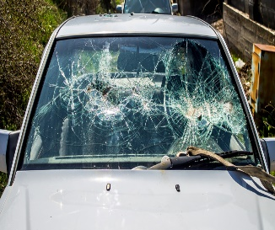

.......................... ................................. .......................................

***Q2: Grammar:***

**1-Choose the correct answer:**

a-The windows need to be  **( clean – cleaning – cleaned)**

b-She can't stand  **( cleaning – clean – cleaned )**

c-Sandra is never on time . She's ging to tell **(it – her -us )** to be more punctual.

***-Rewrite the sentence in two ways :***

1-please turn off the light . .....................................................

***-Write the past participle for each verb:***

**1-break**................. **2-tear** ........................

**3-fix...................... 4-damage ....................**