



قر وزارة التعليم 

إدارةالتعليم **..........**

مدرسة الثانوية ......

اختبار مادة الرياضيات 4 للصف الثاني الثانوي

**لا تجعلي الله أهون الناظرين لك**



**السؤال الأول** / اختر الإجابة الصحيحة

| 1 | C:\Users\Dell\Downloads\photo5807886659096785830.jpg   |  |  |  |  |  |  | | --- | --- | --- | --- | --- | --- | |  |  |  |  |  | |  |  |  | |  |  |  | |  | | | 11 | C:\Users\Dell\Downloads\photo5818716088421168047.jpg |
| --- | --- | --- | --- | --- | --- | --- | --- | --- | --- | --- | --- | --- | --- | --- | --- | --- | --- | --- | --- | --- | --- | --- |
| 2 | C:\Users\Dell\Downloads\photo5807886659096785830.jpg | 12 | C:\Users\Dell\Downloads\photo5818716088421168047.jpg |
| 3 |  | 13 | C:\Users\Dell\Downloads\photo5818716088421168047.jpg |
| 4 | C:\Users\Dell\Downloads\photo5807886659096785830.jpg | 14 | C:\Users\Dell\Downloads\photo5818716088421168047.jpg |
| 5 | C:\Users\Dell\Downloads\photo5807886659096785830.jpg | 15 | C:\Users\Dell\Downloads\photo5818716088421168047.jpg |
| 6 | C:\Users\Dell\Downloads\photo5807886659096785831.jpg | 16 | C:\Users\Dell\Downloads\photo5818716088421168047.jpg |
| 7 | C:\Users\Dell\Downloads\photo5807886659096785831.jpg | 17 | C:\Users\Dell\Downloads\photo5818716088421168048.jpg |
| 8 | C:\Users\Dell\Downloads\photo5807886659096785831.jpg | 18 | C:\Users\Dell\Downloads\photo5818716088421168048.jpg |
| 9 | C:\Users\Dell\Downloads\photo5807886659096785831.jpg | 18 | C:\Users\Dell\Downloads\photo5818716088421168048.jpg |
| 10 | C:\Users\Dell\Downloads\photo5807886659096785831.jpg | 20 | C:\Users\Dell\Downloads\photo5818716088421168048.jpg |

| 21 | C:\Users\Dell\Downloads\photo5834430669382595485.jpg | 31 | C:\Users\Dell\Downloads\photo5861814135321375230.jpg |
| --- | --- | --- | --- |
| 22 | C:\Users\Dell\Downloads\photo5834430669382595485.jpg | 32 | C:\Users\Dell\Downloads\photo5861814135321375230.jpg |
| 23 | سC:\Users\Dell\Downloads\photo5834430669382595485.jpg | 33 | C:\Users\Dell\Downloads\photo5861814135321375230.jpg |
| 24 | C:\Users\Dell\Downloads\photo5834430669382595485.jpg | 34 | C:\Users\Dell\Downloads\photo5861814135321375230.jpg |
| 25 | C:\Users\Dell\Downloads\photo5834430669382595485.jpg | 35 | C:\Users\Dell\Downloads\photo5861814135321375231.jpg |
| 26 | C:\Users\Dell\Downloads\photo5834430669382595486.jpg | 36 | C:\Users\Dell\Downloads\photo5861814135321375231.jpg |
| 27 | C:\Users\Dell\Downloads\photo5834430669382595486.jpg | 37 | C:\Users\Dell\Downloads\photo5861814135321375231.jpg |
| 28 | C:\Users\Dell\Downloads\photo5834430669382595486.jpg | 38 | C:\Users\Dell\Downloads\photo5861814135321375231.jpg |
| 29 | C:\Users\Dell\Downloads\photo5834430669382595486.jpg | 39 | C:\Users\Dell\Downloads\photo5861814135321375231.jpg |
| 30 | C:\Users\Dell\Downloads\photo5834430669382595486.jpg | 40 | C:\Users\Dell\Downloads\photo5861814135321375231.jpg |

السؤال الثاني

(a)

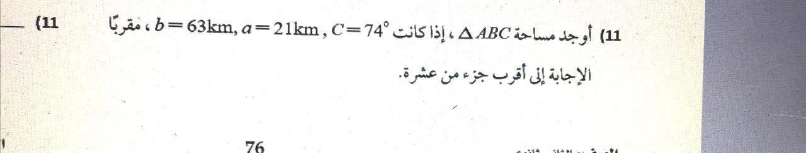



**b)** 

      
        
     
     
     

