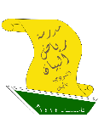

**2nd intermediate Grade - Unit 14 Revision**

**Grammar**

1. **Choose the correct answer:**
2. **Could you ______ me with this bag?**

( helping - helps - help - helped )

1. **Lama will ______ your books.**

( carrying - carry - carries - carried )

1. **Let me ______ you a joke.**

( tell - tells - told - telling )

1. **Nouf wants Sandra to ______ her house.**

( decorates - decorate - decorating - decorated )

1. **If you don't leave immediately, I'll ______ the police.**

( calls - calling - called - call )

1. **Do as shown between brackets:**
2. **Mishaikh won't wears her pink jacket. (Correct)**

**_______________________________________________________________________**

1. **Rose wants something to write with. (Write a request for this situation)**

**_______________________________________________________________________**

1. **Match each sentence with its function:**

|  |  |  |
| --- | --- | --- |
| **A** |  | **B** |
| 1. **Will you buy me some snacks?** | **( )** | **Threat.** |
| 1. **I'll make the salad.** | **( )** | **Request.** |
| 1. **I'll wear my purple sunglasses.** | **( )** | **Offer.** |
| 1. **He will tell the teacher if you didn't stop.** | **( )** | **Instant decision.** |
|  | **( )** | **Farewell.** |

1. **Write "O" if it's an offer and "R" if it's a request:**
2. **Would you help me cleaning the room? ( ________ )**
3. **Let me wash your car for you. ( ________ )**
4. **I'll fix your laptop. ( ________ )**
5. **Could I have an orange juice please. ( ________ )**

**Vocabulary**

1. **Write each word under its picture:**

|  |
| --- |
| **Snack**  **- Receptionist - Graduation - Ticket - Meeting - Emergency - Uniform** |

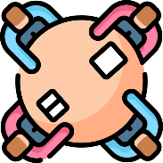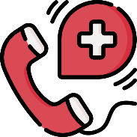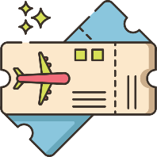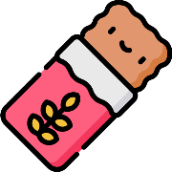

1. **Match the expressions from column A with their meaning in column B:**

|  |  |  |
| --- | --- | --- |
| **A** |  | **B** |
| * + - 1. **Will you do me a favor?** | **( )** | **I don’t Know.** |
| * + - 1. **I have no idea.** | **( )** | **The state of something.** |
| 1. **Condition.** | **( )** | **Will you help me with something?** |
|  | **( )** | **On the day after today.** |

**Dictation Words**

**Snack – receptionist – napkin – gathering – lend – borrow – graduation – ticket – meeting – emergency**

**المراجعة لا تغني عن الكتاب.**