******المملكة العربية السعودية**

**Kingdom of Saudi Arabia**

**Ministry of Education**

**------- Educational Directorate**

**------- Future Educational Schools**

**3rd Grade High School 2022**

**3rd Term – Final Exam**

**وزارة التعليم**

**الإدارة العامة للتعليم بن**

**مدارس م ن التعليمية**

**الصف الثالث الثانوي**

**الاختبار النهائي للفصل الدراسي الثالث1443**

|  |  |  |  |  |  |  |  |
| --- | --- | --- | --- | --- | --- | --- | --- |
| **Total**  **written** | **5**  **Vocabulary** | **4**  **Grammar** | **3**  **Free Composition** | **2**  **Guided Composition** | | **1 Comprehension** | **Q. NO.** |
|  |  |  |  |  | |  | **Mark Given** |
| **30** | **6** | **6** | **6** | **6** | | **6** | **Mark** |
| **6** | | | **Reviser** | |  | | **Corrector** |
|  | |

**زمن الاختبار: 3 ساعات**

**اسم الطالب: ------------------------------------ رقم الجلوس: ------------- الصف الثالث الثانوي**

**1)** **Comprehension**

**Read the following passage then answer the questions**

**King Faisal bin Abdul-Aziz was born in Riyadh in 1905. In 1919, he was sent to Paris Peace Conference at the end of World War 1. On the same trip, he visited the UK. There were many important events in Faisal’s life. In 1925, he became viceroy of the Hejaz and Foreign Minister. During the 1930s, he made many trips abroad to present the Arab’s views on Palestine. Then in 1945, *he* took the Kingdom into the United Nations. He became Prime Minister in 1962 and King in 1964. He is remembered for his piety, his intellectual powers and his quick mind. He died in 1975 at the age of 70.**

***A)* Answer the following questions*:*  
1. Who is this passage about?----------------------------------------------------.**

**2. When was he born? -----------------------------------------------------------.**

**3. Where was he sent in 1919? ---------------------------------------------------.**

**4. When did he die?  --------------------------------------------------------------.**

***B)* Put ( √ ) or ( X ):  
5. King Faisal was sent to Paris Peace Conference after the World War I1. ( )**

**6. King Faisal became Foreign Minister in 1962. ( )**

**7. King Faisal is remembered for his piety. ( )**

**8. King Faisal died at the age of seventeen. ( )  
*C)* Complete*:*  
9. King Faisal took the Kingdom into the --------------------------------.  
10. In 1925, he became viceroy of the -----------------------------------.**

**D) Choose the correct answer:**

**11. He presented the Arab’s views on (**Syria – Yemen – Palestine**).**

**12. He became the king of Saudi Arabia in (**1964 – 1975 - 1905**).**

**2) Guided Composition**

**6**

**Some animals can not live alone in the jungle. They have to make partnership with other animals. Write a short paragraph about:**

**" Animal Partners "**

**(**Write not less than 150 word **(**

**Guiding words:**

(symbiosis – crocodile / plover bird – lacks – zebra / ostrich **…)**

-------------------------------------------------------

--------------------------------------------------------------------------------------------------------------------------------------------------------------------------------------------------------------------------------------------------------------------------------------------------------------------------------------------------------------------------------------------------------------------------------------------------------------------------------------------------------------------------------------------------------------------------------------------------------------------------------------------------------------------------------------------------------------------------------------------------------------------------------------------------------------------------------------------------------------------------------------------------------------------------------------------------------------------------------------------------------------------------------------------------------------------------------------------------------------------------------------------------------------------------------------------------------------------------------------------------------------------------------------------------------------------------------------

**3) Free Composition**

**6**

**Choose one topic from the following to write about.**

**1. There are some places in Saudi Arabia that are visited by many tourists every year. Choose a place and write a paragraph about it.**

**2. The problem of pollution is widespread all over the world. Writ about it**

**(**Write not less than 100 word**).**

-------------------------------------------------------

--------------------------------------------------------------------------------------------------------------------------------------------------------------------------------------------------------------------------------------------------------------------------------------------------------------------------------------------------------------------------------------------------------------------------------------------------------------------------------------------------------------------------------------------------------------------------------------------------------------------------------------------------------------------------------------------------------------------------------------------------------------------------------------------------------------------------------------------------------------------------------------------------------------------------------------------------------------------------------------------------------------------------------------------------------------------------------------------------------------------------------------------------------------------------------------------------------------------------------------------------------------------------------------------------------------------------------------

**4) Grammar**

**6**

**A: Choose the correct answer:**

**1. I like tea, but (another – other – others – so) like coffee.**

**2. Nora didn't use to (sleep – sleeps – sleeping – slept) early on the weekends.**

**3. By 2024, they (will be – will have – will has – will can) completed the bridge.**

**4. Neither Sarah (not – or – and – nor) Norah likes fish.**

**5. He sleeps early (so that – because – in order to – if) get up early.**

**6. He regrets (helps – help – helping – helped) that lady.**

**Do as shown between brackets:**

**1. They played football at school. (**Emphatic do**)**

-------------------------------------------------------------------------------------------------.

**2. They (used to) working for late hours. (Correct)**

-------------------------------------------------------------------------------------------------.

**3. She used to help her mom. (Make Yes/No Question)**

-------------------------------------------------------------------------------------------------.

**4. By 2026, we (complete) our projects. (Use: Future Perfect)**

-------------------------------------------------------------------------------------------------.

**5. Ali can swim. Ahmed can swim. (Join using: Both)**

-------------------------------------------------------------------------------------------------.

**6. They didn't go to school. There was rain. (Join using: because of)**

-------------------------------------------------------------------------------------------------.

**5) vocabulary:**

**6**

**A- Match the words with the pictures:**

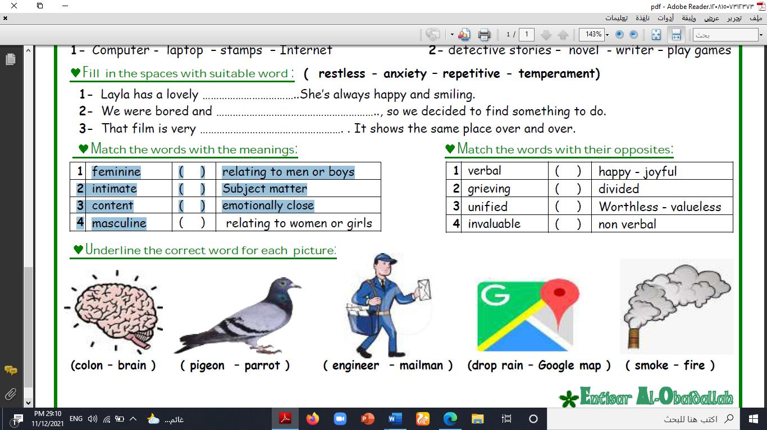**sneakears – prize – Nemo – Language – brain – ostrich**

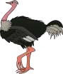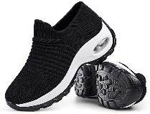

**-------- -------- ---------- ----------- ------ -------**

**A) Match to form new words or expressions:**

**1. fearsome ---- a. accept things**

**2. crucial ---- b. design symbol of a business or product**

**3. logo ---- c. causing great fear**

**4. go with the flow ---- d. extremely important**

**5. broke ---- e. You don't like**

**6. Not my cup of tea ---- f. out of money**

**End of Questions**

**Best of Luck**