**الاسم ............................................................ الصف .....................**

**Skill 24 : Read & match words to photos**

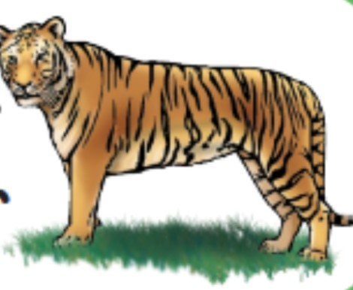**Skill 25 : read & comprehend simple short sentences**

**Skill 5 : recognize & match sounds to letters**

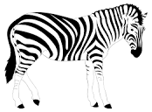**Skill 14 : talk about feelings in simple short sentences**

**Z**

**T**



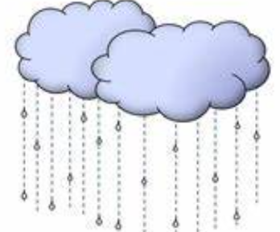

**S**

**It's rainy**

صورة تحتوي على رسوم متحركة, رسم, ابتسامة, الوجه الإنساني

تم إنشاء الوصف تلقائياً

**happy**

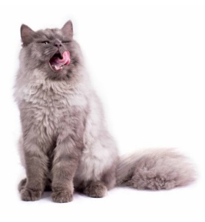

**cat**

**Skill 9 : Ask & respond to basic questions using (am-is-are) & (what – where – who)**

**Skill 8 : Ask & respond to simple present using ( like ) using (Yes – No questions )**

**Skill 12 : recognize & apply subjective pronouns ( I – you – he – she – he – it – we – they )**

1- What day do you **like** ? I …………… Wednesday

2- ( what – where ) is the matter ?

3- I ( am – is - are ) fine . Thank you

**Skill 13 : recognize prepositions of place ( in – on )**

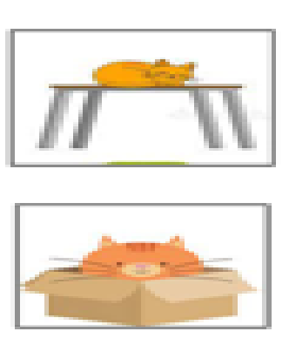**Skill 17 : identify family members & possessions using ( my – your )**

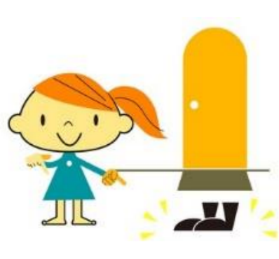

**my**

**in**

**your**

**on**

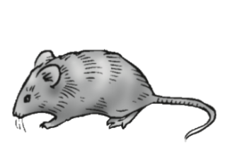

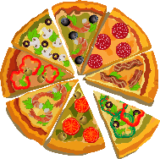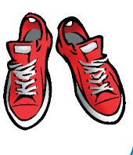**Skill 18 : identify & talk about food , animals , clothes**

**kabsa**

**pizza**

**cat**

**mouse**

**skirt**

**shoes**

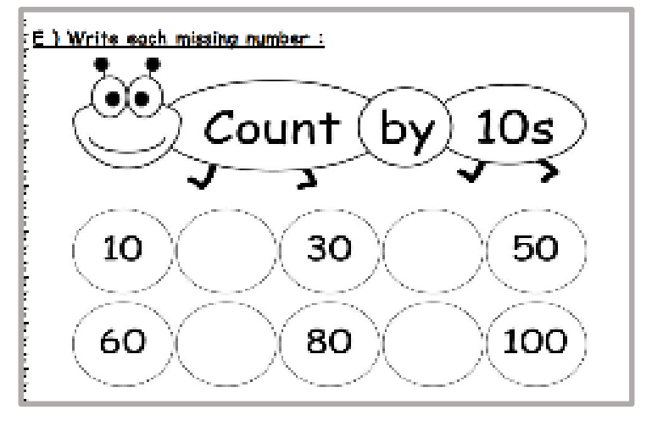**Skill 22 : read & count numbers in tens (10-100)**

**Skill 30 : copy words , numbers, simple short sentences**

**Skill 31 : write upper & lower case letters correctly**

**Skill 32 : use appropriate spacing between words**

**m**

**y**

Write the capital letter:

**T**

**Z**

Write the small letter:

**I'm happy**

صورة تحتوي على نص

تم إنشاء الوصف تلقائياًCopy:

صورة تحتوي على نص

تم إنشاء الوصف تلقائياً

**Skill 33 : write short guided answers to written questions**

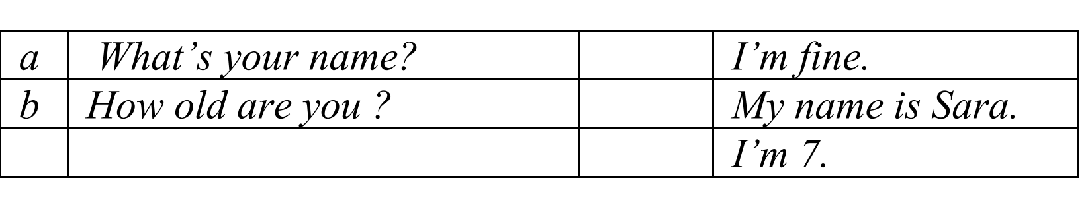

Teacher : Dalal Al-Juaid