10 Reported Speech - Yes-No & Wh-Questions Mix 2
By Mayra García Chincoya, EFL Teacher from Mexico.

YES-NO QUESTION | WH-QUESTIONS
Is our mom at work?  ➔ They asked if/whether their mom was at work. | What time is it?  ➔ They asked what time it was.
Do you know my brother?  ➔ She asked if/whether I knew her brother. | Where did you go?  ➔ She asked where I had gone.
Have you seen my father?  ➔ He asked me if/whether I had seen his father. | Who called?  ➔ He asked me who had called.

  What did the children ask them? | Where are we going on vacation? | Will we travel by plane? | Can we bring our dog? | What cities have we visited?
 | 1. The children asked ____ _______________________________________________. | 2. They wanted to know ____________________________________________________. | 3. They asked ___________ ________________________________________________. | 4. They wondered  _______________________________________________.

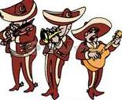  What were they asked? | How much do you charge? | Where can we hear you play? | Do you play romantic songs? | Have you played in birthday parties?
 | 5. They were asked _______________________________________________. | 6. The people wanted to  know___________________________________________. | 7. They were questioned _______________________ _______________________. | 8. A family wanted to know  _______________________________________________.

  What did he ask his friends? | Can I join you to study? | Where would you like to meet? | What time can we meet? | Do you want to come to my house?
 | 9. He asked them _______  _______________________________________________. | 10. He wondered _________ _______________________________________________. | 11. He wanted to know _____  ________________________________________________. | 12. Finally, he asked ________________________ _______________________.

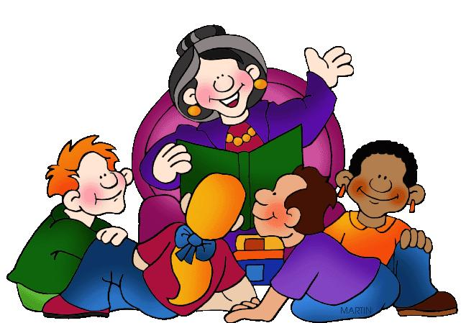  What did the children ask their grandma? | What story are you going to read? | Did you hear this story when you were little? | Is the story about a king? | Will this be a happy story?
 | 13. She was asked _______ _______________________________________________. | 14. A woman asked her _______________________________________________. | 15. We wondered ________ ____________________________________________________. | 16. Finally, she was asked ____________________________________________________.

10 Reported Speech - Yes-No & Wh-Questions Mix 2 - KEY
By Mayra García Chincoya, EFL Teacher from Mexico.

YES-NO QUESTION | WH-QUESTIONS
Is our mom at work?  ➔ They asked if/whether their mom was at work. | What time is it?  ➔ They asked what time it was.
Do you know my brother?  ➔ She asked if/whether I knew her brother. | Where did you go?  ➔ She asked where I had gone.
Have you seen my father?  ➔ He asked me if/whether I had seen his father. | Who called?  ➔ He asked me who had called.

What did the children ask them? | Where are we going on vacation? | Will we travel by plane? | Can we bring our dog? | What cities have we visited?
 | 1. The children asked WHERE they WERE going on vacation. | 2. They wanted to know IF/WHETHER they WOULD travel by plane. | 3. They asked IF/WHETHER they COULD bring THEIR dog. | 4. They wondered WHAT cities they HAD VISITED.

What were they asked? | How much do you charge? | Where can we hear you play? | Do you play romantic songs? | Have you played in birthday parties?
 | 5. They were asked HOW MUCH they CHARGED. | 6. The people wanted to  Know WHERE they COULD hear THEM play. | 7. They were questioned IF/WHETHER they PLAYED romantic songs. | 8. A family wanted to know  IF/WHETHER they HAD played in birthday ...

What did he ask his friends? | Can I join you to study? | Where would you like to meet? | What time can we meet? | Do you want to come to my house?
 | 9. He asked them IF/WHETHER he COULD join them to study. | 10. He wondered WHERE they WOULD like to meet. | 11. He wanted to know WHAT TIME they COULD meet. | 12. Finally, he asked IF/WHETHER they WANTED to come to …

What did the children ask their grandma? | What story are you going to read? | Did you hear this story when you were little? | Is the story about a king? | Will this be a happy story?
 | 13. She was asked WHAT story SHE WAS going to read. | 14. A woman asked her IF/WHETHER she HAD HEARD that story when she was little. | 15. We wondered IF/WHETHER the story WAS about a king. | 16. Finally, she was asked IF/WHETHER that WOULD be a happy story.

