******المملكة العربية السعودية**

**Kingdom of Saudi Arabia**

**Ministry of Education**

**------- Educational Directorate**

**------- Future Educational Schools**

**3rd grade intermediate 2022**

**3rd Term – Final Exam**

**وزارة التعليم**

**الإدارة العامة للتعليم بن**

**مدارس م ن التعليمية**

**الصف الثالث المتوسط**

**الاختبار النهائي للفصل الدراسي الثالث1443**

|  |  |  |  |  |  |  |  |
| --- | --- | --- | --- | --- | --- | --- | --- |
| **Total**  **written** | **5 spelling** | **4 Vocabulary** | **3 Grammar** | **2 Comprehension** | | **1 Composition** | **Q. NO.** |
|  |  |  |  |  | |  | **Mark Given** |
| **30** | **4** | **7** | **7** | **6** | | **6** | **Mark** |
|  | | | **Reviser** | |  | | **Corrector** |
|  | |

**زمن الاختبار: ساعتان**

**اسم الطالب: ------------------------------------ رقم الجلوس: ------------- الصف الثالث المتوسط**

**6**

1) **Composition**

**1- Write a paragraph about “Customs and Culture Shock "**

**You may use these words: in Mediterranean Countries - in England – in Japan - in Asian Country – in Mexico – in India – in United States and China – in Germany**

…………………………………………

………………………………………………………………………………………………………………………………………………………………………………………………………………………………………………………………………………………………………………………………………………………………………………………………………………………………………………………………………………………………………………………………………………………………………………………………………………………………….

**2) Comprehension**

**6**

**2- Read the following passage then answer the questions:**

**Omar Ibn Alkattab**

**Amir EL-Momeneen Omar Ibn Alkattab, may Allah bless him, was the second Caliph. He was a kind man and a good Muslim. He often gave food to the poor. Omar sometimes walks through the streets at night he walked alone, he had no soldiers with him. He had ordinary clothes on, and nobody knew that he was the Caliph. He listened to people to know their problems. One night, Omar was having a walk in a poor part of the city. He could smell food cooking. Many people were having dinner.**

**A- Put ( ) or ( x ):**

**1. Omar Ibn Alkattab was the third caliph. ( )**

**2. Omar Ibn Alkattab was a good Muslim. ( )**

**3. Omar Ibn Alkattab never walked through the streets at night. ( )**

**4. Omar Ibn Alkattab had very high and expensive clothes. ( )**

**5. Omar Ibn Alkattab made sure that many people were having dinner. ( )**

**B- Choose the correct answer:**

**1.Omar Ibn Alkattab gave food to the (**rich – wealthy – poor**) people.**

**2. At night, he had no (**visitors – soldiers – guides**) with him.**

**3. He could smell (**food – books – cars**) cooking.**

**4. At night, nobody knew that he was the (**caliph – captain – poor)

**C- Answer the following questions:**

**1. Who was the second caliph?........................**

**2. Was Omar Ibn Alkattab a kind man?.........................**

**3. Why did he listen to the people? .................**

**7**

**3) Grammar**

**A: Choose the correct answer:**

**1. People (**who – which – when**) live in glass houses shouldn't throw stones.**

**2. They stop (**playing – play – to play**) tennis in winter. They no longer play.**

**3. If you (**sleep – sleeping – sleeps**) in the class, the teacher won’t be happy.**

**4. He has (**yet – already – no**) come home.**

**5. I expect him (**arrive – arriving – to arrive**) home early.**

**6. He was cancelling his flight (**when – while – what**) we were calling him.**

**7. The floor is very messy. Can you clean (**it – them – him**) up.**

**8. (**Helping – helped – Helps**) my friends is a great fun.**

**B: Do as shown between brackets:**

**1. I can’t stand watch scary films. (**Correct**)**

**------------------------------------------------------------------------------------------**

**2. I have done my homework. (**Change into Negative**)**

**------------------------------------------------------------------------------------------**

**3. used – football – He – to – play (**Rearrange**)**

**------------------------------------------------------------------------------------------**

**4. She was (clean) the room when her brother entered the room. (**Correct**)**

**------------------------------------------------------------------------------------------**

**5. Turn the TV down. (**Change into two-word verb**)**

**------------------------------------------------------------------------------------------**

**6. Have they gone to school yet? (**Answer**)**

**------------------------------------------------------------------------------------------**

**4) vocabulary:**

**7**

**A- Match the words with the pictures:**

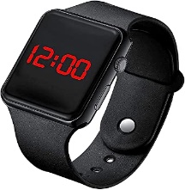**toothpaste – shopping – watch – pedal cab – iron – remove shoes**

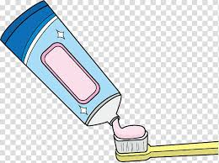****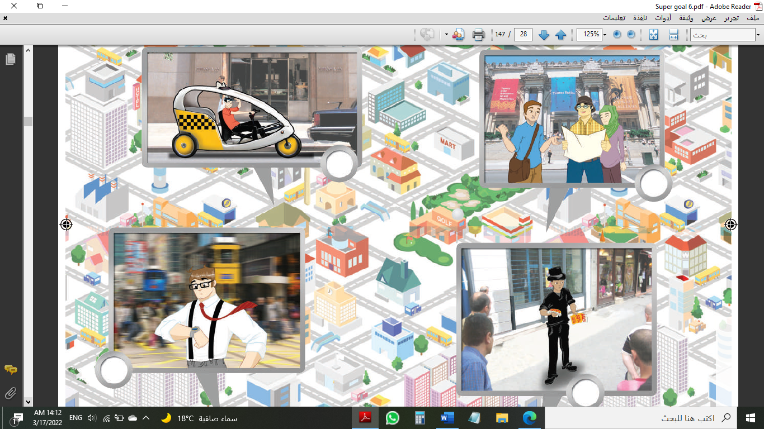

**……………. ……………. ……..……. ………..…… …………… …………..**

**B- Match the answers:**

|  |  |
| --- | --- |
| a. guide | **1. A fashionable person is someone who -------** |
| b. phoned me | **2. He shows the tourists the important places, he is a ------** |
| c. dresses well | **3. He "called me up", means he -------** |
| d. Of course, | **4. When you say, " At long lat." You mean --------** |
| e. Finally | **5. If you want to say, "Yes" in a strong way, you say -------** |

**C- Circle the correct spelling:**

**1. shampo - shampoo – shompoo**

**2. people – poeple - peopel**

**3. tickit – tickete – ticket**

**5) Orthography**:

**4**

**A- Fill in the missing letters:**

**1- cult__re**

**o – a – u – v - f**

**2- polluti__n**

**3- compl__in**

**4- talkati__e**

**B- Choose the odd one out:**

**1. eating reading working sing**

**2. Germany India China Hassan**

**3. done sleep eaten gotten**

**4. funny clever bus athletic**

**End of Questions**

**Best of Luck**