|  |  |  |
| --- | --- | --- |
| **المملكة العربية السعودية**  **وزارة التعليم**  **ادارة التعليم ب.............**  **مدرسة ..............** |  | **المادة/ لغة انجليزية**  **الصف / .................**  **الفصل الدراسي/ .........**  **الزمن/ ...............** |

|  |
| --- |
| **اختبار استماع –الفصل الدراسي ......... – الدور الأول – لعام 1444هـ** |

|  |
| --- |
| **اسم الطالبة بالعربي:** |
| **الفصل: 1🞎 2🞎 🞎انتساب** |

|  |  |  |
| --- | --- | --- |
| **Listening** |  |  |
| **5** |

**A.** Listen to the recording and check **☑** the correct answer for each question:

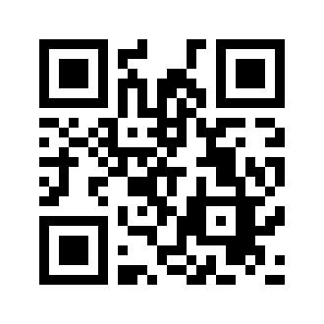

|  |  |
| --- | --- |
| 1-The listening is about …………. | |
| A | Money |
| B | City |
| C | Math |

|  |  |
| --- | --- |
| 2- According to the author of this story, money is…………… | |
| A | Very important |
| B | Not important |
| C | Only used in America |

|  |  |
| --- | --- |
| 3- The dollar is used in……….. | |
| A | Saudi Araba |
| B | United States |
| C | Every country in the world |

|  |  |
| --- | --- |
| 4- How long have people used money ? | |
| A | Thousands of years |
| B | Hundreds of years |
| C | They started recently |

|  |  |
| --- | --- |
| 5- People use money might to………… | |
| A | pay medical needs |
| B | pay for house and food |
| C | Both A and B |

**انتهت الأسئلة ،، بالتوفيق**