|  |  |  |
| --- | --- | --- |
| **المملكة العربية السعودية** |  | **اسم الطالب/ .........................** |
| **وزارة التعليم** | **رقم الجلوس : .........................** |
| **إدارة تعليم منطقة الرياض** | **المادة : انجليزي** |
| **مكتب التعليم بالسويدي** | **الزمن : ساعة ونصف** |
| **مدرسة :سيف الدولة الحمداني** | **الصف : الخامس** |
| اختبار نهاية الفصل الدراسي الثالث للعام الدراسي 1443هـ – لغة انجليزية –– للصف الخامس الابتدائي | | |

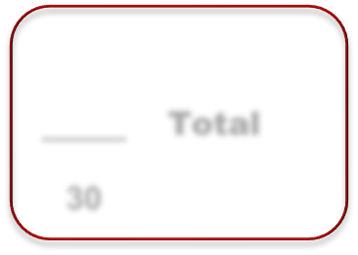

**Total**

**_____**

**3**

**0**

6

**Q1. General Questions:**

**Answer**

1. What time do you get up? Iget up at………o`clock.
2. Can elephants fly ? No,……………………
3. What is the weather today? It's …………………………..

6

**Q2. Vocabulary:**

**Choose**

**Bedroom - Kitchen - Pilot - Mountain - Firefighter - Watches**

|  |  |  |  |  |  |
| --- | --- | --- | --- | --- | --- |
|  |  |  |  |  |  |
| ---------- | ---------- | --------- | ---------- | --------- | --------- |

**Q3. Grammar**

**Choose**

5

1. Is he a teacher ? **( Yes, he is - Yes, he is not )**
2. Does he work in office ? **( Yes, she does - Yes, he does ).**
3. What is this ? **( It's a wallet - My name is Ahmed )**
4. Complete **( 22, ………,………,………, 26 )**
5. Where is Ali? **( He – She )** at home

**Q4. Reading**

5

**Match**

**( on - under - next to - in - behind )**

|  |  |  |  |  |
| --- | --- | --- | --- | --- |
|  |  |  |  |  |
| **………………………** | **………………………** | **………………………** | **………………………** | **………………………** |

**Q5. Orthography**

4

**Fill the missing letters**

**( ee - Sm - ea )**

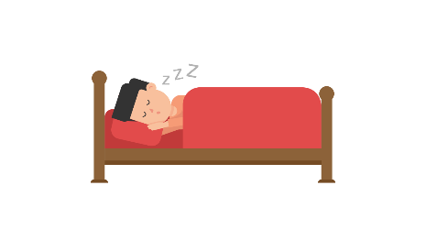

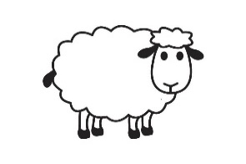

H _ _ d Sl _ _ p Sh_ _p _ _ ile

**Q6. Writing**

4

**Copy**

**Monkeys are cute**

|  |
| --- |
|  |
|  |
|  |

انتهت الاسئلة