**اختبار صف خامس الفصل الثالث الفترة الثانية لمادة اللغة الإنجليزية**

**20**

**الاسم : .....................................................**

**Q1: put ☑ or 🗵 ?**

**3**

**a) 1 , 2 , 3 ( )**

**b) 14 , 17, 18 ( )**

**c) 20 , 21 , 22 ( )**

**-------------------------------------------------------------------------------**

**Q2: match ?**

**3**

|  |  |  |
| --- | --- | --- |
|  |  | **a – paper** |
|  |  | **b – candy** |
|  |  | **c – pens** |

**Q3: complete ?**

**4**

**a) …..ider ( sp – kn )**

**b) ……eater ( sw – qu )**

**c) ……ring ( sp – sd )**

**d) ..…ing ( sw – gh )**

**----------------------------------------------------------------------------------------------**

**Q4: count ?**

**6**

**A)**

**…………………**

**b)**

**………………..**

**c)** 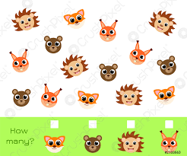

**…..…………**

**---------------------------------------------------------------------------------**

**Q5: choose ?**

**4**

**a) _ _ ail ( sn - sm )**

**b) _ _ ile ( sn - sm )**

**c) What's this ? ( They are watches - It's a wallet )**

**d) What are these ? ( They are watches - It's a wallet )**

**Good luck**

**T. Norah**