**Unit: 3 (My House )**

**Question 1: general questions**

1. **Answer the following questions**
2. Where is he watching Tv ?

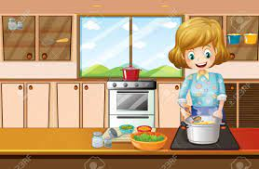…………………………………………………

1. Where is she cooking the dinner ?

…………………………………………………

1. Where is the mouse ?

…………………………………………………..

1. How do you spell box ?

…………………………………………………….

**Question 2: controlled writing**

1. **Rearrange the sentence:**
2. mouse / on / The / is / the / chair/ .

…………………………………………………………………………………………………..

1. in / She / kitchen / is / the / .

…………………………………………………………………………………………………..

1. **Copy the sentence on the four lines :**

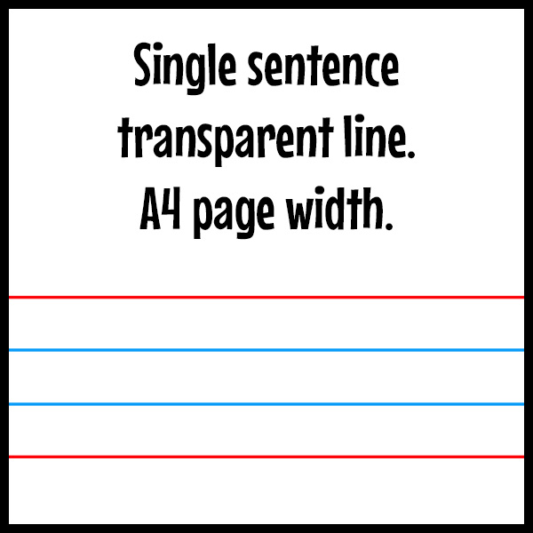The ox is on the box .

**Question 3: Reading short sentences**

1. **Read the sentence then chose T (√ ) or F (×)**



[هذه الصورة](http://www.coolstuff49ja.com/2012/10/man-complains-my-neighbours-loud-sex.html) بواسطة كاتب غير معروف مرخصة بالاسم [CC BY-SA](https://creativecommons.org/licenses/by-sa/3.0/)

1. He is sleeping in the bedroom ( )
2. The books are in the bag ( )

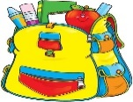

[هذه الصورة](http://www.ciaomaestra.com/search/label/scuola%20primaria) بواسطة كاتب غير معروف مرخصة بالاسم [CC BY-SA-NC](https://creativecommons.org/licenses/by-nc-sa/3.0/)

1. **choose the correct answer**

1- My sister brushes her teeth in the **(bedroom-bathroom) .**

2- We eat the breakfast in the **(dining room –front door ).**

**Question 4: spilling**

1. **choose the missing letters**

|  |  |  |  |  |  |
| --- | --- | --- | --- | --- | --- |
| **……..og** | | | **…….esent** | | |
| **pr** | **fr** | **ou** | **pr** | **fr** | **ou** |
| **m…………..se** | | | **cl……….d** | | |
| **pr** | **fr** | **ou** | **pr** | **fr** | **ou** |

**Question 5: Vocabulary**

**A - fill in the blank with the following words :**

**1-chair 2- bed 3- cupboard 4-fridge**

|  |  |  |  |
| --- | --- | --- | --- |
|  |  |  |  |

**B –match the picture with the suitable word :**

|  |  |  |
| --- | --- | --- |
| **A** |  | **B** |
| 1. House |  | [هذه الصورة](https://www.flickr.com/photos/hunky_punk/27834403574) بواسطة كاتب غير معروف مرخصة بالاسم [CC BY-SA](https://creativecommons.org/licenses/by-sa/3.0/) |
| 1. Front door |  |  |
| 1. Ox |  |  |
| 1. Table |  |  |

**Question 6: Grammar**

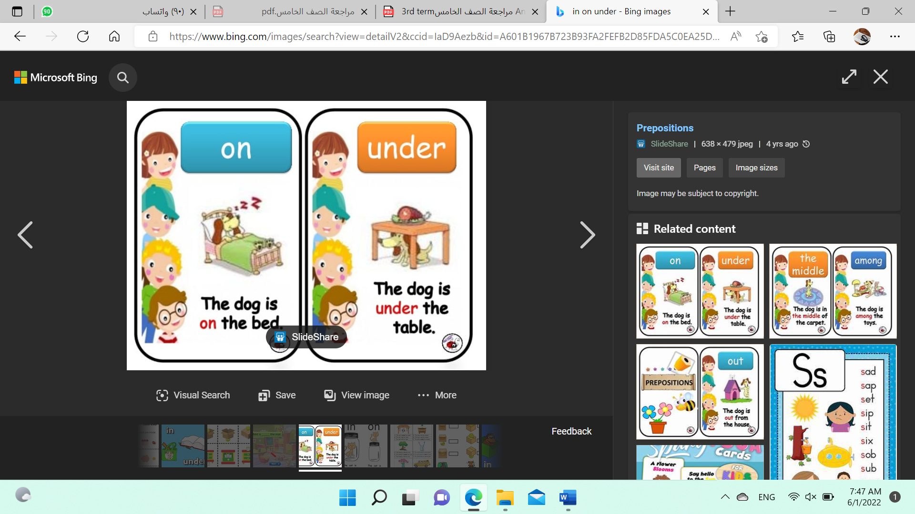**A-choose the correct answer :**

1. The dog is **( in – on )** the bed .



1. The dog is **( under- behind )**the table .

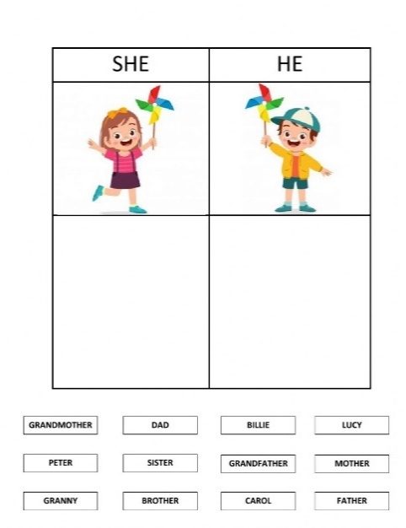

1. **( He – She )** is playing

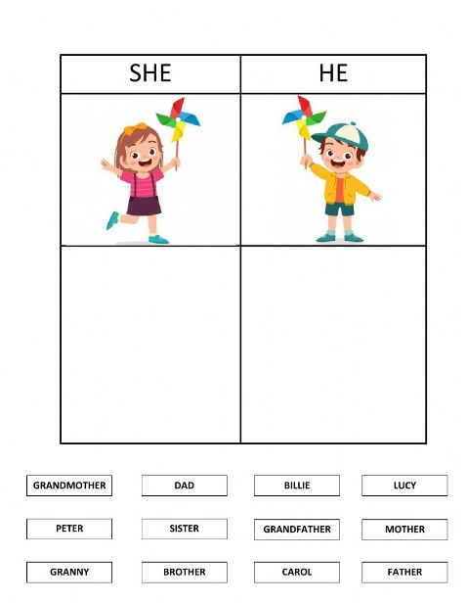

1. **( He – She )** is playing

إعداد المعلمة: عهود سالم باوزير

مراجعة وتدقيق مشرفة المادة: داليا إبراهيم فرغل