**Unit: 4 (My things)**

**Question 1: general questions**

1. **Match the questions with there answers**

|  |  |  |
| --- | --- | --- |
| **A** |  | **B** |
| 1. How many are there ? |  | Here you go . |
| 1. Can I use your pen? |  | There are 17 . |
| 1. What's this ? |  | They're comic books . |
| 1. What are these ? |  | It’s a watch . |

**Question 2: controlled writing**

1. **Rearrange the sentence:**
2. There / 3 / wallets / are / .

……………………………………………………………………………………..

1. an / is / it / Mp3 player/ .

………………………………………………………………………………………….

1. **Copy the sentence on the four lines :**

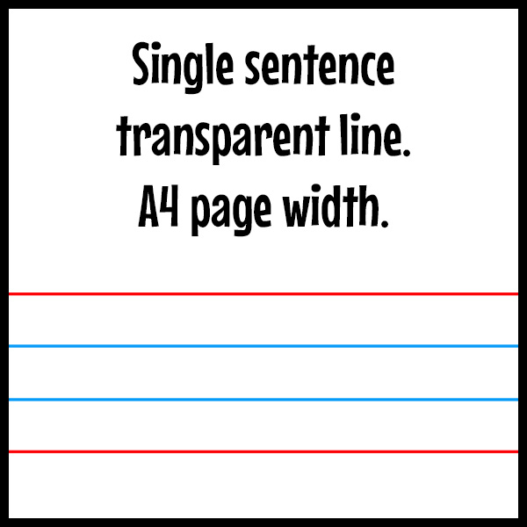A fat hen sat on a pen

**Question 3: Reading short sentences**

1. 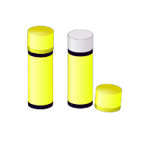**Read the sentence then chose T (√ ) or F (×)**
2. This is a glue ( )

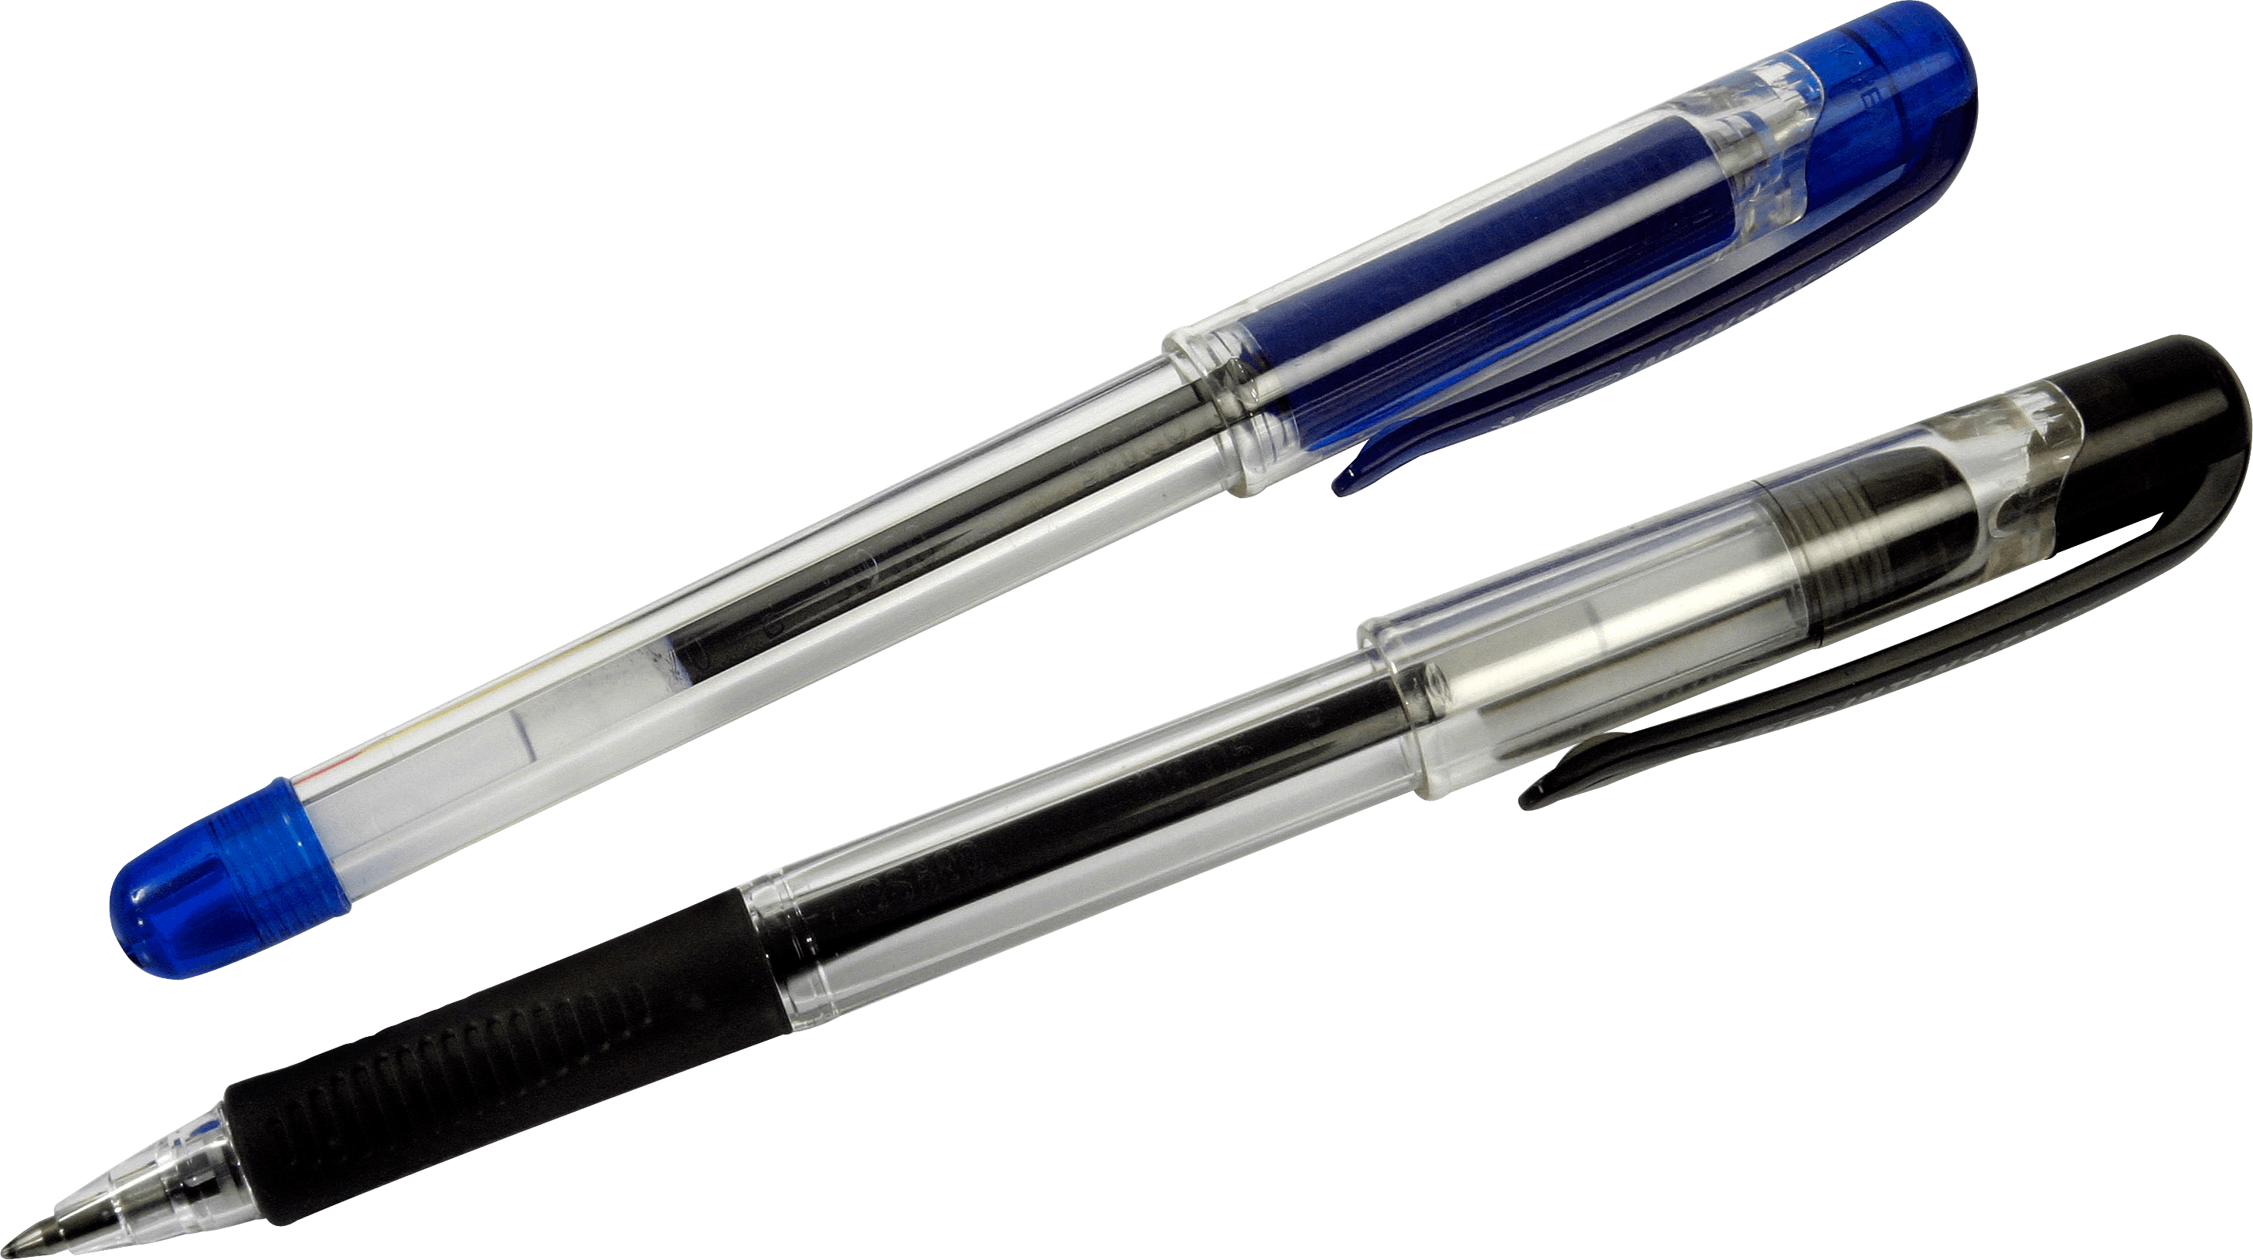

[هذه الصورة](https://freepngimg.com/png/2201-pen-png-image) بواسطة كاتب غير معروف مرخصة بالاسم [CC BY-NC](https://creativecommons.org/licenses/by-nc/3.0/)

1. There are 5 pens ( )

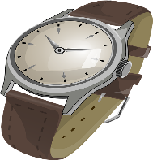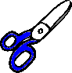**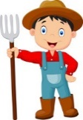C- Match :**

1- Can I use your scissors ?

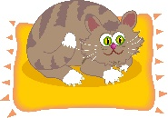

[هذه الصورة](https://www.freeimageslive.co.uk/free_stock_image/cat-mat-jpg) بواسطة كاتب غير معروف مرخصة بالاسم [CC BY](https://creativecommons.org/licenses/by/3.0/)

2- There is a watch

3- A` fat cat sat on a mat

**Question 4: spilling**

1. **complete the missing letters**

**( sm - sn - sp - sw )**

|  |  |  |  |
| --- | --- | --- | --- |
|  | [هذه الصورة](https://www.live-karikaturen.ch/downloads/fussball-sport-kicker-junge/) بواسطة كاتب غير معروف مرخصة بالاسم [CC BY-SA](https://creativecommons.org/licenses/by-sa/3.0/) |  | [هذه الصورة](http://stopthinkandunderstand.blogspot.com/2010/10/smile-if-not-for-yourself-do-it-for.html) بواسطة كاتب غير معروف مرخصة بالاسم [CC BY-NC-ND](https://creativecommons.org/licenses/by-nc-nd/3.0/) |
| **……………..an** | **……….ort** | **………ail** | **……..ile** |

**Question 5: Vocabulary**

**A - fill in the blank with the following words :**

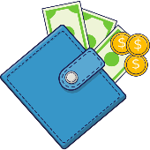**(Erasers – Candy – Scissors – Mp3 players -** **Wallet)**

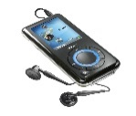

[هذه الصورة](http://askubuntu.com/tags/mp3-player/info) بواسطة كاتب غير معروف مرخصة بالاسم [CC BY-SA](https://creativecommons.org/licenses/by-sa/3.0/)

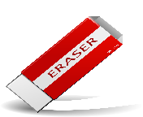

[هذه الصورة](https://www.pngall.com/rubber-png) بواسطة كاتب غير معروف مرخصة بالاسم [CC BY-NC](https://creativecommons.org/licenses/by-nc/3.0/)

|  |  |  |  |  |
| --- | --- | --- | --- | --- |
|  |  |  |  |  |
| [هذه الصورة](https://freepngimg.com/png/27183-candy-photo) بواسطة كاتب غير معروف مرخصة بالاسم [CC BY-NC](https://creativecommons.org/licenses/by-nc/3.0/) |  |  |  |  |

**Question 6: Grammar**

**A-choose the correct answer :**

1. What **( is this – are these )** ?
2. What **( is this – are these )** ?
3. What is this ? **( its – they are )** my book .
4. What are these ? **( its – they are )** my books .
5. It is **( a- an -** **Ø )** comic book
6. They are **( a – an - Ø.)** mp3 players

إعداد المعلمة: عهود سالم باوزير

مراجعة وتدقيق مشرفة المادة: داليا إبراهيم فرغل