**Unit: 5 (My day, Animal, places)**

**Question 1: general questions**

1. **Answer the following questions**
2. 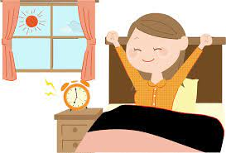What time do you get up?

…………………………………………………

1. What time do you eat lunch?

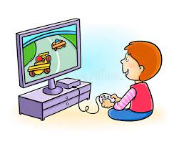…………………………………………………

1. What do you do on Friday?

…………………………………………………..

1. What do you in the evening?

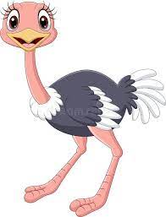…………………………………………………….

1. Can ostriches fly?

……………………………………………………



[هذه الصورة](https://www.pngall.com/teacher-png/download/40872) بواسطة كاتب غير معروف مرخصة بالاسم [CC BY-NC](https://creativecommons.org/licenses/by-nc/3.0/)

1. What dose she do?

……………………………………………………..

**Question 2: controlled writing**

1. **Rearrange the sentence:**
2. I / school / to / go / 6 o'clock / at / .

…………………………………………………………………………………………………..

1. It / sunny / hot / is /and / .

…………………………………………………………………………………………………..

1. **Answer the following question**

**Tell me about your day . what time do you :**

1. **Get up 2- go to school 3- eat lunch 4- come home**
2. I get up at ……………………….
3. I ………………………………………..
4. ……………………………………………
5. ……………………………………………

**Question 3: Reading short sentences**

1. **Read the sentence then choose T (√ ) or F (×)**



1. She has long brown hair ( )



1. He is a farmer ( )



1. He works at the school ( )



1. There is no sun today its cloudy ( )

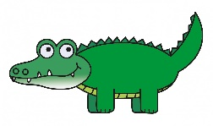

1. It can walk and swim ( )

**Question 4: spilling**

1. **choose the missing letters**

|  |  |  |  |  |  |  |  |
| --- | --- | --- | --- | --- | --- | --- | --- |
| **m…………t** | | **r………..d** | | **Sl……..p** | | **h…………d** | |
| **ee** | **ea** | **ee** | **ea** | **ee** | **ea** | **ee** | **ea** |

**Question 5: Vocabulary**

**A - fill in the blank with the following words :**

1. **pilot 2– architect 3-cook 4- businessman**

|  |  |  |  |
| --- | --- | --- | --- |
|  |  | [هذه الصورة](http://egbertowillies.com/2014/01/21/rich-undeserving-paul-krugman/) بواسطة كاتب غير معروف مرخصة بالاسم [CC BY-ND](https://creativecommons.org/licenses/by-nd/3.0/) | [هذه الصورة](http://www.padhuskitchen.com/2011/07/bachelors-recipes-bachelors-cooking.html) بواسطة كاتب غير معروف مرخصة بالاسم [CC BY-NC-ND](https://creativecommons.org/licenses/by-nc-nd/3.0/) |

**Question 6: Grammar**

**A-choose the correct answer :**

1- **( Do – Dose )** you watch Tv in the evening ?

2- Dose he work in an office? No, she **( dose- doesn't )**.

3- She **( work – works )** in a school .

4- What **( do – dose )** he do ?

5 - Do you get up at 5 o'clock ? yes I **( do – dose )** .

6 - I **( eat – eats )** lunch at 3 o'clock .

7 - She **( has – have** **)** short black hair .

إعداد المعلمة: عهود سالم باوزير

مراجعة وتدقيق مشرفة المادة: داليا إبراهيم فرغل