صورة تحتوي على نص

تم إنشاء الوصف تلقائياً**Final Exam 6th grade 1444H**

6

**I. General Questions**

**A. Match "A" with "B":**

|  |  |  |  |
| --- | --- | --- | --- |
| "A" |  | "B" | |
| 1. Do you have school uniform? |  |  | Yes, we do. |
| 1. Which subject do you like this year? |  |  | This year ,I like English. |
| 1. What would you like to drink? |  |  | I'm going to Dubai. |
| 1. Where are you going? |  | I'd like some juice. |

1. **Choose:**
2. **How many students are there in your school?**

**a.** About 500. **b.** Yes, we do

1. **What should you do to live a healthy life?**

**a.** I have a headache. **b.** I should do some exercise.

صورة تحتوي على نص

تم إنشاء الوصف تلقائياً________________________________________________________________________

**IV. Controlled writing**

**A. Unscramble and write:**

5

1.u– b – e – l

……………………………………………………………………………………….

2. u- t- e c

……………………………………………………………………………………….

**B. Complete: [ Paris –snow - book store - math - orange ]**.

1. I'd like some………………………juice, please.

2. ……………………………..sells books.

3. It's white. You ski on it………………………….

صورة تحتوي على نص

تم إنشاء الوصف تلقائياً

**III. Reading short sentences**

4

**A. Number.**

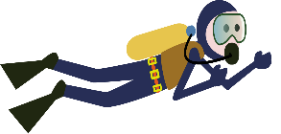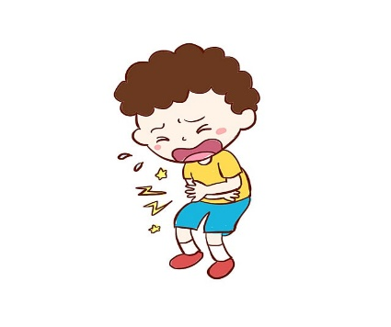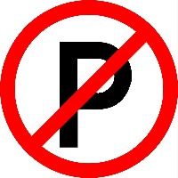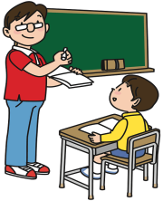1. No parking.

2. Listen to the teacher.

3. He’s scuba diving

4. I have a stomachache.

**II. Grammar**

صورة تحتوي على نص

تم إنشاء الوصف تلقائياً**A. Choose the correct answer:**

**1. There ( was – were - are ) a little green house.**

5

**2. Last year I [ went – go – going ] to Riyadh.**

**3. Did you ( drink – drank - drunk ) milk in the morning?**

**4. I'm going to [ visit – visiting – visits ] my grandma.**

**5. We ( is – are – am ) going to the bookstore.**

صورة تحتوي على نص

تم إنشاء الوصف تلقائياً**__________________________________________________________________**

**V. Vocabulary**

**A.Write the correct number under the correct picture:**

6

**1. bakery 2. stapler 3. School bus 4. toothache 5. science 6. skirt crocodile**

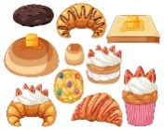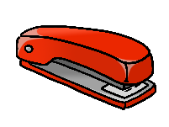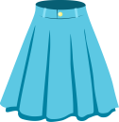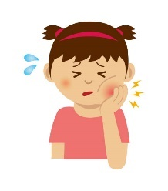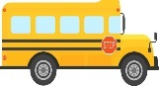

( ) ( ) ( ) ( ) ( ) ( ) .

صورة تحتوي على نص

تم إنشاء الوصف تلقائياً

**VI. Orthography(spelling)**

1. **Circle the correct missing litters:**

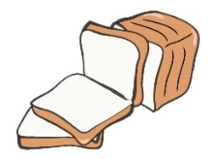

|  |  |  |  |
| --- | --- | --- | --- |
| 4 |  |  | Premium Vector | Little girl has earache touching her ear with finger  because of infection inflammation hurt inside |
| **juice** | **No bicycle** | **shirt** | **earache** |
| **bread** | No Bicycle" Images – Browse 390 Stock Photos, Vectors, and Video | Adobe  Stock**library** | Masculine Elegant Belt Icon Stock Illustration - Download Image Now - Belt,  Leather, Vector - iStock**belt** | **backache** |

1. **Complete:**  **[ ur – sc - ue – ir ]**

|  |  |  |  |
| --- | --- | --- | --- |
| Scary Shark PNG Clipart | Sharks scary, Shark mural, Shark drawing | Blue Tshirt White Collar White Collar | Blue tshirt, Clip art, T shirt  clipart | Super glue Black and White Stock Photos & Images - Alamy | Cheeseburger Clipart Images – Browse 4,880 Stock Photos, Vectors, and Video  | Adobe Stock |
| **_ _ ary** | **sh_ _ t** | **gl_ _** | **b_ _ ger** |

**GOOD LUCK**

**Tr.Amal ☺**