اسم:............................................................................ الصف:............................

**Choose:**

|  |
| --- |
| 34,782 Boy And Cat Cartoon Images, Stock Photos & Vectors | Shutterstockwhat's the matter ?  **A.** I am happy **B**. I like Sunday**.** |

|  |
| --- |
| * What day do you like ?  **A-**I am hungry **B-** I like Friday |
| -A- Do she bored ? B- Are you bored? |
| -A-Who is angry? B- What do angry. |

|  |
| --- |
|  |
|  |
| the apple (  **on - next** ) the books |
| ( **it - she** ) is ( **in - at** ) the box |
| (They - she ) are sad |
|  |

|  |  |  |  |  |  |
| --- | --- | --- | --- | --- | --- |
|  | Premium Vector | Little white sheep cartoon animal illustration bw |  |  | Ghim trên Bulletin boards |  |
| v | sh | p | sh | f | p |
| f | ch | b | ch | v | b |

**Listen then Choose the sound:**

**Choose :**

|  |  |  |  |  |  |
| --- | --- | --- | --- | --- | --- |
|  |  |  |  |  |  |
| Sunny | shoes | dress | thirsty | fox | angry |
| Cloudy | shirt | cap | happy | zebar | happy |

**Copy :**

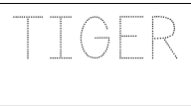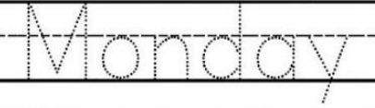

**It is cat .**

……………………………………………………………………………..………………………………………………………………….……..……………………………………………………………………………..……………………………………………………………………..……………………………………………………………………………..……………………………………………………………..……..

**Choose:**

|  |  |  |
| --- | --- | --- |
|  |  |  |
| **20** | **12** | **30** |
| **14** | **2** | **3** |

**5 + 5= ………………**

**4 + 4 =……………….**

**Choose:**

**H ( b - h)**

**C (c - g)**

**D ( d - C)**

|  |  |  |
| --- | --- | --- |
|  |  |  |
| tap | nope | cupe |
| top | rope | cap |

_

Controlled writing

Put

