**SG2 Term 3 General Revision. Grammar A/Correct the following mistakes:**

1. when I studied, My mom was cooked ... **cooking** ....
2. If I am sick, I may **stayed** at home. .…...**stay**....
3. We haven’t **write** any texts yet. …**written**.....
4. She will **is** ten next year. …**be**
5. She couldn’t **played** tennis. ....**play**…

**B/ Choose the correct answer:**

|  |  |  |  |  |  |  |  |
| --- | --- | --- | --- | --- | --- | --- | --- |
| **1-** | I …………… sleeping when you rang | | | | | | |
| **a-** | **were** | **b-** | **is** | **c-** | **are** | **d-** | **was** |
| **2-** | We ……. taken any food. | | | | | | |
| **a-** | **Haven’t** | **b-** | **have** | **c-** | **had** | **d-** | **hasn’t** |
| **3-** | She ……… her horse almost every day. | | | | | | |
| a- | **rides** | **b-** | **rode** | **c-** | **is riding** | **d-** | **has ridden** |
| **4-** | He has …………. his task early. | | | | | | |
| **a-** | **finish** | **b-** | **finishing** | **c-** | **finished** | **d-** | **Finishes** |
| **5-** | He was able to ……… fast when he was younger. | | | | | | |
| **a-** | **runs** | **b-** | **ran** | **c-** | **run** | **d-** | **running** |
| **6-** | Let me ………. you a joke. | | | | | | |
| **a-** | **tell** | **b-** | **tells** | **c-** | **told** | **d-** | **telling** |
| **7-** | 8- Sara won’t………. to her brother. | | | | | | |
| **a-** | **listen** | **b-** | **listening** | **c-** | **listens** | **d-** | **listened** |
| **8** | Ali drives ……… | | | | | |  |
| **a-** | **slowly** | **b-** | **slows** | **c-** | **The slowest** | **d-** | **slow** |
| **9-** | Nora is a ………. Speaker. | | | | | | |
| **a.** | **loud** | **b.** | **louder** | **c.** | **loudly** | **d.** | **louds** |
| **10** | If the lake………..., the children will probably go ice skating. | | | | | | |
| **a.** | **freezes** | **b.** | **freeze** | **c.** | **froze** | **d.** | **frozen** |
| **11** | **He wasn't ……… video games** |  |  |  |  |  |  |
| **a** | **play** | **b.** | **playing** | **c.** | **plays** | **d.** | **played** |
| **12** | **Have you ever ………. to London?** |  |  |  |  |  |  |
| **a.** | **gone** | **b.** | **went** | **c.** | **going** | **d.** | **go** |
| **13** | **She has already ( sleep – slept - sleeping ) late.** |  |  |  |  |  |  |
| **14** | **Let’s (go – going – went) shopping** |  |  |  |  |  |  |

**Vocabulary A/ Choose the correct answer:**

1. Where are my sunglasses? It’s really …….. today.

**a. sunny b. snowy c. windy d. rainy**

2. It will be 40 degrees Celsius today. That’s ……….

**a. hot b. cold c. fine d. cool**

3. It will be ……… this afternoon. You should bring your umbrella!

**a. sunny b. windy c. rainy d. cloudy**

4. This quiet beach is…….…..

**a. noisy b. relaxing c. adventurous d. expensive**

5. He has …….. on his body from the car accident.

**a. wounds b. points c. risk d. sneezing**

6. He was …….. from his last job. He always arrived late.

**a. fired b. risk c. screamed d. shocked**

**\*\*\*\*\*\*\*\*\*\*\*\*\*\*\*\*\*\*\*\*\*\*\*\*\*\*\*\*\*\*\*\*\*\*\*\*\*\***

**B/ Cross out the odd word:**

1. **a/ Shark b/ dolphins c/ camels**
2. **a/ Basketball b/ volleyball c/ biking**

**3. a/ bike b/ spring. c/ winter**

**4. a/ bungee jumping b/ swimming c/ water skiing**

**\*\*\*\*\*\*\*\*\*\*\*\*\*\*\*\*\*\*\*\*\*\*\*\*\*\*\*\*\*\*\*\*\*\*\*\*\*\***

**C/ Write the suitable word under each picture:**

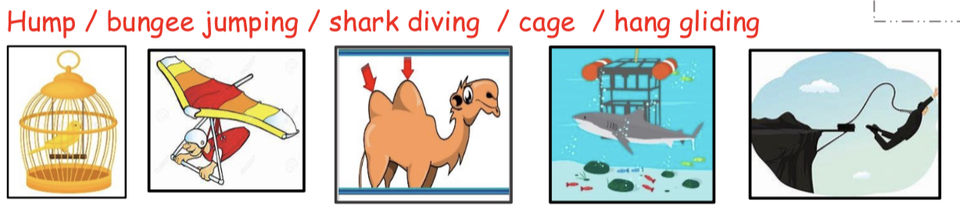

|  |  |  |  |  |
| --- | --- | --- | --- | --- |
| **4 cage** | **5 hang gliding** | **1 hump** | **3 Shark diving** | **2 Bungee jumping** |

**D/ Write the suitable word under each picture:**

**(1- snake / 2- parrot / 3- fall / 4- rainforest / 5- bear)**

|  |  |  |  |
| --- | --- | --- | --- |
|  |  |  |  |
| 4 rainforest | 3 fall | 1 snake | 2 parrot |

**\*\*\*\*\*\*\*\*\*\*\*\*\*\*\*\*\*\*\*\*\*\*\*\*\*\*\*\*\*\*\*\*\*\*\*\*\*\***

**Orthography**

**A- Choose the correct letter:**

1. Are you going on va.....ation ? ( **o – c – r** )

2. Scuba di...ing in The Red Sea ( **q – v – k )**

3. The ele....ator wasn’t working. ( **v – o – y** )

4. The guests arrived ea...ly. ( **r – d – x** )

5. Stay tuned for brea...ing news ! ( **k – u – g)**

6. Children Please put away your to....s ( **v – o – y** )

7. Can I borrow your cell p....one? ( **q – x – h**)

8. Let me ca.....ry that for you. ( **o– u – r)**

9. It was so t…. red. ( **o– u – r)**

10. That s…. ark is wild.( **q – x – h**)

11. We have lived in the dese…t. ( **p – u – r**)

12. They like s….ring. ( **p – b – r** )

Writing **6 marks**

Write a text about your favorite sport

Sample

Check (teams) for samples