

**التاريخ: / / 1444هـ**

**الزمن: ساعة ونصف**

**المادة: اللغة الإنجليزية**



**وزارة التعليم**

**الإدارة العامة للتعليم بمنطقة مكة المكرمة**

**مكتب شرق مكة**

**مدرسة أجيال الوفاء الاهلية (ابتدائي)**

**اختبار اللغة الإنجليزية نهائي – الدور الأول - للصفين الرابع والخامس ابتدائي – الفصل الدراسي الثالث 1444هـ**

**I- General Questions:**

6

A- Answer the following questions correctly:

1- What time is it? It's ……………………. o'clock.

2- Do you watch TV in the evening? Yes, ……………….

3-What is your favorite animal? ……………………….

B- Match the questions in column (A) with the correct answers in column (B)

|  |  |
| --- | --- |
| B | A |
| ( ) I get up at 6 o'clock.  ) Twenty.)  ( ) There are 7 days.  ( ) blue. | 1- How many days in the week?  2- What time do you get up?  3-The 20 its name………. |

**II- Controlled Writing:**

5

A- Complete the sentences with the correct word:

1-A fat………………….sat…………………a box.

(animal) (preposition)

B-How do you spell ( Fun) and ( not)?

………………………………………………………………………………………………………………………………………

C- Copy the sentences:

1- She works in restaurant .

……………………………………………………………………………………………………………………………………………

2- She is a cook.

……………………………………………………………………………………………………………………………………………

**III- Reading Short Sentence:**

4

A- Read the sentences and match them with the correct pictures:

1-They are wallets. 2- It's a sheep. 3- It's snowy and cold. 4- They're cooks.

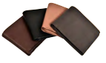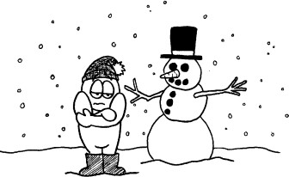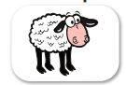

B- .Read the following sentences, then choose the answer below:

1-which animal is jaws are huge and can swim and walk?

a-cat b-crocodile c-fish

2-which animal its skin is green and eyes pop out?

a-frog b-snake c-ostriches

3-can jump but can't fly.

a-bear b-kangaroo c-dog

4- I have many things like.

a- pen b-bag c-all the above.

**IV- Grammar:**

5

A) Choose the correct word:

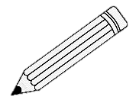

1- They ( is – are - am ) pencils.

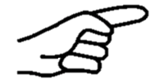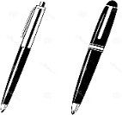2- ( That – These - Those ) is my eraser.

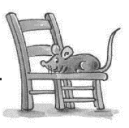3- What are ( this – these - he )?

4- The mouse is ( under – on - in )the chair.

B- Rearrange the words to form a sentence:

1- play / I / friends / . / my / with

………………………………………………………………………………………………………………………….

2- is / a / This / . / watch

………………………………………………………………………………………………………………………….

|  |  |
| --- | --- |
| **Plural** | **Singular** |
|  |  |

C-Classify the following words in the table:

**Walt – comic books – watch – pencils**

**V- Vocabulary:**

6

A) Write the correct number under each picture:

**1**- candy **2**- watch **3**- meat **4**- kangaroo **5**- scissors **6**- firefighter

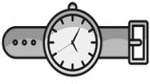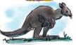

( ) ( ) ( ) ( ) ( ) ( )

B-Circle the odd one out:

1- Livingroom – bedroom – hand – kitchen.

2- pen – paper – glue – teacher.

3- loin – cat – face – monkey.

4- sofa - cook - doctor – businessman.

C- Complete the sentences with the correct word:

**sunny- run - summer**

1-It's ………………………… and very hot in ……………………

**VI- Orthography:**

A- Choose the correct word:

4

**(mile - wan – ead - port)**)(

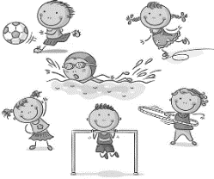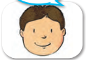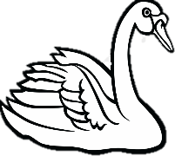

1- S………… 2- h……….. 3- S………… 4-S………..

B-Choose the correct letter:

1-s….ider **(p-f)** 2-su…. **(t-n)**  3-t….ee **(r-s)**  4-c..oud **(m-l)**

5-s…ack **(n-g)** 6-do…tor **(v-c)** 7-pil….t **(o-n)** 8-p…ize **(a-r)**