

**اختبار الفترة الثانية.**

**الفصل: الدراسي الثالث 1443ه.**

**الصف السادس الابتدائي.**

**المادة : انجليزي.**

**We Can 6**

**المملكة العربية السعودية.**

**وزارة التعليم.**

**إدارة التعليم**

**مكتب تعليم**

**المدرسة الابتدائية**

**الاسم / .**....................................................................................الفصل: ..../.....

**General questions: (5m)**

1 – Answer the following questions :

|  |
| --- |
| **1 - What time does your school start?**  A . We bring our own.  B . It starts at 7:00. |
| **2 – What is the matter?**  A . I have a headache.  B . I have a toothache. |
| **3 – Where is the post office?**  A . It's next to the school.  B . You're welcome. |
| **4 - Can you read the sign?**  A . Stand up  B . Don’t shout. |
| **5 – What subject do you like most?**  A . I like English.  B . I like ice cream. |

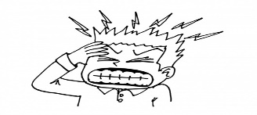

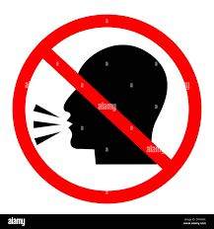

**Reading short sentences: (3m)**

2 – Read and put **🗸 or 🗴**  :

|  |  |  |
| --- | --- | --- |
| **1. She's going to the bakery.** | 🗸 | 🗴 |
| **2. We have a school bus.** | 🗸 | 🗴 |
| **3. You should eat too much junk food.** | 🗸 | 🗴 |



**Grammar: (3m)**

4 – Read and choose the correct answer:

|  |  |  |
| --- | --- | --- |
| liked | like | **1 – Last year, I ……….Math.** |
| There were | There was | **2 – ……… a little green house.** |
| are | is | **3 – We …..going to the bookstore.** |

**Vocabulary: (5 m)**

5 – Write the correct word under each picture:

No Bicycle - burger - square

**1 –** stationery store - candy store - zoo – flower store

**2 –** bank - hospital - school - Arabic

6 – Circle the odd word:

7 – Copy the following:

**……………………………………**

**I have a bicycle.**

|  |  |  |
| --- | --- | --- |
|  |  |  |
| ………..……. | ………..……. | ………..……. |

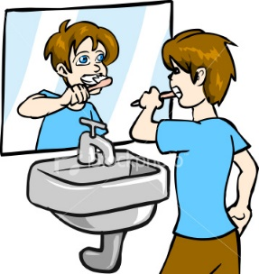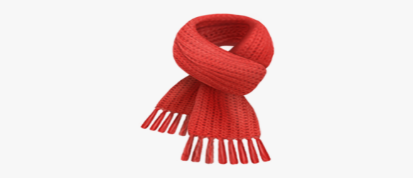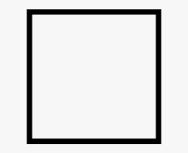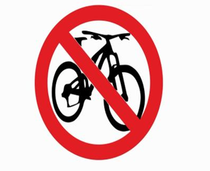

|  |  |  |  |
| --- | --- | --- | --- |
|  |  |  |  |
| **Drin…**  **( h - k )** | **__arf**  **( sc - sq)** | **__rush**  **(b – f )** | **C …be**  **( v– u )** |

7 – Choose the correct letter:

**Orthography (Spelling): (4 m)**