Fifth Grade 2nd Period Exam

|  |  |  |  |  |  |
| --- | --- | --- | --- | --- | --- |
|  | **Mark** | **5/** | **Class** |  | **Name** |

|  |
| --- |
|  |
| 3 |

a.Answer: General Questions

1-What time is it? It is ……………………….

2-Do you sleep at 9 o'clock? Yes, ……………………

b.Match:



|  |  |  |
| --- | --- | --- |
| 1-What are these ? |  | It's hot . |
| 2- Can snakes fly ? |  | No, they can 't. |
|  | They're wallets. |

|  |
| --- |
|  |
| 2 |

Rearrange: controlled Writing

1. is/ a/ He /farmer……………………………………………………………
2. 60/ 90/ 70/ 80……………………………………………

Do as shown: Grammar

|  |
| --- |
|  |
| 4 |

1- erasere ( make it singular)……………….. .

2- man ( make it plural) …………………..

3-What ( are – is ) this ? It is a watch.

4- How many pens are there ( , - ? - ! ) .



|  |
| --- |
|  |
| 2 |

Match : Reading

1. Their skin is green.

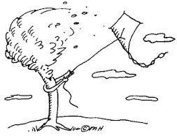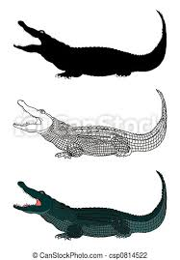

1. Its jaws are huge.

|  |
| --- |
|  |
| 5 |

a.Choose : Vocabulary

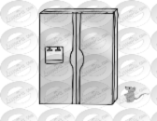1-The mouse is (in – next to) the fridge.

2-He is an (astronaut -cook).

b. circle the odd word:

1-pen - cat - pencil – paper. 2- cow – in – on – under.

|  |
| --- |
|  |
| 4 |

3-computer technician – teacher-doctor – cloudy.

Fill in : Orthography

sp/sn/ee/ea

____ider ___owy br___d sl___p

Good luck…Fadiah Melebari