Grade 5 Final Revision 3rd Term.

**1) Answer the following questions correctly**:

1- Can you spell box ? .. ( b- o- x / Thank you )

2-Welcome to our house?.. ( Thank you / Hello )

3-Food is cooked in the … ( Kitchen / bedroom )

4-My dad is watching TV in the . . . ( Living room / bathroom)

5-My sister brush her teeth in the. . . (bathroom / bedroom )

6-We play football in the . . . (kitchen / Yard )

7-Where do you eat breakfast? . . . I eat breakfast in the. . . (front door / dining room)

8-How do you spell hot? . . . (Hello / h-o-t)

9-Can I use your pen? . . . (Thank you / Here you go)

10-What time do you get up ? . . . I get up at ( comic book / 5:30 AM )

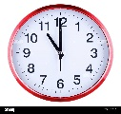

11-What time is it ? . . . It is (ten / eleven) o’clock.

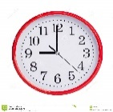

12- What time is it ? . . . It is (nine / seven) o’clock.

13-School days are ( 3 days / 5 days ) a week.

14-There is no sun today , It is ( sunny / cloudy )

15-It’s sunny and hot in ( winter / summer )

16- They can run , but they cannot fly. They are ( Snakes / Ostriches )

17-He cook in a restaurant , he is a ( teacher / cook )



18-This is a ( man / women)

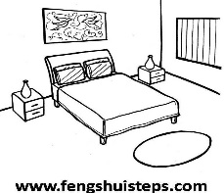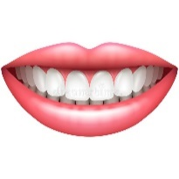2**) Match**:

12

1-Cupboard

10

14

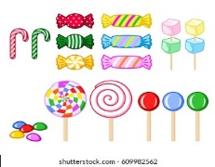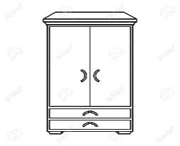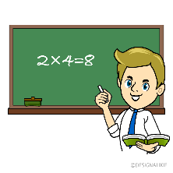2-Seasors

18

6

1

3-Bed

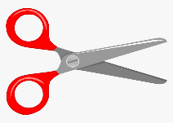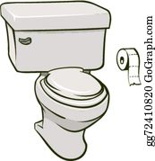

4-Bathroom

2

9

4

5-Glue stick

17

11

3

6-Candy

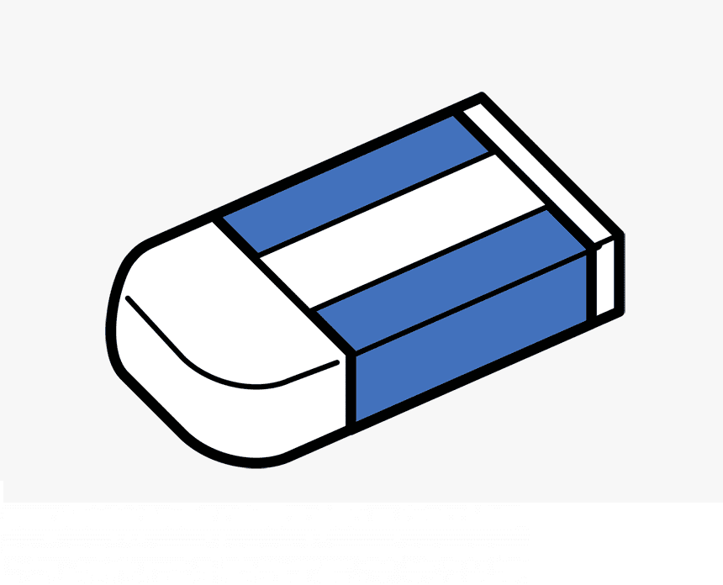 7-Kitchen

8

16

7

8-Tooth

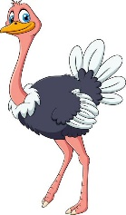

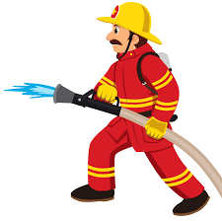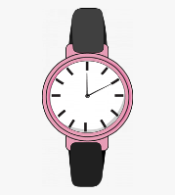9-Paper

20

19

21

10-Astronaut

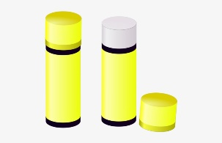

11-Farmer

13

5

15

12-Teeth

13-Fridge 14- Bedroom 15- Wallet

16-Eraser 17- Pilot 18- Teacher

19- Watch 20- Firefighter 21-Ostrich

**3) Choose**:

1- He is = ( She’s , He’s ) .

2-Where is = (Where’s , Who’s )?

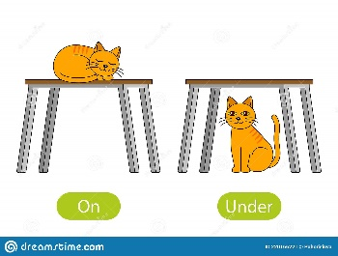

3-The cat is ( on / in / under ) the chair.



4-The dig is ( behind / under / next to) the table .



5- The pen is ( in / next to /on ) the bag .

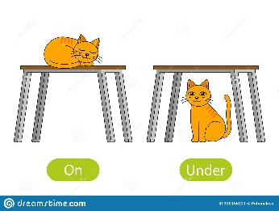

6- The cat is (behind / in / on ) the table.

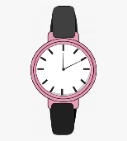

7- What are ( this / these )? .



8-These ( is / are ) pens .



9-What is ( this / these) ?



10-( These / Those) are teeth.

11-( This / That ) is a mouse.

12-Does ( They / he ) work in an office ?

13-Is he a teacher ? . . . Yes, ( he / she ) is.

14-(She / He/ They) is a doctor.

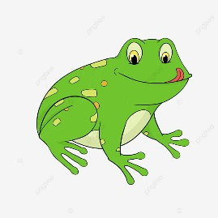**4 ) Fill in the missing lette**r:

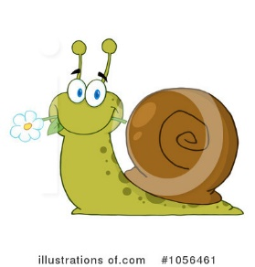

br_ea_d

M_ea_t

Cl_ou_d

M_ou__se

M__ou_ntain

H__ou_se

_Pr_esent

_Fr_ies

_Fr_og

_Pr_rize

Sh_ee_p

H_ea_d

R_ea_d

Sl_ee_p

_Sw_an

_Sw_ing

_Sp_ort

_Sp_ring

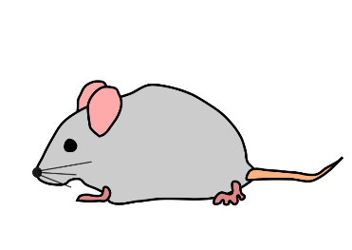

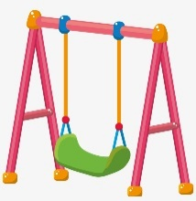

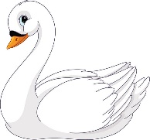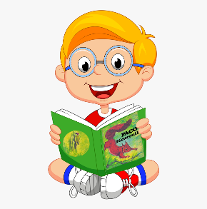

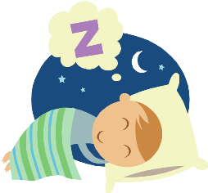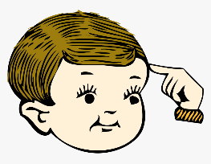

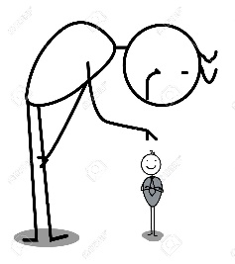

Sn__ack

Sm__all

_Sn_ail

_Sm_ile

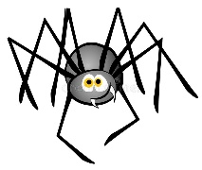

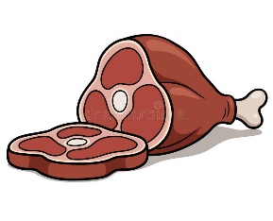

Sw__eater

Sp__ider

All the best of luck