اختبار الفترة الثانية–– للصف الخامس ابتدائي – الفصل الدراسي الثالث

الأسم ثلاثي: |  | الفصل | 6 / | الدرجة

General questions match
No, they can't. |  | What time do you eat your lunch ? | 1
At 2:00 o'clock. |  | Do you watch TV in the evening ? | 2
Yes, I do . |  | Can kangaroos fly ? | 3
Controlled writing match
nine o'clock |  | It is sunny and very hot in ______. | 1
winter |  | are – what - ? – these ( REARRANGE) | 2
summer |  | summer , _____ , autumn , spring | 3
What are these? |  | 9:00 ) . It is ____________. ) | 4
Grammar CHOOSE
They are _____ . | Q2 | What ___ this ? | Q1
a wallet | A | is | A
wallets | B | are | B
___ he work in the office? | Q4 | I get up ___ 6:00 . | Q3
Do | A | in | A
Does | B | at | B
vocabulary match
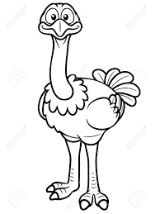 |  | wallet | 1
 |  | ostrich | 2
 |  | sunny | 3
 |  | astronaut | 4
Orthography match
ee |  |   _ _ eater | 1
sw |  |   _ _der | 2
sp |  | 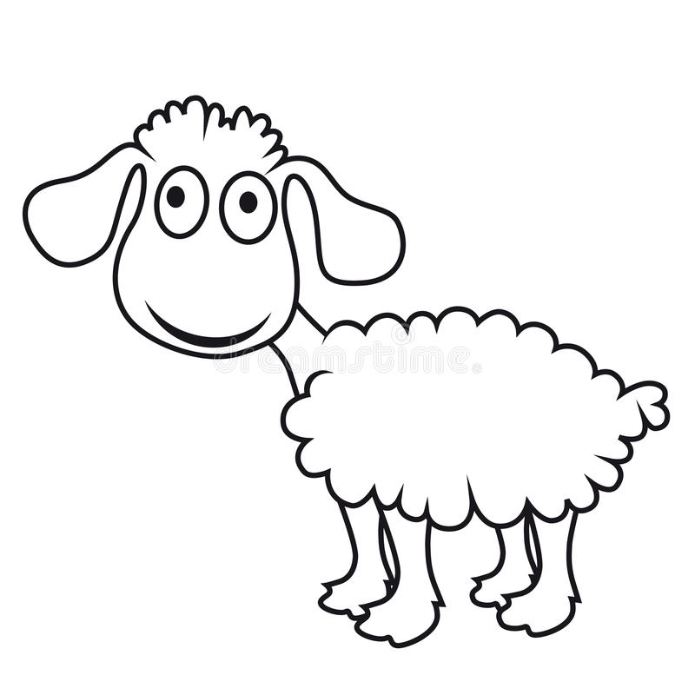  sh_ _p | 3
Reading match
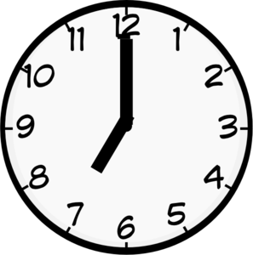 |  | It is rainy and wet. | 1
 |  | I get up at 7 o'clock. | 2
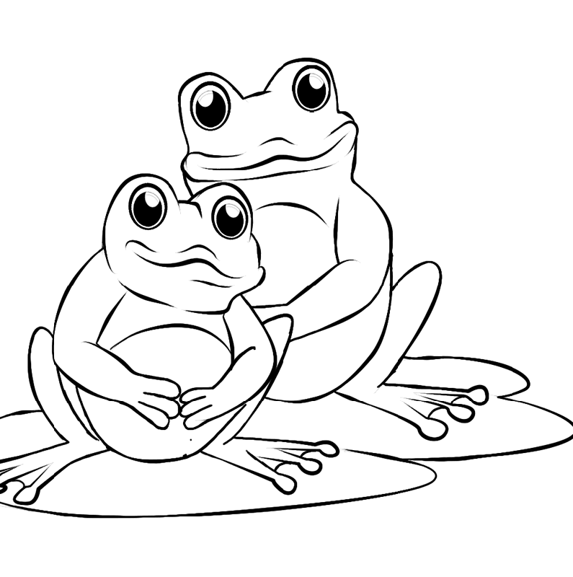 |  | He is a doctor. | 3
 |  | They can jump and dive. | 4

توزيع الدرجات المقترح

General questions 1mark each

Controlled writing 1mark each

Grammar 1mark each

Vocabulary 1mark each

Orthography 1mark each

Reading 1/2 each

______________________
الاسئلة من الوحدة الر ابعة الدرس الثالث الى الوحدة الخامسة حسب توزيع المنهج ( وللمعلم الخيار حسب توزيعة )
وفقكم الله

T. Mohamad Zaid Al Asmari

