**4thperiod Revision we can الاولي مراجعة الفترة** 

1. **Match**
2. **Do you have a pet ? a- 16 cats**
3. **What is this ? b- yes , I have a rabbit.**
4. **How many cats ? c- It’s a farm.**
5. **Choose**
6. **Yes , I ( do – don’t )**
7. **No , I ( do – don’t )**
8. **I have 6 ( bird – birds )**
9. **( Do – Are ) you have a cat .**

**3- Match** 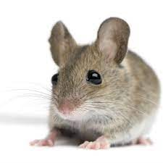

1. **Farmer** 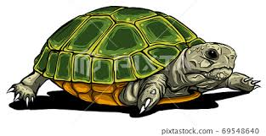
2. **Sheep** 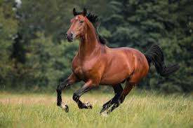
3. **Mouse** 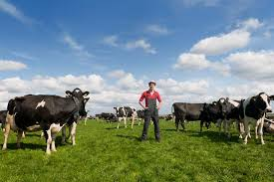
4. **Turtle**

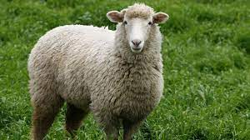

1. **Horse**

4- Complete the numbers :-

….., 12 , ….., 14 ,….., 16 , 17 , ….. , 19 , …..

1. Read and answer

My name is Ali. I’m nine. I have a nice pet . It is a fish . Its name is Nemo . It is red

1. Ali is nine . ( true- false )
2. Ali has a pet . ( true- false )
3. **Ali has a ( cat - fish )**
4. **Nemo is ( red - green )**
5. supply the missing letters:-

**( T - S - V - U )**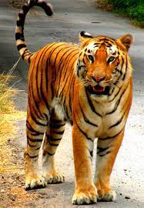

**…un ….iger …..mbrella ….ase**

Goodluck

Teacher/ Mr. Islam Moustafa