**Unit : 9 My School is Cool !**

**General Questions**

A)- Match the questions in column A with the answers in column B:

|  |  |  |
| --- | --- | --- |
| B | A | |
| About 1,000 students( ) | 1- What’s the name of your school |
| ( )Yes, it does. It has a big yellow bus | 2- How many students are there in your school? |
| ) It starts at 7:00 ) | 3- Does your school have a school bus? |
| ( ) Rhadah Elementary School | 4- What time does your school start? |

**Reading short sentences**

**B) Read the following sentences then Put ( T ) or ( F )**

|  |  |  |  |
| --- | --- | --- | --- |
| X | √ | Don`t Shout stock vector. Illustration of noise, pictogram ... | 1- Don't shout; speak clearly |
| X | √ | Ask For Help Clipart, Transparent PNG Clipart Images Free Download -  ClipartMax | 2- Ask for help when you have a problem. |
| X | √ | Premium Vector | Back to school illustration with teacher and boy | 3-Don't listen to the teacher |

**Grammar :**

**C) Choose the correct answer:**

1-Which subject ( do – did ) you like most this year?

2-This year I ( liked – like ) math.

3-Which subject ( did – do ) you like most last year?

4-Last year I ( like – liked) PE.

5-( Who – Which) city do you live in? I live in Makkah.

6-Last year we ( go - went ) to Riyadh.

**D) Write the past tense of the verbs :**

Has---------- is------------ Follow------------ Make------------ Go--------------

**Vocabulary**

**E) Write the correct word under each picture :**

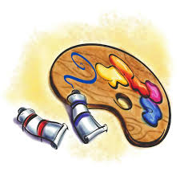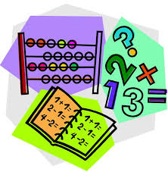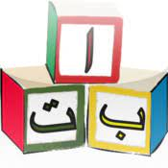1-English 2-Science 3- Math 4- Art 5- Geography 6- Arabic

------------------ ---------------------- ----------------------- -------------------- -------------------- --------------------

F) Fill in the missing letters : sc , sk, sq

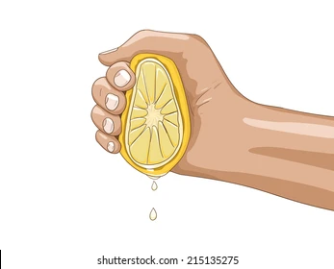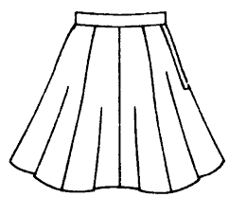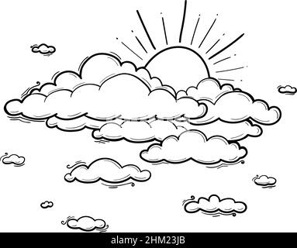

**ueeze---- ---- uare ---- --- y ---- ---- irt ---- ----**

**Controlled writing**

G)- Do as shown between brackets :

1-There are about ______ students in my school. (Complete the sentence)

2-Our school starts at ___________ . (Complete the sentence)

H) Copy

Rana had a Little lamb

----------------------------------------------------------------------------------------------------------------

----------------------------------------------------------------------------------------------------------------

I)**Rearrange the sentences**

Math – like – I---------------------------------------------------------------------------------

**Unit : 10 (A Healthy Life . ) Revision .**

**General Questions**

A)- Match the questions in column A with the answers in column B:

|  |  |  |
| --- | --- | --- |
| I shouldn‘t drink too much soda. |  | 1- What should you do to live a healthy life?) |
| I have a headache. |  | 2- Bad Things I Shouldn‘t Do |
| It’s 60 SAR. |  | 3- What‘s the matter? |
| I should drink a lot of water. |  | 4- How much is the sweater? |

**Reading short sentences**

**B) Read the following sentences then Put ( T ) or ( F ):**

|  |  |  |
| --- | --- | --- |
| Clip Art Healthy Food Poster - Healthy Food Vs Junk Food Poster, HD Png  Download , Transparent Png Image - PNGitem |  | 1- I shouldn't eat too much junk food. |
| Free Fun Exercise Cliparts, Download Free Fun Exercise ... |  | 2- I should do some exercise. |
| Brushing Your Teeth Clipart Hd PNG, Cute Brushing Teeth ... |  | 3- I brush my teeth this morning. |
| Cartoon Kids Eating Breakfast Images – Browse 9,648 Stock Photos, Vectors,  and Video | Adobe Stock |  | 4- I ate breakfast this morning. |

**Grammar**

**A-Choose the correct answer:**

1-Did you ( got up - get up) early this morning?

2-I ( got up - get up) early this morning.

3-I didn‘t ( drank – drink) milk this morning.

4-I ( brush – brushed) my teeth this morning.

5- I didn‘t ( brush – brushed) my teeth this morning

**B-Write the past tense of the verbs :**

Play-------------- get up------------------ Talk------------------ eat---------------------

**Vocabulary :**

**C) Write the correct word under each picture :**

What's the matter?

|  |  |  |  |
| --- | --- | --- | --- |
| Little girl suffering from toothache touching her cheek feeling painful.  Kid with dental problem and sensitive teeth showing upset facial expression  7533108 Vector Art at Vecteezy | 132 Earache Cartoon Stock Illustrations, Cliparts and Royalty Free Earache  Cartoon Vectors | Premium Vector | Young boy suffering stomach ache | Man with Headache and Cold clipart. Free download transparent .PNG |  Creazilla |
|  |  |  |  |

**Toothache – Stomachache- Earache – Headache**

**D) Fill in the missing letters : ur - ir**

|  |  |  |  |
| --- | --- | --- | --- |
| 1,629 Sea Turtle Clip Art Stock Vector Illustration and Royalty Free Sea  Turtle Clip Art Clipart | School Clipart | Chicken burger clip art free vector in open office drawing svg jpg -  Clipartix |  |
| t---- ---- tle | Sh---- ---- t | b--- ---- ger | g--- --- l |

**E) Write the correct word under each picture**

1-uniform 2- trousers 3- belt 4- scarf 5- jacket 6- skirt

|  |  |  |  |  |  |
| --- | --- | --- | --- | --- | --- |
| School Uniform Clipart Images | Free Download | PNG Transparent Background  - Pngtree | Boys Junior 1880 School Trousers | Pattern Clipart Stripe - Scarf Clip Art Png, Transparent Png , Transparent  Png Image - PNGitem | Jacket - Cowan and Lewis | Skirt Clipart Images | Free Download | PNG Transparent Background - Pngtree |  |
|  |  |  |  |  |  |

**Controlled writing**

**A)- Do as shown between brackets :**

Late to bed makes you _________ and tired. ( Complete the sentence)

drank – I – milk ------------------------------------------ ( Rearrange )

**I want a sweater B) Copy :**

------------------------------------------------------------------------------------------------------------------------------------------------------------------------------------------------------------------------------------------------------------------------------------

**Unit : 11 (Hanging Out in Town )**

**General Questions**

**A)- Match the questions in column A with the answers in column B:**

|  |  |
| --- | --- |
| B | A |
| ( )I'm going to the bakery | 1- Where’s the post office? |
| ( )Go to the candy store | 2- Mom wants some bread and cakes |
| I'm going to Jizan( ) | 3- Where are you going? |
| Go straight and you’ll find it ( ) | I want some candy |

**Reading short sentences**

**B) Read the following sentences then Put (✓ T ) or ( ⎦ F )**

|  |  |
| --- | --- |
| Stapler Stock Illustrations – 6,894 Stapler Stock ...  **( )** | **1- I want a stapler and staples** |
| Bakery Clipart Vector Art, Icons, and Graphics for Free Download  **( )** | **2-We are going to the bookstore** |
| Flower shop clipart. Free download transparent .PNG | Creazilla  **( )** | **3-MY grandpa and grand ma want some flowers and pots** |
| Flower shop clipart. Free download transparent .PNG | Creazilla  **( )** | **4-We are going to the bookstore** |

|  |  |
| --- | --- |
| a-do not litter .  b-No Balls .  c-No eating or drinking. | a-No parking.  b-No Balls  c-No eating or drinking. |
| Main product photoa-No parking.  b-No Balls .  c-No eating or drinking | No ball games stock vector. Illustration of signage, games ...a-No parking.  b-No Balls  c-No eating or drinking |

**C) Circle the correct meaning for each sign:**

**Grammar**

**D) Choose the correct answer:**

1. I ( am – is – are ) going to the stationery store.
2. You ( am – is – are ) going to the candy store.
3. He ( am – is – are ) going to the DVD store.
4. We ( am – is – are ) going to the bookstore.

5-There ( was – were ) a big white house.

6-There ( was – were) two floors.

7- There (was -were) two bedrooms.

8- There (was – were ) one living room .

**F) Complete the sentences :**

1- The supermarket is.........................the coffee shop.

2- The supermarket is.............................the school .

3-The kids are ................................the school.

**Vocabulary**

G) Write the correct word under each picture :

DVD store- coffee shop – candy store - post office - supermarket -train station

|  |  |  |  |  |  |
| --- | --- | --- | --- | --- | --- |
| Train Clipart - train-at-covered-outdoor-train-station-clipart-814788 -  Classroom Clipart | 900+ Post Office Clip Art | Royalty Free - GoGraph |  | A girl in front of the dvd store. Illustration of a girl in front of the  dvd store. | CanStock | Woman Shopping In Grocery Store Royalty Free SVG, Cliparts, Vectors, And  Stock Illustration. Image 39567241. | Candy Store Png - Candy Store Clipart Png, Transparent Png - vhv |
|  |  |  |  |  |  |

H) Unscramble the letters and write:

|  |  |  |  |
| --- | --- | --- | --- |
| Cube | ClipArt ETC1- uecb  ---------------------- | 2- stuesi.  Tissue Box Clipart Images – Browse 673 Stock Photos, Vectors, and Video |  Adobe Stock  --------------- | Happy Tuesday Cute Sun Smile And Cloud Cartoon Vector Illustration Doodle  Style Stock Illustration - Download Image Now - iStock3- deTsuya.  --------------------- | Free Blue Paint Splatter Transparent, Download Free Blue ...4- ubel  ------------------ |

**Controlled writing**

**I)- Do as shown between brackets :**

1- Where is the supermarket ? ( answer the question ) It's __________ the school.

2- We‘re going to the ___________. (complete the sentence)

**J) Copy :**

I like to have barbecue in our garden .

|  |
| --- |
| -------------------------------------------------------------------------------------------------------------------------------------------------------------------------------------------------------------- |

Unit : 12 (My Dream Vacation. )

**General Questions**

A)Match the questions in column A with the answers in column B

|  |  |
| --- | --- |
| A | B |
| 1- How long does it take to get there? | ( ) You’re welcome |
| 2- What are you going to do there? | ( ) I’d like some juice, please |
| 3- What would you like to drink? | ( )I’m going skiing |
| 4- Thank you. | ( ) It takes about two hours |

**Reading short sentences**

B) Read the following sentences then Put ( T ) or ( F )

|  |  |
| --- | --- |
| 1- This man is a flight attendant. | 2,700+ Male Flight Attendant Illustrations, Royalty-Free Vector Graphics & Clip  Art - iStock | Man flight attendant, Pilot, Stewardess  ( ) |
| 2- This shirt is too small . | Little boy | Stock vector | Colourbox  ( ) |
| 3- This black shirt is not big enough | Man holding a tiny shirt stock vector. Illustration of happy - 44958655  ( ) |

**Grammar**

C) Choose the correct answer:

1- I ( am – is – are ) going (to visit – visit ) the city of Abha .

2- You ( am – is – are ) going ( to watch- watch) camel races .

3- She ( am – is – are ) going (to shop – shop ) in Dubai.

4- They ( am – is – are ) going (eat - to eat traditional dishes in Lebanon.

**Vocabulary**

F) Write the correct verb under each picture:

What are you going to do ?

1- camp 2- eat 3- climb 4- drive 5- shop 6- swim

|  |  |  |  |  |  |
| --- | --- | --- | --- | --- | --- |
| Eating clipart Vectors & Illustrations for Free Download | Freepik | Girl Shopping Clipart Images - Free Download on Freepik | Rock Climbing Wall Cartoon Images - Free Download on Freepik | Vector Illustration of Kid Swimming Stock Vector - Illustration of clipart,  holiday: 112206643 | Vector Flat Illustration Of A Happy Young Woman Driver Sitting Rides In His  Red Car Design Concept Of Buy A New Car Stock Illustration - Download Image  Now - iStock | Free Camping Clipart Pictures - Clipartix |
|  |  |  |  |  |  |

G) Classify the words under the correct column :

Sunday – May –Thursday – seas - He – Her – February- Saturday - scarf - April -clouds - They

|  |  |  |  |
| --- | --- | --- | --- |
| Sounds and Letters | Days | Months | Pronouns |
|  |  |  |  |
|  |  |  |  |
|  |  |  |  |

**Control writing**

**Do as shown between brackets**

H) Write the missing words:

1- __________ , Monday ,_________ , Wednesday, ___________, Friday,________________.

I-Choose

1- This shirt is (too- enough) big.

2- This shirt is not big (too- enough)

I) Copy :

Our future will be strong and bright.

|  |
| --- |
| -------------------------------------------------------------------------------------------------------------------------------------------------------------------------------------------------------------- |