|  |  |  |
| --- | --- | --- |
| **Kingdom of Saudi Arabia**  **Ministry of Education**  **Education Directorate**  **Intermediate Schoo**l | نتيجة بحث الصور عن شعار الوزارة شفاف | **Super goal 2. - English Language**  **1st Intermediate Grade**  **Super goal 1 Time: 3hours** |

**اختبار نهاية الفصل الدراسي الثالث الدور الاول لصف الاول المتوسط 1444 هـ -2023م**

**اللهّم لا سَهلَ إلا ما جعلتُه سَهلاً فإنكَ تَجعَلُ الحزنَ إذا شِئتَ سَهلاَ "**

اسـم الطالبة: .......................... رقم الجلوس...............................

***30***

**لدرجة النهائية رقما**: **الدرجة النهائية كتابة: ................................................**

|  |  |  |  |  |  |
| --- | --- | --- | --- | --- | --- |
| **السؤال** | **الدرجة** | **الدرجة كتابة** | **المصححة** | **المراجعة** | **المدققة** |
| **الأول** |  | فقط |  |  |  |
| **الثاني** |  | فقط |  |  |  |
| **الثالث** |  | فقط |  |  |  |
| **الرابع** |  | فقط |  |  |  |
| **الخامس** |  | فقط |  |  |  |

1) **Composition**

**6**

**1- Write a paragraph about “Your Favorite Place"**

**You may use 50 words:**

…………………………………………

……………………………………………………………………………………………………………………………………………………………………………………………………………………………………………………………………………………………………………………………………………………………………………………………………………………………………………………………………………………………………………………………………………………………………………………………………………………………………………………………………………………………………………………………………………………………………………………………………………………………………………………………………………………………………………………………………………………………………………………………………………………………………………….

**2) Comprehension**

**6**

**2- Read the following passage then answer the questions:**

**The Sports Center**

I like to go to the sports center. I go there every weekend. At the sports center, you can do many things. For example, you can play golf or tennis. There is a pool, so you can also swim or relax by the pool. There is a beach next to the sports center. You can swim, water-ski, or windsurf in the ocean. You can also sail on windy days. There aren’t any fish near the beach, so you can’t snorkel. When I go to the sports center, I like to play volleyball on the beach. I also like to jog on the beach. I can’t swim well, so I don’t like to water-ski or windsurf.

**A- Put ( ) or ( x ):**

1. The writer likes the sports center. ( )

2. You can swim in the pool or in the ocean. ( )

3. People can windsurf in the pool. ( )

4. You can’t use a boat in the ocean. ( )

5. In the sports center, there aren't many things. ( )

B- Choose the correct answer:

1. There is a (peach – beach – fetch) next to the sports center.

2. There aren’t any (fish – meat – fruit) near the beach

3. He doesn’t like to water-ski or (windows – doors – windsurf).

4. You can also sail on (rainy – snowy – windy) days.

C- Answer the following questions:

1. Where does the writer like to go?.............................

2. When does he go?...........................

3. What does he play on the beach? ..............................

**3) Grammar**

**A: Choose the correct answer:**

**7**

1. We like to ( goes – going - go - went ) shopping .
2. ( Are -Am - Is ) you going to go to Dubai ?
3. Amal is ( book – books – booking – booked ) the restaurant tonight .
4. Sami answers ( he - his – him - her ) homework everyday .
5. Where ( was - were - is – am ) you born ?
6. I can ( play - plays – playing - played ) chess .
7. Last week ,we ( travel -travels - travelled – travelling ) to Jeddah .
8. We must ( followed - follow – following ) the rule .
9. There ( are - were - was - is ) many fountains in this park 20 years.
10. They enjoy ( swim - swimming - swims - swimed ) in the summer .

**B: Do as shown between brackets ;**

1. Ahmad is going to wear sandals to the beach. **(Chang into Negative )**

……………………………………………………………………………………………………………………………………

2. She was tired .( **Make Yes/No question )**

……………………………………………………………………………………………………………………………………

3..Snacks / to buy / you / Do / need / ? ( **Reorder )**

……………………………………………………………………………………………………………………………………

4- Ahmad can't **writes** stories ………………………………. **( correct the verb )**

**4) vocabulary:**

**7**

**A- Match the words with the pictures:**

- basketball – Socks - Tie - fireworks- Calender –Suchi

 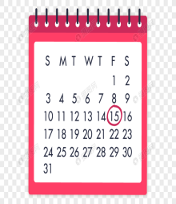  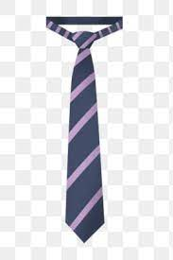 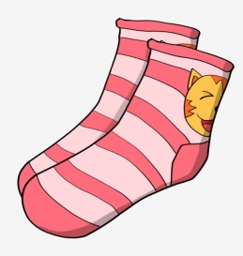 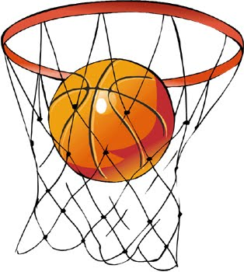

**……………... ……………. ……..………. ……..…… ………… …………..**

**B- Match the answers:**

|  |  |
| --- | --- |
| a. hotel | 1. a place you can shopping and meet friends |
| b. bank | 2. a place you can fly to places |
| c. airport | 3. a place you can open an account |
| d. mall | 4. a place visitors can sleep there |

**c- Find the odd words ;**

1. Dress jeans abaya skirt ……………
2. Shirt hats sandals shoes ……………
3. T-shirt shirt gloves blouse ……………
4. Watch school help eat …………..

**5) Orthography**:

**4**

1. **Fill in the missing letters:**

**k- m– d – r – c – s - t- n**

1- restaura……t 2- boo….s

3- bu….inessman 4- Sa..rifice

5- celeb__ation 6-Gra……..uation

7- gy…… 8-Stri…..er

**B- Circle the correct spelling:**

1.musuem - museum – meusum

2. house – huoes - hosue

3. snack - sncak - scnak

4- spicy - sbicy - sipcy

**C-Write the correct missing letters under each picture ;**

**( z - s - n - t )**

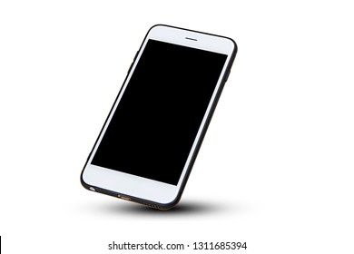 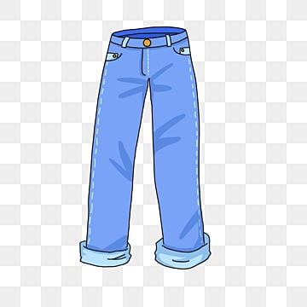 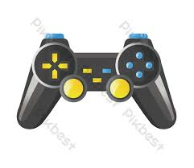 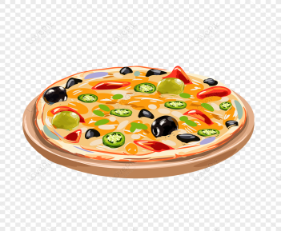

Smar…phone Pa…… ts Con……ole Piz…….a

**Best of Luck**