|  |
| --- |
|  |
| 6 |

**Q1-Choose the correct answer:**

1. **What’s the name of your school**?

36th elementary school. About 600 students .

1. **Do you have a school uniform?**

Yes, we do. It starts at 7:00.

1. **How much is the scarf?**

It is 80 SAR . Here you go .

1. **How long does it take?**

I’d like some juice. It takes 3 hours.

1. **Where is the supermarket?**

I play outside. It’s near here.

1. **Which subject do you like?**

I go to Riyadh. I like English.

|  |
| --- |
|  |
| 5 |

**Q2-Answer the following question**

1. **Re arrange**

**Abha - I - live - in. ………………………………………………………………………………..**

1. **Read the sentence and say if it is (✔️ ) or (❌ ) :**

|  |  |  |  |
| --- | --- | --- | --- |
| 1- | I should drink a lot of water . |  |  |
| 2- | I sleep in your bed because, I was very sleepy. |  |  |
| 3- | Sunday, Monday, Tuesday are days. |  | . |
| 4- | He wants new DVD. He is going to flower store . |  | . |

|  |
| --- |
|  |
| 4 |

**Q3- Match the sentence to the suitable picture:**

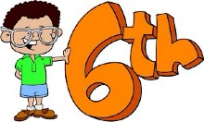

1. I shouldn’t play too many computer games.



1. Listen to the teacher.

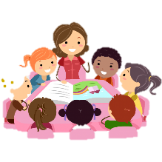

1. I want some candy. I am going to candy store.

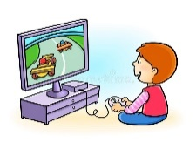

1. I’m in the 6th grade.

|  |
| --- |
|  |
| 5 |

**Q4- Choose the correct answer:**

1. **Last year, I** (was – is) **in the 5th grade.**
2. (There is – There are)  **books on the table.**
3. **I** (are – am) **going to Jeddah.**
4. (What – Where) **is your school? It’s in Abha.**
5. **I** (should – shouldn’t) **brush my teeth.**

|  |
| --- |
|  |
| 6 |

**Q5- Write the correct word:**

|  |
| --- |
| **Bus stop - head ache - math - No balls - flower store - Library** |

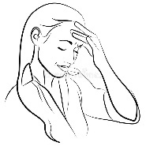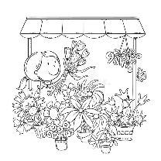

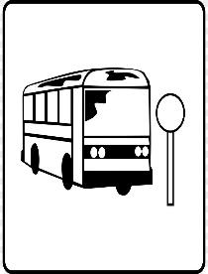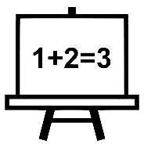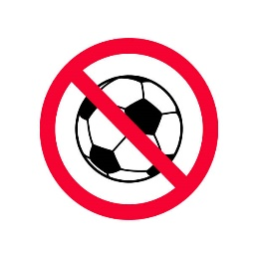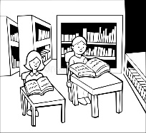

**Page 2 - Next**

|  |
| --- |
|  |
| 4 |

**Q6- Choose the correct letters:**

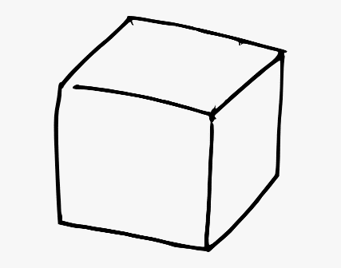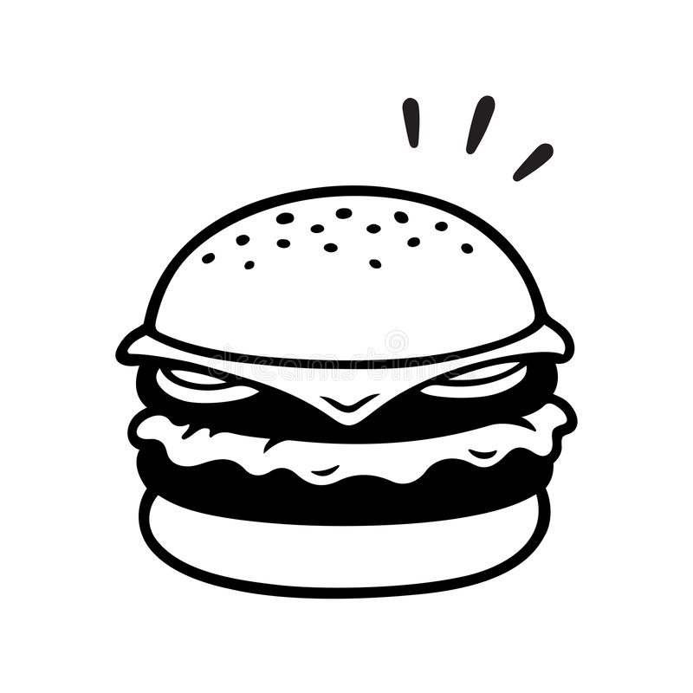

**B …… …… ger c …… b ……**

**( u r / i r ) ( u - e / e _u )**

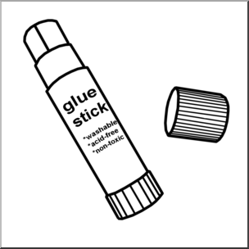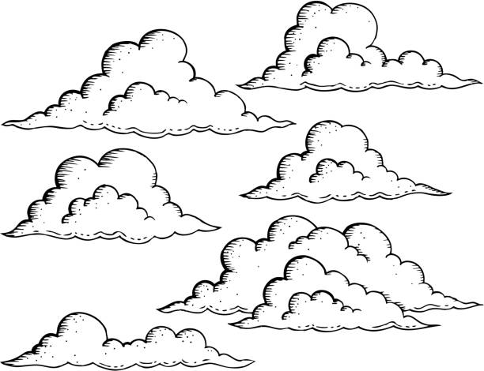

**…… …… y g l …… ……**

**( s k / s q ) ( w e / u e )**

**End of question**

**Good luck my sweet girls**

**Page 3 - End**