**20**

اختبار مادة اللغة الإنجليزية الفترة الثانية للصف السادس الفصل الدراسي الثالث لعام 1443

**اسم الطالبة : ........................................... الصف : ..........................**



**3**

**A ) – Match :**

|  |  |  |
| --- | --- | --- |
| **I shouldn't stay up late .** |  | **1-What should you do to live in a healthy life ?** |
| **Yas, I drank milk this morning.** |  | **2-Did you drink milk this morning ?** |
| **I should drink a lot of water.** |  | **Bad thing I shouldn't do 3-** |

**2**

**Q2. Controlled Writing**

**Rearrange : A ) -**

**EAT – BREAKFAST – MORNING – THIS – DID – MORNING – YOU - ?**

**.................................................................................................................**

**Q3. Grammar**

**3**

**A)- Choose :**

**1 - You ( should – were) get up early .**

**2 - The past of ( drink ) is _________ . ( drank – drinking )**

**3 - The past of ( eat ) is _________ . ( ate – eating )**

(1)

**Q4. Reading short sentences**

**3**

**A) - Complete the sentences with words from the list :**

**Early – healthy - wealthy**

**…………… to bed**

**and early to rise ,**

**makes you ……………… , ……………… and wise .**

**5**

**Q5. Vocabulary**

**A) - Circle the odd word :**

**( white – black – candies – blue ) 1 –**

**B) - Read and write the matching number :**

**1 – headache 2 – toothache 3 – stomachache 4 - earache**

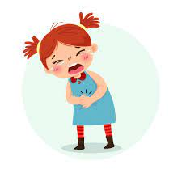

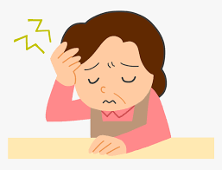

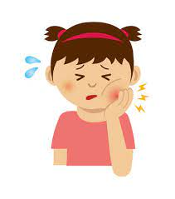

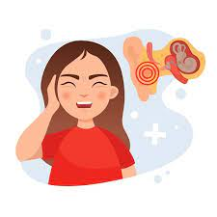

**Q6. Orthography**

**4**

**A) - Fill in the missing letters with : ( ur – ir )**

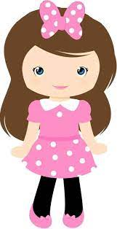







Good luck T \

(2)

**P _ _ ple b _ _ d sh _ _ t g _ _ l**