**Unit: 6 (My dream Vacation)**

**Question 1: general questions**

1. 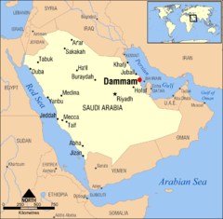**Answer the following questions**
2. Where are you going ?

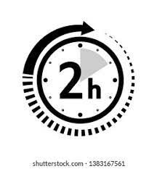…………………………………………………

1. How long dose it take to get to Dammam ?

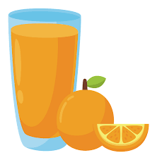…………………………………………………

1. What would you like to drink ?

…………………………………………………..

1. Why did you buy this pizza ?

………………………………………………………….

**Question 2: controlled writing**

1. **Rearrange the sentence:**
2. I / going / am / to / visit / Abha / .

……………………………………………………………………………………..

1. would / like / What / to / eat / you / ?

………………………………………………………………………………………….

**Question 3: Reading short sentences**

**A- Match :**

1. I drink all the juice because I was thirsty
2. I am going to visit Yanbu to dive in the Red sea
3. I am going to Dubai to shop

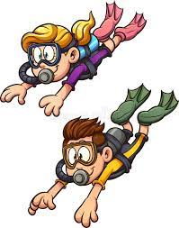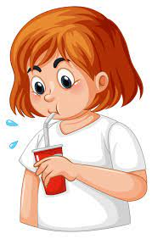

**Question 4: Vocabulary**

**A - fill in the blank with the following words :**

**1-Rock climbing 2 – Camp 3 – Camel race**

**4 – Flight attendant**

|  |  |  |  |
| --- | --- | --- | --- |
| ……………………. | …………………… | ……………………. | …………………….. |
|  |  |  |  |

**Question 5: Grammar**

**A-choose the correct answer :**

1- I am going to **( go – going )** rock climbing .

2- We are going to **( eat- eating )** traditional dishes.

3 – I didn’t buy the T-shirt it was **( too – enough )** big .

إعداد المعلمة: عهود سالم باوزير

مراجعة وتدقيق مشرفة المادة: داليا إبراهيم فرغل