**Unit: 5 (Hanging out in town)**

**Question 1: general questions**

1. **Match the questions with there answers**

|  |  |  |
| --- | --- | --- |
| **A** |  | **B** |
| 1. Where is the bus stop ? |  | No parking . |
| 1. Is it far ? |  | Go straight and you will find it in your write . |
| 1. What dose this sign mean ? |  | Its near hear . |

**Question 2: controlled writing**

1. **Rearrange the sentence:**
2. It's / to / school / next / the / .

……………………………………………………………………………………..

1. WE / going / are / to / the / flower store/ .

………………………………………………………………………………………….

1. **Complete the following :**

**( brown box – red box - little cat - green frog )**

|  |  |
| --- | --- |
|  |  |
| There was a little……………………  ……………..and in the …………………..  …………………………………..there was ……………………………………….. | There was a little……………………  ……………..and in the …………………..  …………………………………..there was ……………………………………….. |

**Question 3: Reading short sentences**

1. **Read the sentence then chose T (√ ) or F (×)**
2. The post office is on the right ( )



1. I am going to the candy store ( )

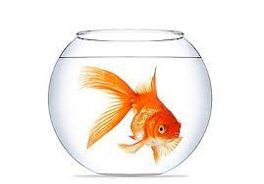

1. There was a little gold fish ( )

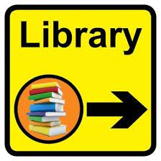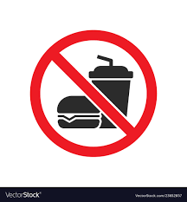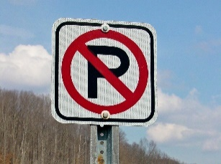**B- Match :**

1- No parking .

2- No eating .

3- Library on the right .

**C-choose the correct direction**

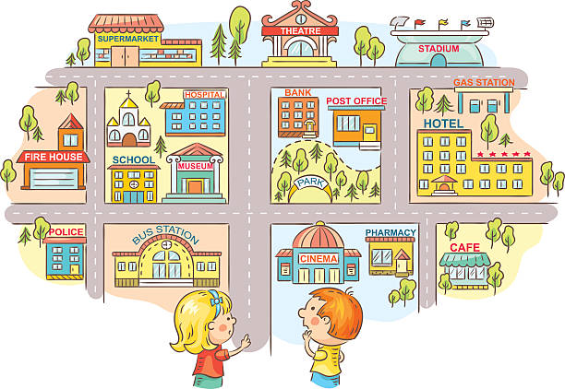

How can I go to school ??

1. ( go straight – its near )
2. ( turn left – turn right )
3. Its on your ( left – right )

**Question 4: spilling**

1. **Unscramble the letters and write the words :**

|  |  |  |  |
| --- | --- | --- | --- |
|  |  |  |  |
| **H e g u** | **l G e u** | **t u e C** | **B u e l** |
| **…………………….** | **…………………………** | **……………………..** | **…………………….** |

**Question 5: Vocabulary**

**A - fill in the blank with the following words :**

**1-Train station – 2- post office**

1. **bus stop 4-convenince store**

|  |  |  |  |
| --- | --- | --- | --- |
| ……………………. | …………………… | …………………. | …………………….. |
|  |  |  |  |

**B –match the iteam with the store name :**

|  |  |  |
| --- | --- | --- |
| **A** |  | **B** |
| 1. Butcher shop |  | Cake and bread |
| 1. Stationary store |  | Meat |
| 1. Bakery |  | Stapler |
| 1. Supermarket |  | Eggs |

**Question 6: Grammar**

**A-choose the correct answer :**

1- I **( am – is )** going to the supermarket .

2- She **( is- are )** going to the book store .

3- They **( are – is )** going to buy some flowers .

4 – You are **( go – going )** to the candy store to buy some candy .

5- There **( is – are )** a book on the table .

6-There **( was – were )** a cat in the box .

7-There **( is – are )** some flowers here .

8-There **( was -were )** 5 cackles in the box .

إعداد المعلمة: عهود سالم باوزير

مراجعة وتدقيق مشرفة المادة: داليا إبراهيم فرغل