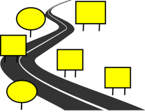

Two-word verb

- Choose the suitable words:

clean up – turn on – put away – take out – throw away – turn off

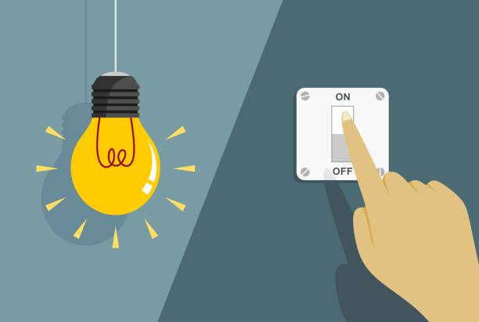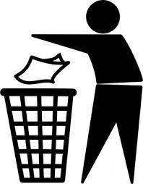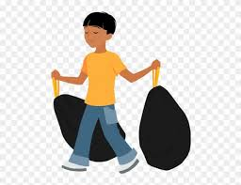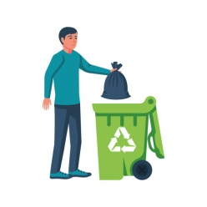

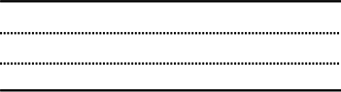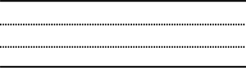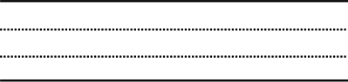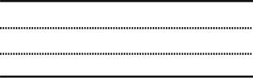

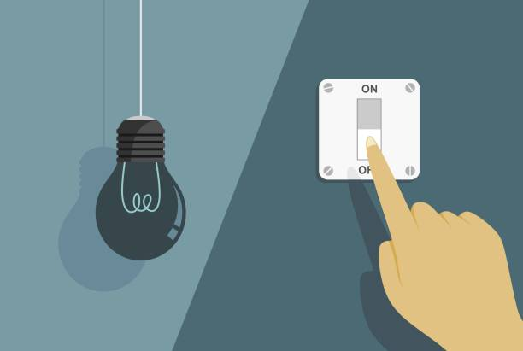



I can't stand …

1- Using someone else's mobile charger.

2- Playing video games very loudly.

3- People who stand in the way of others.

4- Someone interrupts you while you're speaking

5- People who don't wait their turn.

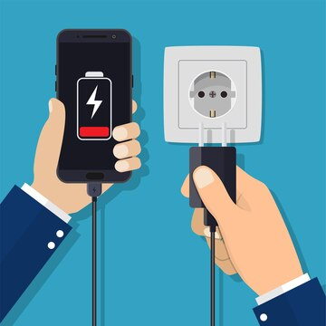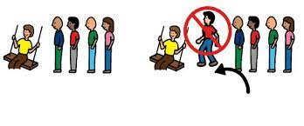

Application

**Present Perfect have/has + past participle V3**

**Key words :**

**حتى الآن للـتـو بالفعل**

**already just yet**

**1- already**

**تأتي في نهاية الجملة أو السؤال, بين have …… v3.**

They have **already** painted the room .

They have painted the room **already** .

**2- just**

**تأتي في الوسط بينhave + just + p.p.**

He has **just** gone out .

We have **just** written homework.

She has **just** cooked the food .

**3- yet**

**تأتي في نهاية الجملة الخبرية المنفية و السؤال**

**Has** he written homework **yet** ?

I **haven’t** studied the lesson **yet** .

We **haven’t** seen the new car **yet** .

**\*** Complete using **already, just** or **yet:**

**a-** We haven't written the lesson …………………… .

**b-** Have you done the duties ………………… ?

**c-** Has Ahmed ………………….. come home ?

**d-** I have ………………. arrived.

**e-** They don't attend the lecture …………………… .