

Vocabulary

- Choose the suitable words:

preference – weekend – decide – conservation – highway – scenic route



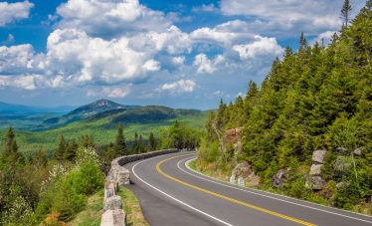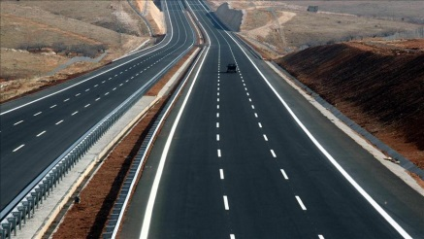

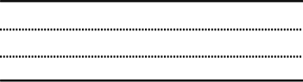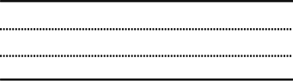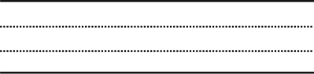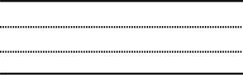





Comprehension





Application













Exercises

**\* Complete the sentences:**

**1-** If he ……………… (visit) his cousin, he …………….. (meet) his uncle there.

**2-** If they …………..……… (not study hard) the curriculum, they …………….. (fail) the exam.

**3-** If you ……………… (obey) your parents, you ……………………….. (succeed) in your live.