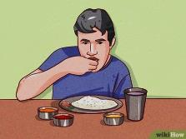

Vocabulary

- Choose the suitable words:

tip – chopsticks – customs – rest – punctual – skyscrapers



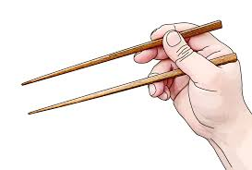

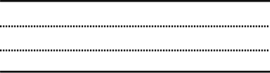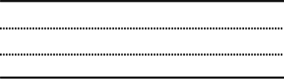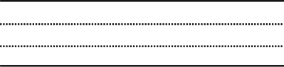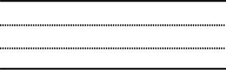





Comprehension





Application





Exercises

**\* Make sentences, Use infinitives. Add "*it's*" where necessary:**

**1-** good idea / follow / local customs ………………………………………………………………

**2-** We / managed / get seats / on the crowded bus ………………………………………………………………

**3-** not advisable / carry / a lot of money ………………………………………………………………

**4-** Make sure / tip / taxi drivers ………………………………………………………………

composition



















