**Kingdom of Saudi Arabia 1443. H**

**Ministry of Education**

**The First session- The third Term**

**…………………. Intermediate School**

**Time : 2 hours**

**Final Exam of English for third Grade Intermediate**

**أسم الطالبة /.................................................................... الصف/............................... رقم الجلوس /............................**

**انتظام ( ) انتساب ( ) التاريخ / / 1443 هـ**

ختم المدرسة

عزيزتي الطالبة؛

تأكدي أن عدد الأوراق ( 3 )

بدون الغلاف

|  |  |  |  |  |
| --- | --- | --- | --- | --- |
| **Items** | **Marks in numbers** | **The deserved**  **mark** | **Teacher's Sign** | **Reviser's Sign** |
| Guided Composition | **6** |  |  |  |
| Reading Comprehension | **6** |  |
| Grammar | **7** |  |
| Vocabulary | **7** |  |
| Orthography | **4** |  | **Auditor’s sign** |
| Total | **30** |  |  |
| Listening | **5** |  |
| Speaking | **5** |  |
| Final mark | **40** |  |
|  |  |  |

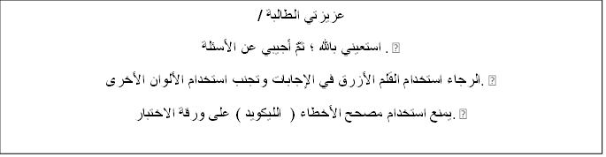

عزيزتي الطالبة /

استعيني بالله ؛ ثمَّ أجيبي عن الأسئلة . •

الرجاء استخدام القلم الأزرق في الإجابات وتجنب استخدام الألوان الأخرى. •

يمنع استخدام مصحح الأخطاء ( الليكويد ) على ورقة الاختبار. •

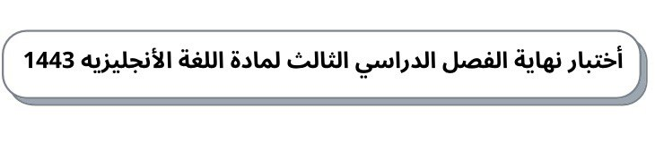

30

ثانوية ومتوسطة ............... الصف/ ثالث متوسط الدور الأول            الزمن/ساعتان

**A -Writing** **6 /**

1.**write about culture customs at your country ,**   
**Use helping word (culture -famous -generosity -present – together-forehead )**

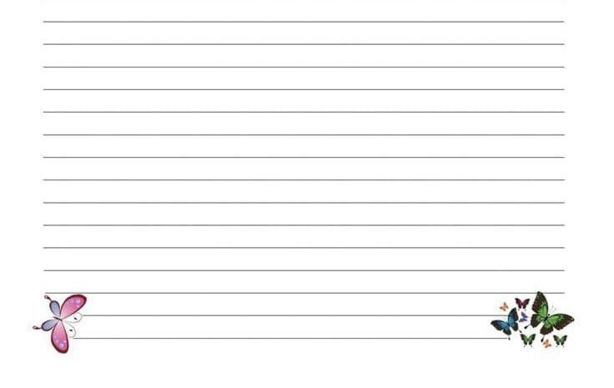

**B -Reading Comprehension 6 /**

.**Read the following passage and answer the questions:**

**Sara is interested in Geography books. She has already read many books about India  
Indonesia, Bangladesh and Japan. She learned a lot about these countries. Sara visits the school library almost every day where she can read a lot of Geography books. The librarian is always ready to help her choose any book which she likes to read about it. Last week, Sara wrote a very good note in the school Magazine and the headmaster was happy to read that note. She gave her some books as a gift..**

**1-** **What does Sara visit ?**

**2. What did Sara write ?**

**3. Sara is interested in English books..**

** True**

**False**

**4- The headmaster was .....................to read Sara's note.**

**happy**

**sad**

**5-The headmaster gave Sara some books as a gift**

** True**

** False**

**6- The librarian isn’t always ready to help her choose any book.**

**True**

**False**

**C-Grammar 7/**

1. **You have done the dishes yet**.                                              ( **Make it negative** )

2. **Turn the TV down** .                                                    **( Replace the object noun by pronoun)**

3**- If you cook an egg in the microwave , it** .

explode

explodes

4**- He is………. Fast that he won the race.**

so

such

5 – **They stop ……………………….. tennis in the winter**.

play

playing

6-  **It has ………………….. a beautiful view of the harbor.**

such

so

7- **the airline refusing to …………… for our hotel**

pay

paying

**D- Vocabulary** **7 /**

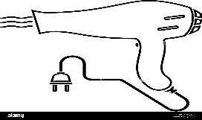1 -.**This is**

hair dryer

Mall

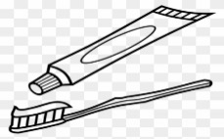2.**This is**

tooth past

airport

3-.**the odd word is**

hair brush

hair dryer

door



4.**This is**

****nail polish

scissors

5- **At long last . Means**:

****Finally.

this has gone too far.

6- **write the name under each picture**

1. ……………………….. 2 ………………………………..

**E- Orthography    Write the missing letter 4/**

1- Sــــــــــــــampo      2- boـــــــــــk   3-scisـــــــــــors 4- dishwasـــــــــing

**End of questions**

**T.Nora ALenzy**