|  |  |  |
| --- | --- | --- |
| English Language Final Exam | شعار وزارة التعليم بدون خلفية بيضاء الجديد مفرغ وشفاف - موقع محتويات | Kingdom of Saudi Arabia |
| The third Trimester, 1st Session, 1443 | Ministry of Education |
| The second Intermediate Grade | General Directorate of Education in Bisha |
| Time: 2 hours | East Education Office |
| No. of pages: 3 | Rabbah Intermediate School |
| **مستعينة بالله أجيبي عن الأسئلة التالية:** | | |

**I- Guided Composition:**

6

Write a paragraph about yourself:

**نموذج اجابة**

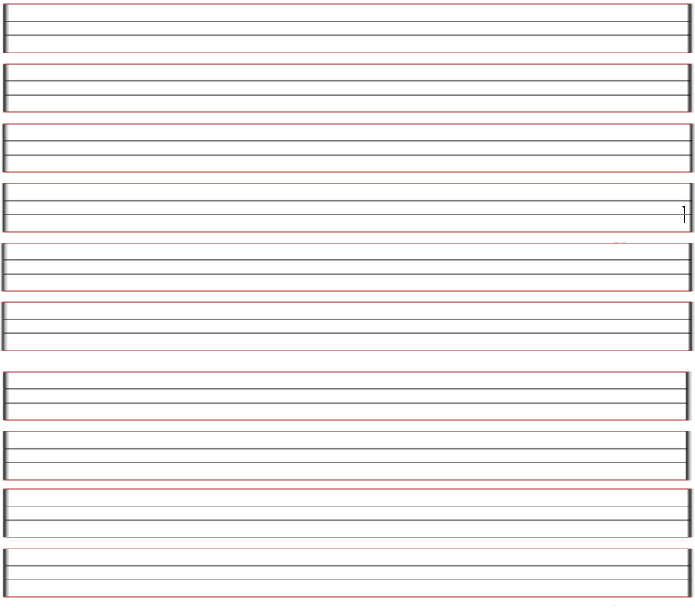

**II- Reading Comprehension**

6

**Read the passage carefully and answer the questions below:**

Noura and her family were in London last week. It was very expensive. They stayed in a hotel for three days. Then they took an apartment. Noura stayed there until Friday. She flew home last night. Her father is still there. Her mother is with her father. Next week Noura is going somewhere else.

Choose the correct word:-1

1. Noura and his family were in London last ( day - week – month)

2. They took an ( apartment – hotel – taxi ) .

3. She stayed there ( after – before - until ) Friday.

4. Next ( week – month - holiday ) Noura is going somewhere else .

B)Put ( 🗵 ) or ( ☑ ):-1

1- Noura and his family went to Paris. ( ꭓ )

2-lt was very expensive in London. ( √ )

**-------------------------------------------------------------**

**III- Grammar:**

**A- Choose the correct answer:1**

7

1. Omar drives ( slow – slows – slowly )
2. I will ( travel – traveling _ travels ) to Jeddah
3. Could you ( give – gives – giving ) me a pen?

4. I ( was – were – is ) sleeping

5. Omar ( read – reads – reading ) the book.

**B- correct the mistake: 1**

1. Sara was able to finishing all housework yesterday ( reorder).

…………………………………………… finish ……………………………………………………………..…………………………..

1. Omar has eat chocolate. (correct the mistake)

…………………………… eaten ……………………………………………………………………….………………………………

**-------------------------------------------------------------**

**IV- Vocabulary:**

7

A**) Write the correct number under each picture:1**

**1**- relaxing **2**- rainy **3**- graduation **4**-carseat phone

|  |  |  |  |
| --- | --- | --- | --- |
|  |  |  |  |
| relaxing | rainy | graduation | carseat |

[هذه الصورة](https://collection.maas.museum/object/580836) بواسطة كاتب غير معروف مرخصة بالاسم [CC BY-NC-ND](https://creativecommons.org/licenses/by-nc-nd/3.0/)

**B) Find the odd words. 1**

1. winter August summer
2. thanks sorry not now
3. football hang gliding basketball

**-------------------------------------------------------------**

**V- Orthography:**

4

**Choose the correct letter:1**

1. o_v_erpower 3- _h_umidity
2. mo_s_quito 4- desert sa_f_ari

**------------------------------------------------------------**

**The End of the Questions**

Good Luck😊 Latifa Alyousef ♥