|  |  |  |
| --- | --- | --- |
| English Language Final Exam | شعار وزارة التعليم بدون خلفية بيضاء الجديد مفرغ وشفاف - موقع محتويات | Kingdom of Saudi Arabia |
| The third Trimester, 1st Session, 1443 | Ministry of Education |
| The first Intermediate Grade | General Directorate of Education in Bisha |
| Time: 2 hours | East Education Office |
| No. of pages: 3 | Rabbah Intermediate School |
| **مستعينة بالله أجيبي عن الأسئلة التالية:** | | |

**I- Guided Composition:**

6

Write a paragraph about yourself:

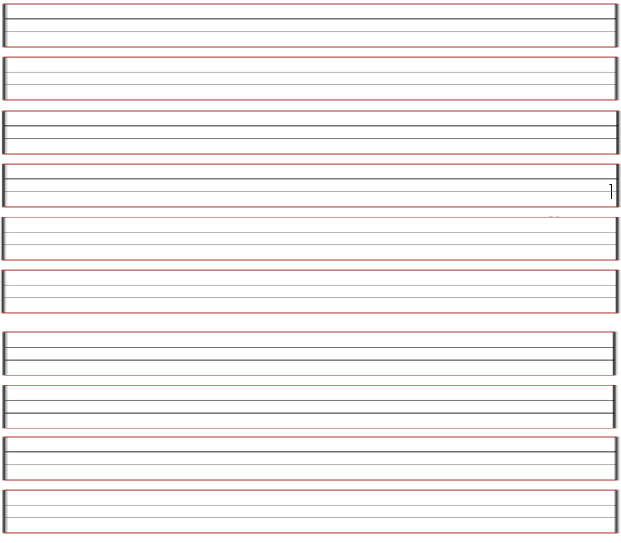

**II- Reading Comprehension**

6

**Read the passage carefully and answer the questions below:**

Maha is 37 years old . She is an engineer . She lives in Riyadh with her father . Her father is a doctor . She goes to work by car. She likes sports especially tennis and football.

A/Questions :1- Where does she live ? …………………………..…...................................................

B/ Choose the right answer:

1-Her father is a ( engineer – doctor – teacher ).

2- She is an ( engineer _ police – law).

C/ Put ( 🗸 ) or ( 🗴 ) :

1- She goes to work by bus . ( ) 2- Maha is 37 years old . ( )

3- Maha likes sports. ( )

**-------------------------------------------------------------**

**III- Grammar:**

**A- Choose the correct answer:1**

7

1. Renad ( like – likes – liked ) to read.
2. Masha’el ( are – is - was ) going to study for the exam.
3. Please listen! I’m talking to ( them – him – you ).

4. There ( was – were – is ) an old castle in the city.

5. Nja’ah ( work – worked – working ) yesterday.

**B- correct the mistake: 1**

1. Bana\ going \a new dress \ is \to buy ( reorder).

…………………………………………………………………………………………………………..…………………………..

1. Dhabyah must followed the rules. (correct the mistake)

…………………………………………………………………………………………………….………………………………

**-------------------------------------------------------------**

**IV- Vocabulary:**

7

A**) Write the correct number under each picture:1**

**1**- balcony **2**- oaisis **3**- restaurant **4**-race

|  |  |  |  |
| --- | --- | --- | --- |
|  |  |  |  |
|  |  |  |  |

[هذه الصورة](https://collection.maas.museum/object/580836) بواسطة كاتب غير معروف مرخصة بالاسم [CC BY-NC-ND](https://creativecommons.org/licenses/by-nc-nd/3.0/)

**B) Find the odd words. 1**

1. bank hotel park apple
2. shorts jeans shirt pants
3. flags cat parade fireworks

**-------------------------------------------------------------**

**V- Orthography:**

4

**Choose the correct letter:1**

1. hospi__al 3- holi__ay
2. b_ouse 4- celeb__ity

**------------------------------------------------------------**

**The End of the Questions**

Good Luck😊 Latifa Alyousef ♥