المملكة العربية السعودية المادة / اللغة انجليزية
وزارة التعليم الصف / ثالث متوسط
الإدارة العامة للتربية والتعليم ( بنات ) اليوم/ ...................
بمنطقة ......................................... الزمن/ نصف ساعة
المدرسة / المتوسطة .......................... عدد الصفحات / 2
ــــــــــــــــــــــــــــــــــــــــــــــــــــــــــــــــــــــــــــــــــــــــــــــــــــــــــــ
أسئلة اختبار مادة اللغة الإنجليزية ( الصف ثالث متوسط )
للفصل الدراسي ( الثالث ) الفترة ( الثانية ) للعام الدراسي 1443
اسم الطالبة /......................................................................................................................................
ـــــــــــــــــــــــــــــــــــــــــــــــــــــــــــــــــــــــــــــــــــــــــــــــــــــــــــــــــــــــــــــــــــ
: 1- Choose the correct answers
1- If you ................. water in freezer, It becomes ice.
A) put
B) putting
2- We didn't expect to………………so later.
A) arrived
B) arrive
3- a teacher ......................... helped teach students.
A) had
B) is
4- I can't speak French ( use wish )
A) I wish I could speak French
B) I wish I speak French
5- Had she finished her homework yet ?
A) yes, she is
B) yes, she had
6-They had ..................... there car.
A) clean
B) cleaned
7- I had...................to football game
A) go
B) gone

8- Had you ever …………sushi before you traveled to Japan ?
A) eat
B) eaten
9- She tried to ........... on plane, but she couldn't.
A) sleep
B) slept
10- is \ a good \ to learn \ other \ Traveling \ way \ cultures \ about ( reorder )
A) Traveling is a good way to learn about other cultures.
B) a good way other cultures way is Traveling.
-------------------------------------------------------------------------------------------------------
2-Choose the correct answer:
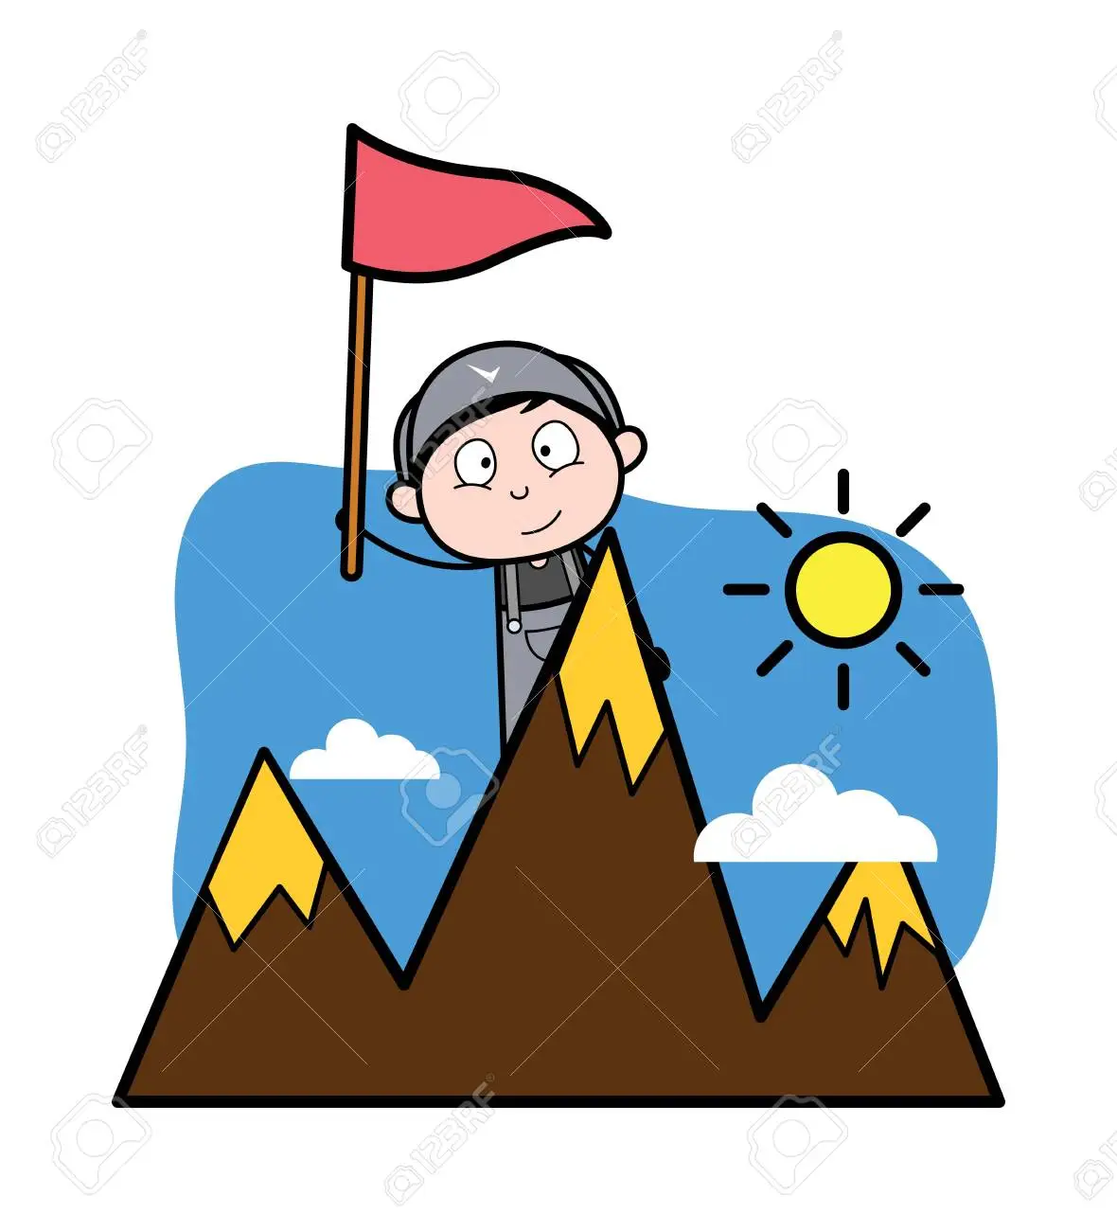 | 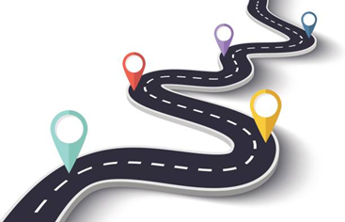   | 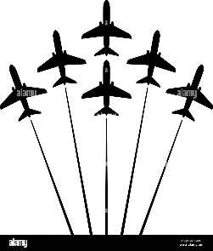 |  | 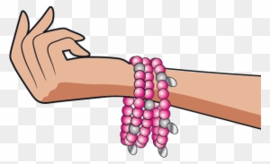
5- What is in this picture?  a- pedal cab  b-highway | 4-This man is ………  a-lawyer  b-doctor | 3- what is this?  a-airshow  b-nail polish | 2- what is this?  a- funny  b-scenic | 1- what is this?  a- shampoo  b- bracelet
 | 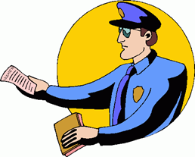 | 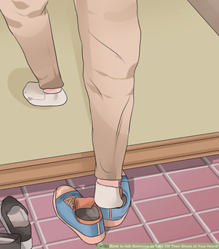 | 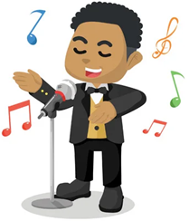 | 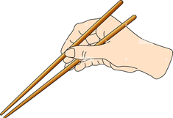
10-what is this?  a- a resort  b- gold fish | 9-The police man gives the driver……..  a-a ticket  b-gym | 8-The man is………  a-removing shoes  b-want to travel | 7-This man is…..  a-thief  b-talent | 6- what are these?  a-dish washing  b-chopsticks
-------------------------------------------------------------------------------------
انتهت الأسئلة Good luck
T/ ………………………………..

