 بسم الله الرحمن الرحيم

English Language

Intermediate Grade 3rd

2nd period Exam

Kingdom of Saudi Arabia

Ministry of Education

Student's Name : class:

**Grammar**

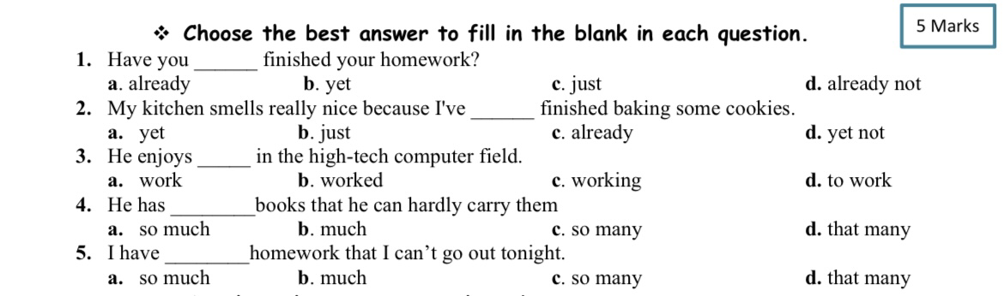

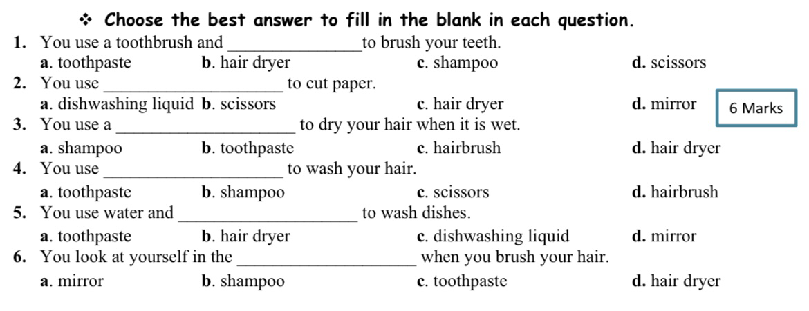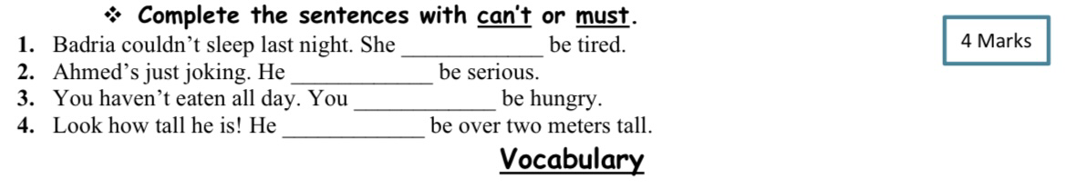

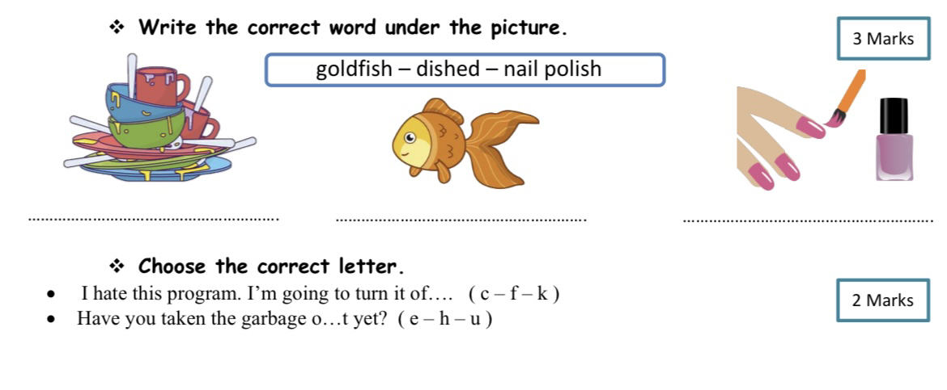

I wish you all the best!

Ms. Rawan Alhajri