ا



Kingdom of Saudi Arabia

The Ministry Of Education

General Directorate of Education

Secondary School



English Language Final Exam

English : Mega Goal 4

Time: 3 Hours

Final Exam – 1st term -1443.H

اختبار مقرر ( اللغة الانجليزية ) الفصل الدراسي الثاني ( الدور الأول)- - للعام الدراسي 1443هـ - نظام المقررات

**اسـم الطالبة:** ................................................................. **رقم الجلوس:** .......................... **الصف:** ........................

" **اللَهُم لاَ سَهْلَ إلاَ مَا جَعًلَتُهُ سَهْلاً ,وَ أنْتَ تَجْعَل الحَزَنَ إذا شِئتً سَهْلاً**"

|  |  |  |  |  |  |  |  |  |
| --- | --- | --- | --- | --- | --- | --- | --- | --- |
| Guided comps | Free Comps. | Reading Comprehension | Grammar | Vocabulary | Total | Corrected by | Revised by | Checked by |
| **_____** 6 | **_____** 6 | **______** 6 | **______** 6 | **_____** 6 | **______** 30 |  |  |  |

**🖎Ⅰ-** Guided Composition



**🖎 A) Write an assay about ( Laughter is the Best Medicine) using the notes below** :

**Guided words:** positive - benefits – get rid – depression - anxiety – relationship - faster –

mood - normal - amazing – mental - medicine -fun – tough - situation - easy- cute

…………………………………………………………………………………………………………………………………………..………………………………………………………………………………………………………………………………………..………………………………………………………………………………………………………………………………………………….…

ـــــــــــــــ

**6**

…………………………………………………………………………………………………………………………………………………………………………………………………………………………………………………………………………………………………………………………………………………………………………………………………………………………………………………………………………………………………………………………………………………………………………………………………………………………………………………………………………………………………………………………………………………………………………………………………………………………………………………………………………………………………………………………………………………………………………………………………………………………………………………………………………………………………………………………………………………………………………………………………………………………………………………………………………………………………………………………………………………………………………………………………………………………………………………………………..………………………………………………………………………………………………………………………………………..……………………………………………………………………………………………………………………………………………………………..………….…

…………………………………………………………………………………………………………………………………………..………………………………………………………………………………………………………………………………………..………………………………………………………………………………………………………………………………………………….…………………………………………………………………………………………………………………………………………………………………………………………………………………………………………………………………………………………………..

|  |  |
| --- | --- |
| mark | item |
| 2 | organization of ideas  ( main idea , supporting details) |
| 2 | accuracy and range of vocabulary and grammar |
| 1 | mechanism  ( punctuation , capitalization , spacing ) |
| 2 | spelling |

|  |  |
| --- | --- |
| mark | item |
| 2 | organization of ideas  ( main idea , supporting details) |
| 2 | accuracy and range of vocabulary and grammar |
| 1 | mechanism  ( punctuation , capitalization , spacing ) |
| 2 | spelling |

………………………………………………………………………………………………………………………………………………………………………………………………………………………………………………………………………………………………………………………………………………………………………………………………………………………………………………………………………………………………………………………………………………………………………………………………

……………………………………………………………..………………………………………………………………………………

……………………………………………………………………………………………………………………………………………………………………………………………………………………………………………………………………………………………………………………………………………………………………………………………………………………………………………………………………………………………………………………………………………………………………………………………………………………………………………………………………………………………………………………………………………..………………………………………………………………………………………………………………………………………..………………………………………………………………………………………………………………………………………………………………………………………………………………………….……………………………………………………………………….

**Page: 1 out of 4**

**P. T. O**

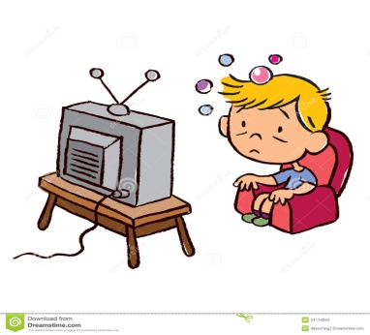

Page: 1 out of 4

**P. T. O**

Page: 1 out of 4

**P. T. O**

**🖎** **II -** Free Composition



**🖎 Choose ONE of the following topics, and then write a composition about it:**

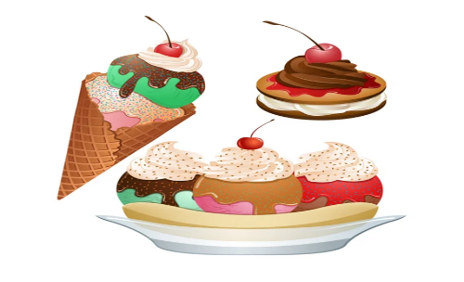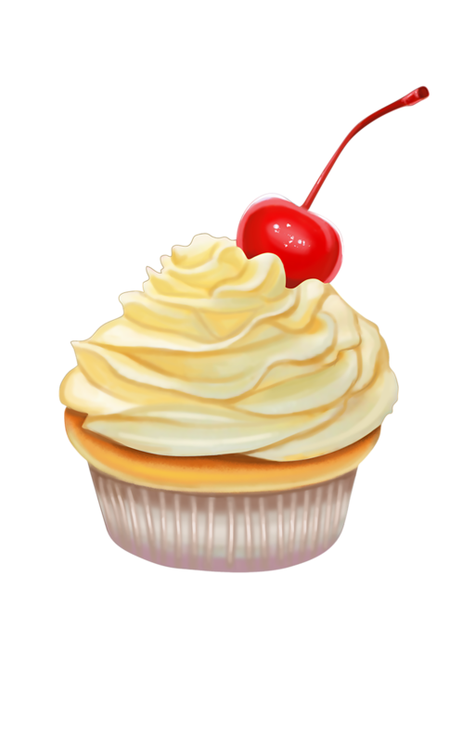

1-Write a list of the most popular " Desserts and Snacks" in the world .

…………………………………………………………………………………………………………………………….………………………………………………………

…………………………………………………………………………………………………………………………………………..………………………………………

………………………………………………………………………………………………………………………………………………………………………………….

…………………………………………………………………………………………………………………………………………………………………………………

…………………………………………………………………………………………………………………………………………………………………………………

……………………………………………………………………………………………………………………………………………….……………………………….

…………………………………………………………………………………………………………………………………………………………………………………

…………………………………………………………………………………………………………………………………………………………………………………

……………………………………………………………………………………………………………………………………………….……………………………….

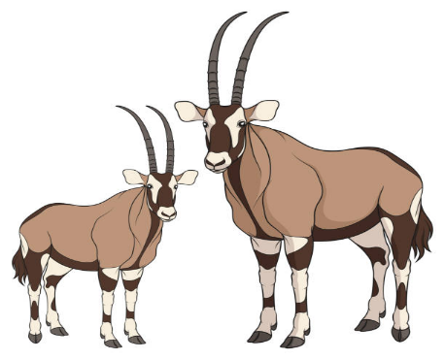

ـــــــــــــــ

**6**

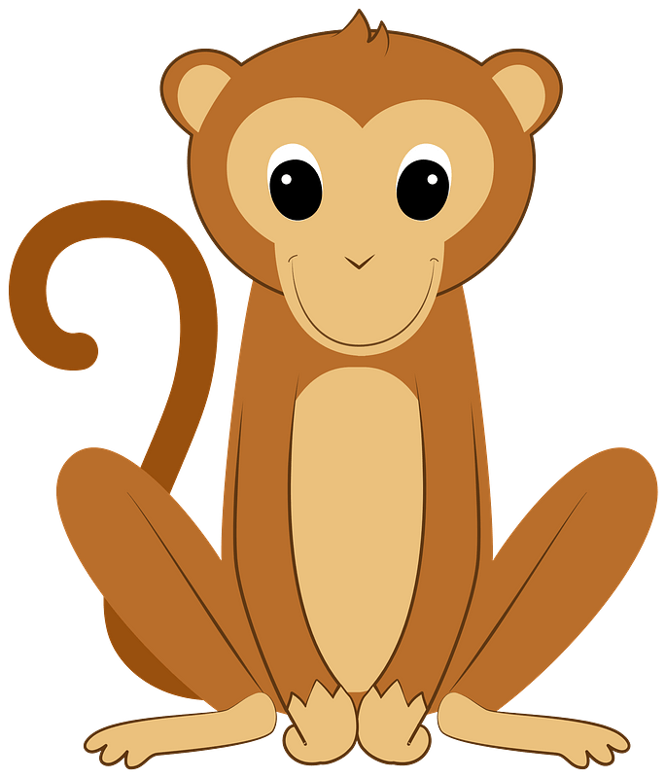

**2-**Write a list of **( Animals )** that live in Saudi Arabia ::

…………………………………………………………………………………………………………………………….………………………………………………………

…………………………………………………………………………………………………………………………………………..………………………………………

………………………………………………………………………………………………………………………………………………………………………………….

…………………………………………………………………………………………………………………………………………………………………………………

…………………………………………………………………………………………………………………………………………………………………………………

……………………………………………………………………………………………………………………………………………….……………………………….

……………………………………………………………………………………………………………………………………………..………………………………

…………………………………………………………………………………………………………………………………………………………………………………

…………………………………………………………………………………………………………………………………………………………………………………

……………………………………………………………………………………………………………………………………………….……………………………….

**Page: 2 out of 4**

**P. T. O**

**🖎 Ⅲ** Comprehension

ـــــــــــــــ

**6**



**🖎Read the following passage then answer the questions below *:***

**French Fries**

French fries are one of the most common food around the world . French fries are long, thin pieces of potato fried in oil or fat . Vegetables oil is the best fat to make amazing fries . French fries are served hot, either soft or **crispy,** and are generally eaten as part of lunch or dinner or by themselves as a snack, and they commonly appear on the menus of [diners](https://en.wikipedia.org/wiki/Diner) and [fast food](https://en.wikipedia.org/wiki/Fast_food) restaurants. French Fries are usually salted and, depending on the country, may be served with [ketchup](https://en.wikipedia.org/wiki/Ketchup), [mayonnaise](https://en.wikipedia.org/wiki/Mayonnaise) or [tomato sauce](https://en.wikipedia.org/wiki/Tomato_sauce).

To achieve golden-brown perfection, you have to fry them twice: first at a low temperature, to poach them; then at a high heat, to crisp them up. Actually , French fries are better when cooked at restaurants .Some people got addicted to French Fries because they don't need a fork or spoon to eat them . They can eat French fries with their fingers .

Many restaurants selling French fires frequently combine servings of fries with another food, for example, fried fish or beef burgers. In fact , French fries go with hot dogs, hamburgers, fish and all sorts of sandwiches. Many countries in every corner of the globe have their own way of eating this **beloved** dish.

**🖎A-Answer the following questions :**

**1-** What are French fries ?

………………………………………………………………………………………………………………………………………………………

**2-** Why did some people get addicted to French Fries ?

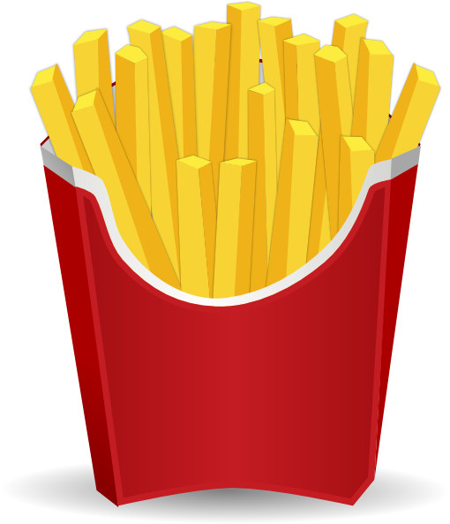

……………………………………………………………………………………………………………………………………………………………………

**3-** Do French fries go with all sorts of sandwiches ?

………………………………………………………………………………………………………………………………………………………………….

**🖎B-Choose the correct answer:**

1. The best fat to make amazing French fries is **(** **vegetables – corn – olive - palm )** oil.
2. To achieve golden-brown perfection, you have to **(grill - roast – boil - fry)** them twice
3. **crispy** in line **(3)** means **(crunchy – flexible – organic - neutral)**
4. The opposite of **beloved** is **(admired – popular – favorite - unloved )**

**🖎C- Write ( True ) or ( False ) :**

**1-** French Fries are usually salted. ( )

**2-**French fries may be served without [ketchup](https://en.wikipedia.org/wiki/Ketchup), [mayonnaise](https://en.wikipedia.org/wiki/Mayonnaise) or [tomato sauce](https://en.wikipedia.org/wiki/Tomato_sauce).( )

**Page: 3 out of 4**

**P. T. O**

**P. T. OP. T. OP. T. O**

**Page:3 out of 4Page: 2 out of 4**Page: 2 out of 4

**🖎V-- Grammar**

ـــــــــــــــ

**6**



**🖉A-**Choose the correct answer from those given between brackets:

**1-** I can't drink the coffee. It's **(not – too - more – enough)** hot.

**2 –** He has been **(teach – teaches – taught – teaching)** since 2002.

**3-**My mom is very **(tired – tiring - tiredness – tiresome).** She worked very hard today.

**4-**She is **(so – such – too – very)** a beautiful girl that everyone stares at her .

**5-** There aren't (**some – no - much – any )** students in the class .

**6**- Neither students **( nor – or – but- and)** teacher was at class..

**🖉B-**Do as shown between brackets

**1-** He is a hard worker**…**…………………………………………………………………………..  **(Rewrite** using **adverb of manner)**

**2-**I’m not very tall. I ……………………………………………………………**(be)** taller. **(Complete** using **wish**)

**3-**He was not ill. Still, he walked very slowly.  **(Combine using as if)**

…………………………………………………………………………………………………………………………………………………………………………………………………….……………

**4-** I put my shoes on. ………………………………………………………………………. **(Replace the noun object with a pronoun)**

**🖉C-**Correct the verb between brackets

**1-** He should **( take)** …………………………………… to hospital .

**2-** He used to **(loves) …………………………**chocolate as child**.**

**🖎** **Ⅳ-Vocabulary**

ـــــــــــــــ

**6**



**A-**Fill in the spaces with suitable word :

**aroma**  - **furnish - marathon**

1. Thousands of runners participate in the ………………………………………… every year.
2. I love the ………………………………………… of coffee .

**B -**Fill in the spaces with suitable word :

1. **1**- Large – red – small – medium **2**- Cancer – Alzheimer – Rheumatism – test

C-Match the words with their meanings: D-Match the words with their opposites:

|  |  |  |  |
| --- | --- | --- | --- |
| **1** | cool | ( ) | bad |
| **2** | rotten | ( ) | great |
|  |  | ( ) | poisons |

|  |  |  |  |
| --- | --- | --- | --- |
| **1** | exterior | ( ) | immoral |
| **2** | moral | ( ) | monolingual |
|  |  | ( ) | interior |

**F-** Write the correct word for each pictures :

**(whisk – adobe house – measure - medal – DNA)**

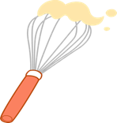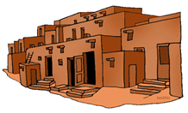

**…………………………………….. …………………………………………………. ……………………………………… ……………………………………..**

**…………**

♥The End ♥

☺**Good Luck** ☺

**Page:4 out of 4**

**English Teacher : Entisar Al-Obaidallah**

**Page:4 out of 4**

ا



Kingdom of Saudi Arabia

The Ministry Of Education

General Directorate of Education

Secondary School



English Language Final Exam

English : Mega Goal 4

Time: 3 Hours

Final Exam – 1st term -1443.H

اختبار مقرر ( اللغة الانجليزية ) الفصل الدراسي الثاني ( الدور الأول)- - للعام الدراسي 1443هـ - نظام المقررات

**اسـم الطالبة:** ................................................................. **رقم الجلوس:** .......................... **الصف:** ........................

" **اللَهُم لاَ سَهْلَ إلاَ مَا جَعًلَتُهُ سَهْلاً ,وَ أنْتَ تَجْعَل الحَزَنَ إذا شِئتً سَهْلاً**"

|  |  |  |  |  |  |  |  |  |
| --- | --- | --- | --- | --- | --- | --- | --- | --- |
| Guided comps | Free Comps. | Reading Comprehension | Grammar | Vocabulary | Total | Corrected by | Revised by | Checked by |
| **_____** 6 | **_____** 6 | **______** 6 | **______** 6 | **_____** 6 | **______** 30 |  |  |  |

**🖎Ⅰ-** Guided Composition



**🖎 A) Write an assay about ( Laughter is the Best Medicine) using the notes below** :

**Guided words:** positive - benefits – get rid – depression - anxiety – relationship - faster –

mood - normal - amazing – mental - medicine -fun – tough - situation - easy- cute

…………………………………………………………………………………………………………………………………………..………………………………………………………………………………………………………………………………………..………………………………………………………………………………………………………………………………………………….…

ـــــــــــــــ

**6**

…………………………………………………………………………………………………………………………………………………………………………………………………………………………………………………………………………………………………………………………………………………………………………………………………………………………………………………………………………………………………………………………………………………………………………………………………………………………………………………………………………………………………………………………………………………………………………………………………………………………………………………………………………………………………………………………………………………………………………………………………………………………………………………………………………………………………………………………………………………………………………………………………………………………………………………………………………………………………………………………………………………………………………………………………………………………………………………………………..………………………………………………………………………………………………………………………………………..……………………………………………………………………………………………………………………………………………………………..………….…

|  |  |
| --- | --- |
| **mark** | **item** |
| **2** | organization of ideas  (main idea , supporting details) |
| **2** | accuracy and range of vocabulary and grammar |
| **2** | mechanism  (punctuation, capitalization , spacing ) |

………………………………………………………………………………………………………………………………………………

………………………………………………………………………………………………………………………………………………………………………………………………………………………………………………………………………………………………………………………………………………………………………………………………………………………………………………

……………………………………………………………..………………………………………………………………………………

……………………………………………………………………………………………………………………………………………………………………………………………………………………………………………………………………………………………………………………………………………………………………………………………………………………………………………………………………………………………………………………………………………………………………………………………………………………………………………………………………………………………………………………………………………..………………………………………………………………………………………………………………………………………..………………………………………………………………………………………………………………………………………………………………………………………………………………………….……………………………………………………………………….



Page: 1 out of 4

**P. T. O**

Page: 1 out of 4

**P. T. O**

**Page: 1 out of 4**

**P. T. O**

**🖎** **II -** Free Composition



**🖎 Choose ONE of the following topics, and then write a composition about it:**



1-Write a list of the most popular " Desserts and Snacks" in the world .

…………………………………………………………………………………………………………………………….………………………………………………………

…………………………………………………………………………………………………………………………………………..………………………………………

………………………………………………………………………………………………………………………………………………………………………………….

…………………………………………………………………………………………………………………………………………………………………………………

…………………………………………………………………………………………………………………………………………………………………………………

……………………………………………………………………………………………………………………………………………….……………………………….

…………………………………………………………………………………………………………………………………………………………………………………

…………………………………………………………………………………………………………………………………………………………………………………

……………………………………………………………………………………………………………………………………………….……………………………….



ـــــــــــــــ

**6**



**2-**Write a list of **( Animals )** that live in Saudi Arabia ::

…………………………………………………………………………………………………………………………….………………………………………………………

|  |  |
| --- | --- |
| **mark** | **item** |
| **2** | organization of ideas  ( main idea , supporting details) |
| **2** | accuracy and range of vocabulary and grammar |
| **2** | mechanism  (punctuation , capitalization , spacing ) |

…………………………………………………………………………………………………………………………………………..………………………………………

………………………………………………………………………………………………………………………………………………………………………………….

…………………………………………………………………………………………………………………………………………………………………………………

…………………………………………………………………………………………………………………………………………………………………………………

……………………………………………………………………………………………………………………………………………….……………………………….

……………………………………………………………………………………………………………………………………………..………………………………

…………………………………………………………………………………………………………………………………………………………………………………

…………………………………………………………………………………………………………………………………………………………………………………

……………………………………………………………………………………………………………………………………………….……………………………….

**Page: 2 out of 4**

**P. T. O**

**🖎 Ⅲ** Comprehension

ـــــــــــــــ

**6**



**🖎Read the following passage then answer the questions below *:***

**French Fries**

French fries are one of the most common food around the world . French fries are long, thin pieces of potato fried in oil or fat . Vegetables oil is the best fat to make amazing fries . French fries are served hot, either soft or **crispy,** and are generally eaten as part of lunch or dinner or by themselves as a snack, and they commonly appear on the menus of [diners](https://en.wikipedia.org/wiki/Diner) and [fast food](https://en.wikipedia.org/wiki/Fast_food) restaurants. French Fries are usually salted and, depending on the country, may be served with [ketchup](https://en.wikipedia.org/wiki/Ketchup), [mayonnaise](https://en.wikipedia.org/wiki/Mayonnaise) or [tomato sauce](https://en.wikipedia.org/wiki/Tomato_sauce).

To achieve golden-brown perfection, you have to fry them twice: first at a low temperature, to poach them; then at a high heat, to crisp them up. Actually , French fries are better when cooked at restaurants .Some people got addicted to French Fries because they don't need a fork or spoon to eat them . They can eat French fries with their fingers .

Many restaurants selling French fires frequently combine servings of fries with another food, for example, fried fish or beef burgers. In fact , French fries go with hot dogs, hamburgers, fish and all sorts of sandwiches. Many countries in every corner of the globe have their own way of eating this **beloved** dish.

**3**

**🖎A-Answer the following questions : (1 mark each)**

**1-** What are French fries ?

**French fries are long, thin pieces of potato fried in oil or fat .**

**2-** Why did some people get addicted to French Fries ?



**because they don't need a fork or spoon to eat them .**

**OR They can eat French fries with their fingers .**

**3-** Do French fries go with all sorts of sandwiches ?

**Yes , they do**

**🖎B-Choose the correct answer: (½ mark each)**

1. The best fat to make amazing French fries is **(** **vegetables – corn – olive - palm )** oil.
2. To achieve golden-brown perfection, you have to **(grill - roast – boil - fry)** them twice
3. **crispy** in line **(3)** means **(crunchy – flexible – organic - neutral)**

**2**

1. The opposite of **beloved** is **(admired – popular – favorite - unloved )**

**🖎C- Write ( True ) or ( False ) : (½ mark each)**

**1**

**1-** French Fries are usually salted. ( **T** )

**2-**French fries may be served without [ketchup](https://en.wikipedia.org/wiki/Ketchup), [mayonnaise](https://en.wikipedia.org/wiki/Mayonnaise) or [tomato sauce](https://en.wikipedia.org/wiki/Tomato_sauce).( **F**  )

**Page: 3 out of 4**

**P. T. O**

**P. T. OP. T. OP. T. O**

**Page:3 out of 4Page: 2 out of 4**Page: 2 out of 4

**🖎V-- Grammar**

ـــــــــــــــ

**6**



**🖉A-**Choose the correct answer from those given between brackets: **(½ mark each)**

**1-** I can't drink the coffee. It's **(not – too - more – enough)** hot.

**2 –** He has been **(teach – teaches – taught – teaching)** since 2002.

**3**

**3-**My mom is very **(tired – tiring - tiredness – tiresome).** She worked very hard today.

**4-**She is **(so – such – too – very)** a beautiful girl that everyone stares at her .

**5-** There aren't (**some – no - much – any )** students in the class .

**6**- Neither students **( nor – or – but- and)** teacher was at class..

**2**

**🖉B-**Do as shown between brackets**(½ mark each)**

**1-** He is a hard worker **. He works hard .**   **(Rewrite** using **adverb of manner)**

**2-**I’m not very tall. I **wish I were** **(be)** taller. **(Complete** using **wish**)

**3-**He was not ill. Still, he walked very slowly.  **(Combine using as if)**

**He walked very slowly as if he was ill .**

**4-** I put my shoes on.  **(Replace the noun object with a pronoun)**

**I put them on** ..

**🖉C-**Correct the verb between brackets**(½ mark each)**

**1**

**1-** He should **( take) be taken** to hospital .

**2-** He used to **(loves) love** chocolate as child**.**

**🖎 Ⅳ-Vocabulary**

2

ـــــــــــــــ

**6**



**A-**Fill in the spaces with suitable word : **(½ mark each)**

**aroma**  - **furnish -** **marathon**

2

1. Thousands of runners participate in the **marathon** every year.
2. I love the **aroma**  of coffee .

1

**B -**Circle the odd word : **(½ mark each)**

1. **1**- Large – **red** – small – medium **2**- Cancer – Alzheimer – Rheumatism – **test**

C-Match the words with their meanings: **(½ mark each)** D-Match the words with their opposites:

|  |  |  |  |
| --- | --- | --- | --- |
| **1** | cool | ( **2**  ) | bad |
| **2** | rotten | ( **1**  ) | great |
|  |  | ( **-** ) | poisons |

2

|  |  |  |  |
| --- | --- | --- | --- |
| **1** | exterior | ( **2** ) | immoral |
| **2** | moral | ( **-** ) | monolingual |
|  |  | ( **1** ) | interior |

2

**F-** Write the correct word for each pictures : **(½ mark each)**

**(****whisk –** **adobe house – measure - medal – DNA)**



**DNA adobe house medal whisk**

**…………**

♥The End ♥

☺**Good Luck** ☺

**Page:4 out of 4**

**English Teacher : Entisar Al-Obaidallah**

**Page:4 out of 4**