|  |  |  |  |  |  |
| --- | --- | --- | --- | --- | --- |
| **Kingdom of Saudi Arabia**  Ministry of Education  Tabuk) )  Al Abnna 2 Secondary School |  | Corrected by:  ………………….. | | **Mid term Exam**  Third term  1444  Second grade  Time:45 min  Mega Goal 2.3 | |
| Reviewed by:  ………………….. | |
| اختبار منتصف الفصل الدراسي الثالث  …………………..  10 |
| Checked by:  ………………….. | |
| Name | ……………………………………………….... | | Class | | …………… |

عزيزي الطالب: كل فقرة ستكون بـ (0.5) درجة، والتعبير سيكون بـ( ٤ درجات)، ومجموع ما تحصل عليه من هذا الاختبار من درجات سيقسم على ( 2 ) ليكون مجموع درجات اختبار منتصف الفصل ( 10) درجات ، مع تمنياتي لك بالتوفيق.

**1.Reading**

***Read the following paragraph then chose the correct answer****:*

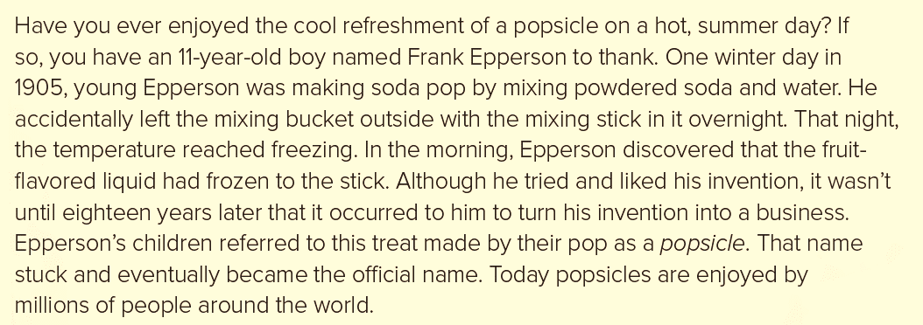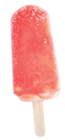

1. **Who discovered the food?**
2. 11-years-old boy
3. Frank Epperson
4. One winter
5. **When was is discovered?**
6. in 2030
7. in 1905
8. in 776 b.c.e
9. **How did he happen to discover it?**
10. He put it in his refrigerator.
11. Frank mixed it with ice.
12. Frank left a bucket of soda out one cold night with a mixing stick in it, and it froze.
13. **What happened after he discovered it?**
14. Turning into a business
15. He gave it to his friend as a gift.
16. Just ate it.

1

**2. Grammar**

|  |  |  |  |
| --- | --- | --- | --- |
| 1. This movie is so ………… . | | | |
| 1. bore | 1. too bored | 1. boredom | 1. boring |
| 1. The older we grow, ………………. we become. | | | |
| 1. wise | 1. wiser | 1. the wiser | 1. wisest |
| 1. She is ………………… a beautiful girl that everyone stares at her. | | | |
| 1. so | 1. such | 1. too | 1. very |
| 1. I failed my exam. I wish I had ……………. harder. | | | |
| 1. study | 1. studies | 1. studying | 1. studied |
| 1. Most of the news on TV is ………….. | | | |
| 1. depressed | 1. depress | 1. depressing | 1. bored |
| 1. He is …………… dressed. | | | |
| 1. get | 1. got | 1. gets | 1. getting |
| 1. I wish I had …………….. early. | | | |
| 1. wake up | 1. waken up | 1. woke up | 1. wake |
| 1. Ali decided to ………………. smoking. | | | |
| 1. pick up | 1. wake up | 1. give up | 1. cut up |
| 1. I wake …………………. at 7:30 every day. | | | |
| 1. up | 1. off | 1. on | 1. over |
| 1. Please , turn ……………. the TV I want to watch the new program. | | | |
| 1. off | 1. on | 1. down | 1. into |
| 1. There aren't …………….. students in the class. | | | |
| 1. some | 1. no | 1. much | 1. any |
| 1. How …………….. milk does she drink? | | | |
| 1. many | 1. much | 1. old | 1. long |
| 1. How ………….. burgers does he eat? | | | |
| 1. many | 1. much | 1. old | 1. long |
| 1. He has ………………… friends that will help. | | | |
| 1. a few | 1. a little | 1. much | 1. any |

2

**3.Vocabulary**

1. **Choose the correct answer:**

|  |  |  |  |
| --- | --- | --- | --- |
| 1. The odd word is: | | | |
| 1. sugar | 1. spoon | 1. vanilla | 1. cocoa |
| 1. The odd word is: | | | |
| 1. half | 1. a quarter | 1. taste | 1. one |
| 1. I love the ……………. of coffee. | | | |
| 1. bitter | 1. licensed | 1. aroma | 1. distinguish |
| 1. The medicine tastes too ………………. | | | |
| 1. bitter | 1. licensed | 1. aroma | 1. distinguish |
| 1. The odd word is: | | | |
| 1. worried | 1. longer | 1. bigger | 1. funnier |
| 1. Khaled is ……… . He can speak Arabic and English perfectly. | | | |
| 1. Pediatric | 1. puzzled | 1. bilingual | 1. irritated |
| 1. Nora decided to be become a ………. because she really loves children. | | | |
| 1. Pediatric | 1. puzzled | 1. bilingual | 1. irritated |
| 1. 3- I'm really getting …………. where the insect spray. | | | |
| 1. Pediatric | 1. puzzled | 1. bilingual | 1. irritated |

1. **Choose the correct word for each picture:**

|  |  |  |
| --- | --- | --- |
|  | a. a parrot b. mynah |  |
|  | a. prompt b. cardiovascular | Premium Vector | Anatomical heart. cartoon human biological cardiovascular  organ, vector illustration of pump for blood with muscle and veins isolated  on white background |
|  | a. laugher b. talker |  |
|  | a. popsicle b. cocoa |  |
|  | a. wafer b. cookies |  |
|  | a. potato chips b. popcorn |  |

3

**4. Writing**

**🖎** Write an essay about “**laughter** “explaining the beneficial effect

on mood and sense. These guide words may help you:

increases your heart rate, oxygen levels in your body, lose weight, burn up to 50 calories, physical advantages, make people alert, sleep more soundly, laughter club,

.....................................................................................................................................................

.....................................................................................................................................................

.....................................................................................................................................................

.....................................................................................................................................................

.....................................................................................................................................................

.....................................................................................................................................................

.....................................................................................................................................................

.....................................................................................................................................................

.....................................................................................................................................................

.....................................................................................................................................................

.....................................................................................................................................................

.....................................................................................................................................................

4

**Best wishes ..**

My Regards - Tr. Abdullah AL Zahrani

2023