**Revision**

**I. General Questions**

**A. Match "A" with "B":**

**IV. Controlled writing**

|  |  |  |  |
| --- | --- | --- | --- |
| "A" |  | "B" | |
| 1. What's the name of your school? |  |  | This year I like English. |
| 2. Do you have school uniform? |  | Yes, we do. |
| 3. Which subject do you like this year? |  |  | 9th Elementary School. |
| 4. What would you like to drink? |  |  | I'm going to Dubai. |
| 5. where is the post office? |  | Go straight and you'll find it. |
| 6. Where are you going? |  | I'd like some juice. |

1. **Choose:**
2. **How many students are there in your school?**

**a.** About 500. **b.** Yes, we do

1. **What should you do to live a healthy life?**

**a.** I have a headache. **b.** I should do some exercise.

1. **Where’s the post office?**

**a.** It’s near here. **b.** Do not litter.

________________________________________________________________________

**A. Unscramble and write:**

1.u– b – e – l

……………………………………………………………………………………….

2. u- t- e c

……………………………………………………………………………………….

**B. Complete: [ Paris – candy store –snow - book store - laugh - math - orange ]**

1. ……………………………….sells candy.

2. The Eiffle Tower is in ……………………….

3. I'd like some………………………juice, please.

4. When I feel happy, I ………………

5. My favourite subject is …………

6……………….sells books.

7. it's white. You ski on it………………

**III. Reading short sentences**

**A. Number.**

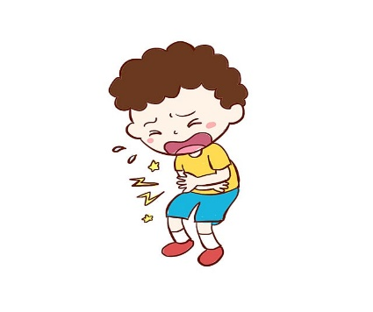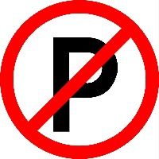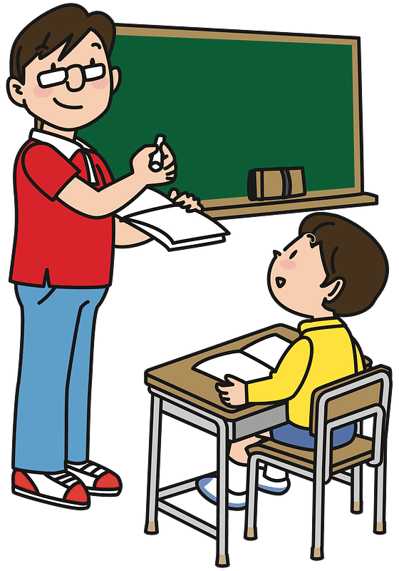1. No parking.

2. Listen to the teacher.

3. He's scuba diving.

4. I have a stomachache.

**II. Grammar**

صورة تحتوي على نص

تم إنشاء الوصف تلقائياً**A. Choose the correct answer:**

5

**1. Did you ( drink – drank - drunk ) milk in the morning.**

**2. We ( is – are – am ) going to the bookstore.**

**3. There ( was – were - are ) a little green house.**

**4. I'm going to [ visit – visiting – visits ] my grandma.**

**5. Last year I [ went – go – going ] to Riyadh.**

**B. Do as shown between brackets.**

**1. Last year I ( am ) in the 5th grade. ( Correct )**

………………………………………………………………………

**2. The past tense of get up is…………….. ( Complete )**

**__________________________________________________________________________**

**V. Vocabulary**

…

**A.Write the correct number under the correct picture:**

**1**. toothache **2**. science **3**. School bus **4**. bakery **5**. stapler **6**. **skirt gliding** crocodile

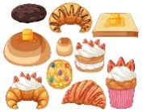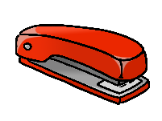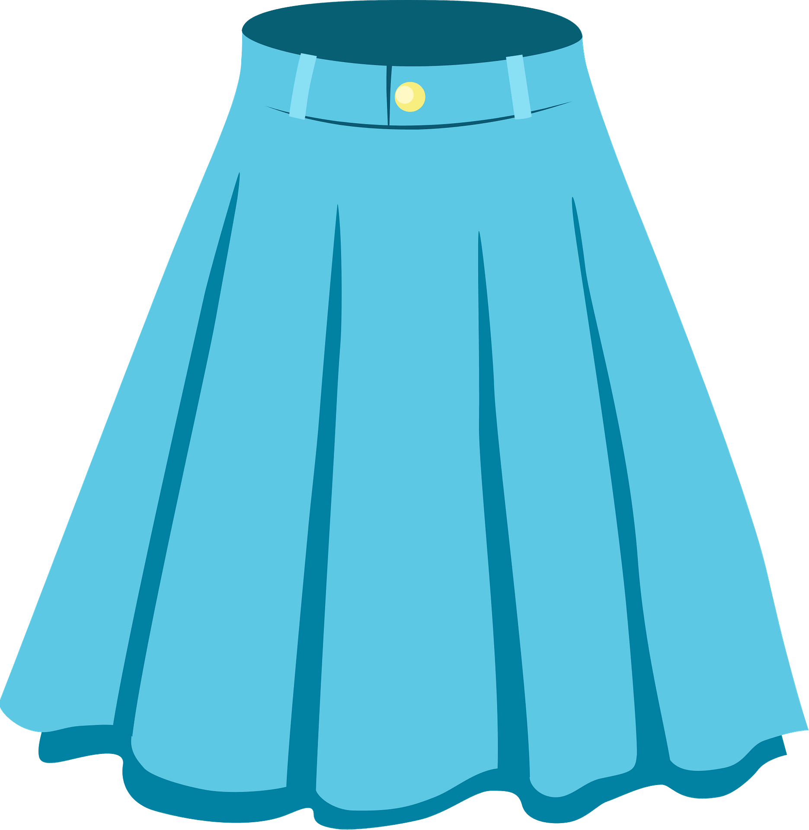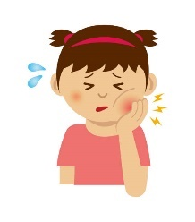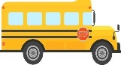

( ) ( ) ( ) ( ) ( ) ( )

|  |  |  |  |  |
| --- | --- | --- | --- | --- |
| Free Bread Clipart Pictures - Clipartix | No Bicycle" Images – Browse 390 Stock Photos, Vectors, and Video | Adobe  Stock | Flower Shop Clipart Flower Stand Florist Girl Selling - Etsy Israel | Masculine Elegant Belt Icon Stock Illustration - Download Image Now - Belt,  Leather, Vector - iStock | Premium Vector | Little girl has earache touching her ear with finger  because of infection inflammation hurt inside |
| **juice** | **No bicycle** | **Candy store** | **shirt** | **earache** |
| **bread** | **library** | **Flower store** | **belt** | **backache** |

**VI. Orthography(spelling)**

**A. Circle the correct missing litters:**

|  |  |  |  |
| --- | --- | --- | --- |
| Page 2 | Bird Clipart Images - Free Download on Freepik    **4. b __ __ d** | Turtle Clipart Images - Free Download on Freepik  **3. t __ __ tle** | **Square Shield Clipart | i2Clipart - Royalty Free Public Domain Clipart**  **2. __ __ uare** | içgüdü Gezmek Oyna scarf clipart - union-ea.org  **1.__ __arf** |
| **ir / ur** | **ir / ur** | **sc / sq** | **sc / sk** |
| 21,498 Blue Sky Clipart Images, Stock Photos & Vectors | Shutterstock  **8. __ __ y** | Vector Of Hand Pressing Bottle Lotion Or Soap On White Background. Royalty  Free SVG, Cliparts, Vectors, And Stock Illustration. Image 115019438.  **7. lo _ _ _ _** | Free Vectors | tissue  6. tiss **__ __** | **5. c __ b e** |
| **sc / sk** | **sh / tion** | **qe / ue** | **w /u** |

**B. Complete:**  **[ ur – sc - ue – ir ]**

|  |  |  |  |
| --- | --- | --- | --- |
| Scary Shark PNG Clipart | Sharks scary, Shark mural, Shark drawing | Blue Tshirt White Collar White Collar | Blue tshirt, Clip art, T shirt  clipart | Super glue Black and White Stock Photos & Images - Alamy | Cheeseburger Clipart Images – Browse 4,880 Stock Photos, Vectors, and Video  | Adobe Stock |
| **_ _ ary** | **sh_ _ t** | **gl_ _** | **b_ _ ger** |

**T. Dalal Al-Otaibi**