Read the following passage , then answer the questions in complete sentences:

Fast food is the food sold in many inexpensive restaurants as McDonald’s, Kentucky and Hardee's . It is called “Fast” because you get your food very quickly. It might take you only twenty minutes to get in, order your meal, eat it and leave. The kinds of food served in those restaurants are beef and cheese burger, hot sausage, fried chickens and French fries which are full of fats and carbohydrates. A fast food meal also includes a soft drink like cola, soda, juice or milk shake.
The problem is that such kind of food is so rich in fats, sugar, salt and cholesterol. Doctors advise us to eat less fast food, more salads because they are good for health, and drink less sugary juice. They say that fast food is a reason for getting fat and it might cause some people to get heart problems.
A. Answer the Questions in complete sentences:
- Why is it called fast food?
It is called fast food because you get your food very quickly . It might take you only twenty minutes to get in, order your meal, eat it and leave.
- What is fast food rich in?
fast food is rich in fats, sugar, salt and cholesterol .
- Does eating much fast food cause a person to become heavier?
Yes , it does .

1.
2.
3.
4.
B. Tick ( ) or ( ) next to each statement :
- Eating more beef burgers is healthy.
- Food that contains too much fats is bad for the heart.
- Doctors advise us to eat more salads.
- French fries are rich in proteins.
B. Complete the sentences :

- Fast drinks like ………… cola ……..… and ………… soda.……..
- Famous fast food restaurants as…………… McDonald’s …. and ………….… Kentucky ………….

C. From the passage, find words that mean :
- not expensive …………… inexpensive ………
- not hard ………… soft …………
- not cold ………… hot …………
- not slow ………… Fast …………
D. Write down what each pronoun stands for :

1. they ………… Doctors ………… 2. it ………… fast food …………

E. Write under each picture whether ( it's )Fast food or Healthy food :
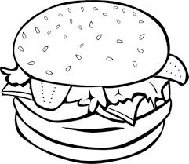  …… Fast food … | 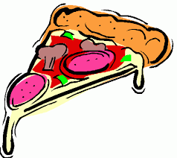  … Fast food …. | …… Fast food ……. | … Healthy food …..

