Final Revision

**1- Write a short paragraph about one of the jobs that would be good for you : Explain why this is a job that would be good for you :**

………………………………………………………………………………………………………………………………………………………………………………………………………………………………………………………………………………………………………………………………………………………………………………………………………………………………………………………………………………………………………………………………………………………………………………………………………………………………………………………………………………………………………………………………………………………………………………………………………………………………………………………………………………………………………………………………………………………………………………………………………………………………………………………………………………………………………………………………………………………….

**2- Wrir a short paragraph about your choice . Write what you will do and explain your choice :-**

………………………………………………………………………………………………………………………………………………………………………………………………………………………………………………………………………………………………………………………………………………………………………………………………………………………………………………………………………………………………………………………………………………………………………………………………………………………………………………………………………………………………………………………………………………………………………………………………………………………………………………………………………………………………………………………………………………………………………………………………………………………………………………………………………………………………………………………………………………………….

***2 - Read the passage then answer the questions***

Food is very important for our bodies. It should be various and healthy. Having three meals regularly is necessary. Fruit, vegetables, milk and yoghurt are good for our health. At the same time, we must eat very little of fats, sugar, and sweets. Soda water must be avoided. We must drink juices instead of soft drinks. Prophet Mohammed (peace be upon him) advised us not to eat a lot. We must always remember that we eat to live and not live to eat.

**A) Answer the following question :-**

**1-**  What kind of food that we must eat very little?

…………………………………………………………………………………………………………………………………

2- Is food important for our bodies?

…………………………………………………………………………………………………………………….………….

**B) Choose the correct answer :-**

**a- Having three is necessary**.

a) pens b) meals c) chocolate d) juice

**b- ………. must be avoided**.

a) Fruit b) Soda water c) Juice d) meet

**c- Our ………. advised us not to eat a lot .**

a) teacher b) prophet c) doctor d) editor

**d- Prophet Mohammed peace be upon him ………. us not to eat a lot**

. a) promised b) advised c) told d) talk

**C) Put ( T ) for the right sentences and ( F ) for the wrong ones.**

1. Food should be various and unhealthy. [ ]
2. Fruit, vegetables, milk and yoghurt are bad for health. [ ]
3. Soda water must be avoided. [ ]
4. We eat to live and not live to eat. [ ]

**Read the following passage, then answer the questions below:**

Hamad is forty years old. He lives in Gaza with his family. He is a fisherman. He has a small fishing boat. He always thinks of his work. Hamad gets up early in the morning. He goes to the sea. He catches fish. He earns much money everyday. He always feels happy because he loves his work.

A) Tick (T) or (F):

1- Hamad has a small fishing boat ( )

2- Hamad earns little money everyday. ( )

3- Hamad loves fishing. ( )

4-Hamad always feels unhappy . ( )

B: Answer the following questions:

1- What is Hamad’s job?

2- When does he get up?

C: Write the opposite of these words from the passage :-

big X sad X late X

Read the following passage, then answer the questions below:

Mr. Ali is a rich man. He is a doctor in a big hospital. He has a big house. He has two children, a boy and a girl. The boy's name is Usamah. He is nine years old. The girl is Yasmeen, she is seven years old. They go to elementary school near their house. In holidays, Mr. Ali's family goes to the beach house. They enjoy swimming in the sea.

A) answer the following questions.

a- Is Mr. Ali a doctor ?

b- How many children does he have?

B) Choose the correct answer a, b, c or d.

a- Mr. Ali's house is ………. a) big b) small c) middle d) under

b- They go to a school ….Their house a) near b) behind c) in d) on

c- Mr. Ali works in a ………. a) hospital b) farm c) school d) house

d- Yasmeen is …Years old a) 7 b) 9 c) 5 d) 8

C)Put ( T ) for the right sentences and ( F ) for the wrong ones.

1. Mr. Ali has two boys. [ ]

2. Mr. Ali's son name is Sami. [ ]

3. Mr. Ali's family goes to abroad in holidays. [ ]

4. Mr. Ali's family like swimming in the sea. [ ]

Grammar 3-

**A- Choose the correct answer :-**

**1- Have you finished your homework ……….?**

a) yet b) already c) just

**2 - He has …………. books that he can hardly carry them .**

a) so many b) so much c) that many

**3- A doctor is a person …………….helps sick people .**

a) who b) which c) where

**4- English is a language …………… ……….. is easy to learn .**

a) which b) when c) who

**5- Can I ………………………… you a question ?**

a) ask b) asking c) asked

6- **Wafa is …………………smart that she can solve any problem .**

a) such b) so c) much

**7 ) It was ……………….. a good movie that we decided to watch it again .**

a) much b) such c) so

**8- You haven't eaten all day . You …………………… be hungry.**

a) can b) must c) would

**9- I ………….at the show when someone called my name .**

a) look b) was looking c) looked

**10- If Amal ……………..to Paris, she will see Eiffel tower .**

a) go b) went c) goes

**11- If you heat the ice , it ……………….**

a ) melt b) melting c) melts

**12- …………….a new language is important .**

a) learn b) learns c) learning

**13- if my family had to move to another city , ……………miss my friends**

a) going to b) will c) would

…………………………………………

**Where**

**14 ) Badriah couldn't sleep last night . She …………… be tired .**

a) can b) so c) must

**15) Please , stop ………….. while you are chewing .**

a) talk b) talked c) talking

**16) Roby can't stand ………………..without knowing about her sister .**

a) living b) lives c) lived

**17) I finished reading the book ………….. I was riding the bus .**

a) where b) which c) who

**18) If people cared about the environment , there would ………………less pollution .**

a) been b) being c) be

19 ) **It is good idea to ……………….local custom .**

a) follow b) following c) follows

**20 ) By the time we got to the airport ,our flight had already ……….**

a) left b) leaves c) leave

>>>>>>>>>>>>>>>>>>>>>>>>>>>>>>>>>>>>>>>>>>>>>>

**B ) Correct the underlined mistakes :-**

1- Nora enjoys **read** short story

…………………………………………….………………………..

2- It is rude to **wearing** shoes inside the house

…………………………………………………………………………..….

3- If you put water in the freezer , it **become** ice

**………………………………………………………………………………..**

4– Sara aren't used to **speaking** Latin .

…………………………………………………………………………………

**5 -** Our flight had already **leave** .

…………………………………………………………………………………

6 - They **has** eaten their lunch .

………………………………………………………………………………….

_________________________________________________

|  |  |  |
| --- | --- | --- |
| flexible |  | a- lack f job |
| newcomer |  | b- return |
| poverty |  | c- advantages |
| To reduce |  | d- money you borrow |
| Unemployment |  | e- phone |
| Give back |  | f- person who has arrived recently |
| benefit |  | g- being poor |
| To study |  | h- make thing neat |
| Loan |  | i- to make less |
| Call up |  | j- able to change in different situation |
| Clean up |  | k- to prepare for a test |

**4- Vocabulary**

**A- Match the words with the definition :_**

**B- Put the correct word under each picture:**

Business card - scissors - police officer - hair brush - thief - mirror - escalator - toothpaste – air show - tipping - nail polish - hair dryer - tourist

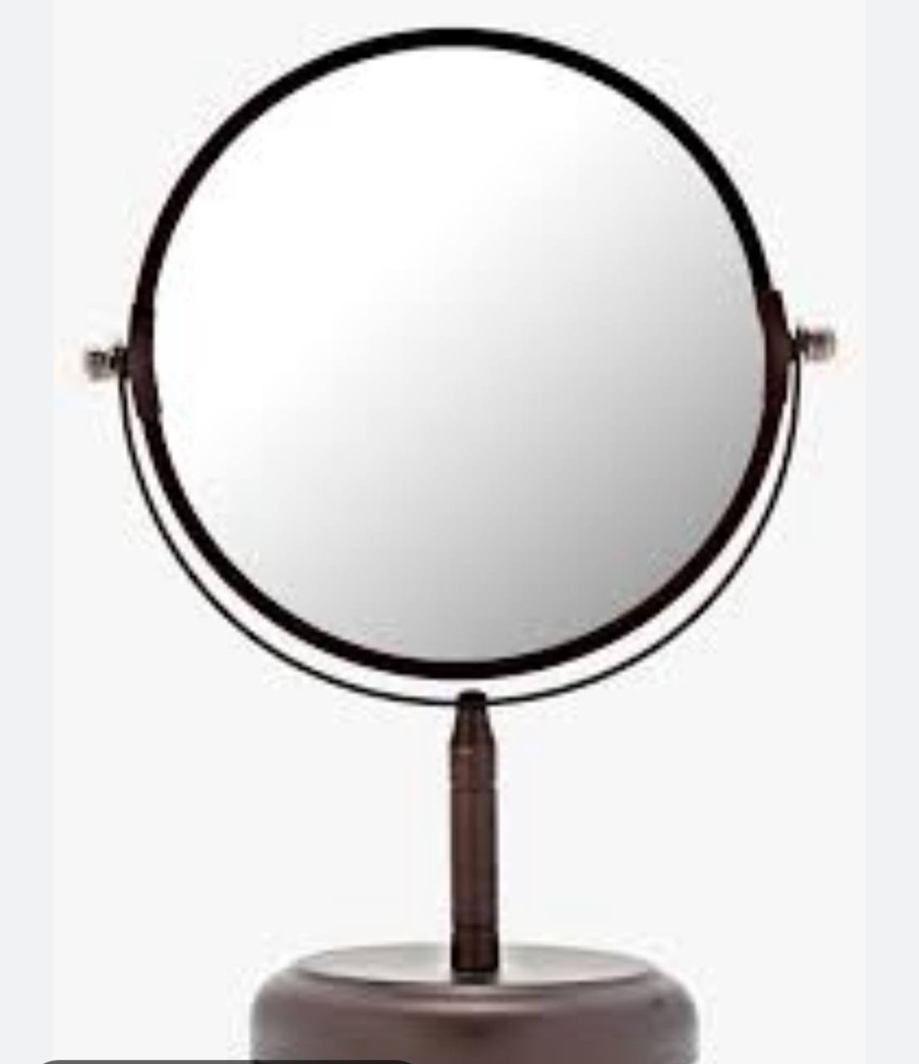



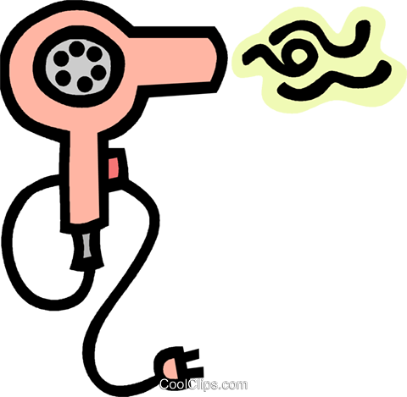

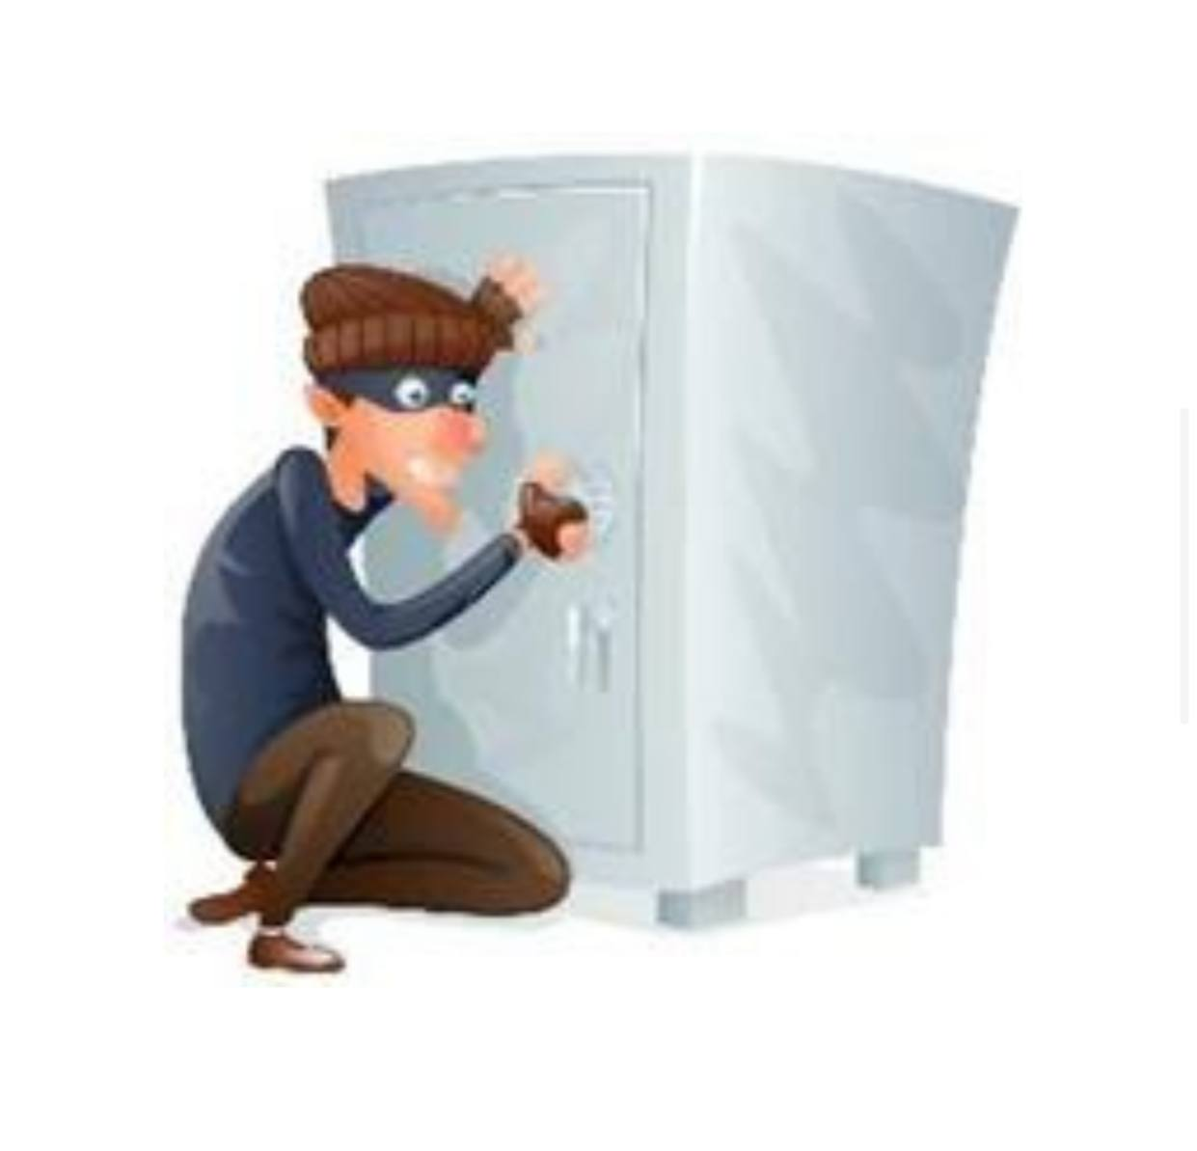

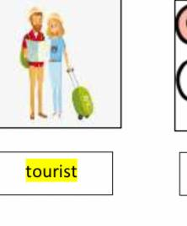

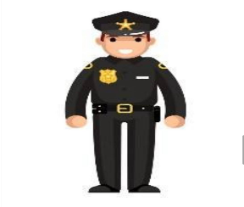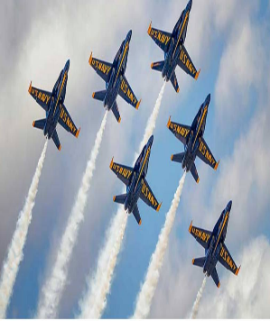

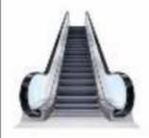

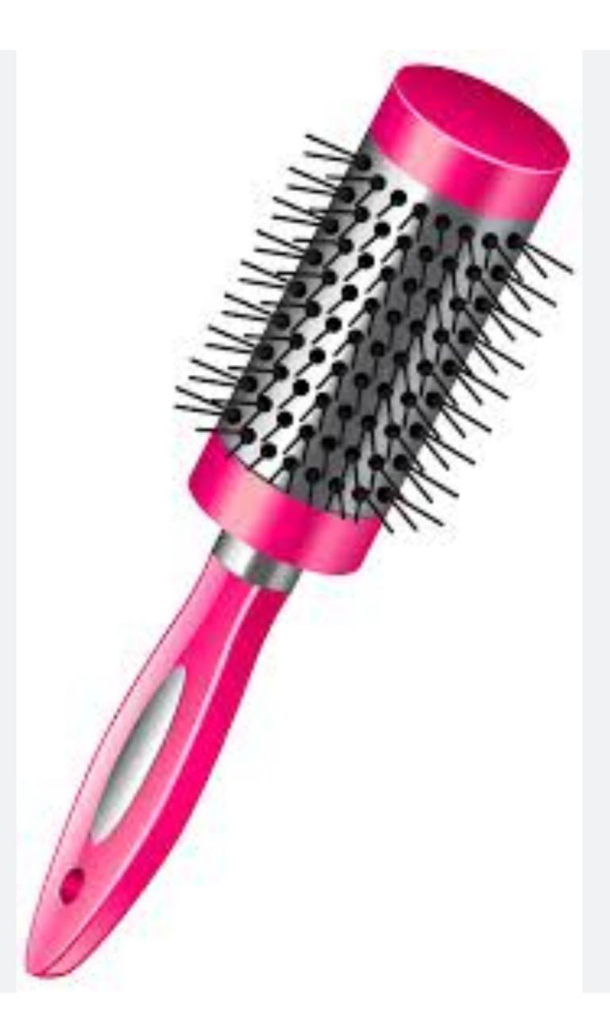







**5- Orthography**

**Write the missing : letters**

1- Some sclu…..tures are really beautiful . ( j - p - w )

2- I will put away the d…..shes ? ( i – k - x )

3- Where is my hair dr…..er ? ( g - y - f )

4- It is a real treat for me to be invited to these cha….ity events. ( y - u - r )

5- The flowers that grow in the city garden are very c….lorful. ( r - o - c )

6- Remember to stand in li…..e. ( t - n - k )

7- Try not to spread dust and mud in the ho….se. ( u - h - s )

8- It's polite to sha……e hands. ( b - h - k )

Tr. Amal Al'Zhrani..

May Allah bless you.. .