

الأسـم : …………………………………………………………………… الصـف : ………………………….

**المملكة العربية السعودية مادة اللغة الإنجليزية**

**وزارة التعليم الصف الثالث متوسط**

**إدارة التعليم بـ ................... اختبار تشخيصي ( قبلي)**

**مدرسة ........................... الدرجة : ........... \ 15**

**A- Read then answer the questions :**

|  |  |  |
| --- | --- | --- |
| 1-When do the Canadians celebrate Earth Day? | | |
| c- 22nd May | b- 22nd January | a-22nd April |
| 2- How many Canadians take part in Earth Day? | | |
| c- Over 27 million | b- Over 6 million | a- Over 11 million |
| 3- The Canadian Earth Day takes place in………………. | | |
| c- Toronto | b- Montreal | a- Ottawa |
| 4- -On Earth Day, people can enjoy riding……………… | | |
| c- elephants | b- bikes | a-camels |

Every year on 22nd April in the city of Toronto and all over Canada , people celebrate Earth Day. Lots of activities take place on that day. It's a time to celebrate the environment, learn about the city's problems and do something to help. Over 6 million Canadians take part in Earth Day. Families and friends get together and clean parts in the city. Everyone is welcome to help plant trees. On that day, people can also enjoy walking, riding bikes

**B-Choose the correct answer.**

1- Riyadh(is – are – am )in Saudi Arabia.

2-(open – opening – opened ) the book please.

3- Omar ( work – works – working ) at hospital.

4- A doctor is a someone ( who – which – where ) treats sick people .

5- Ali usually ( play – plays – playing ) videogames.

6- it will ( rain – rains – raining ) tomorrow.

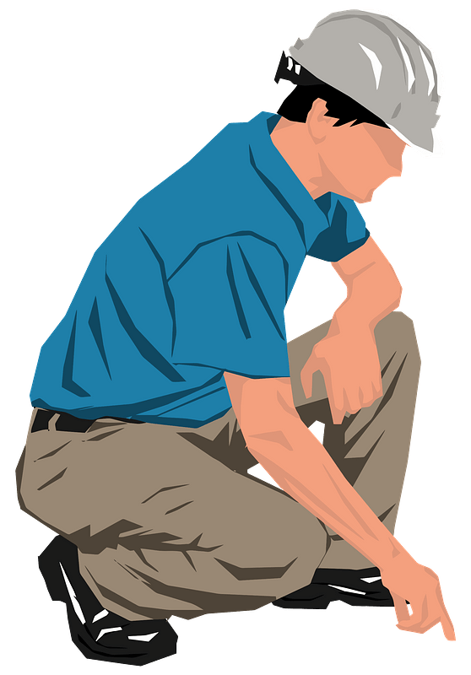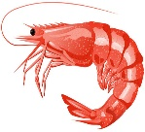**C-Write the missing letter for each picture.**

Good luck

Your Teacher ………………..

**D-Choose the correct answer**

1- He had a ( book - windy - snack )of chips and chocolate. .

2- Where are my sunglasses? It’s really(snowy-sunny - cloudy) today.

Shri…p

Ticke….

En….ineer