

**المملكة العربية السعودية مادة اللغة الإنجليزية**

**وزارة التعليم الصف : الثاني الابتدائي**

**إدارة التعليم بـ ................... اختبار تشخيصي ( قبلي)**

**مدرسة ........................... الدرجة : ........... \ 20**

الأسـم : …………………………………………………………………… الصـف : ………………………….

**A- Match**

|  |  |  |  |
| --- | --- | --- | --- |
| My name is Ahmad. |  | what is your name ? | 1 |
| Nice to meet you, too. |  | Good bye. | 2 |
| Good bye. |  | What’s this color? | 3 |
| Hi |  | Nice to meet you. | 4 |
| It's blue. |  | hello | 5 |

**B- Choose the correct answer**

1- This is ( a – an - are ) apple.

2-How are you? – ( I'm fine - good morning – welcome)

3- That is ( a – is - an ) flower.

4-What shape is it ? it is…….

5- What color is it ?

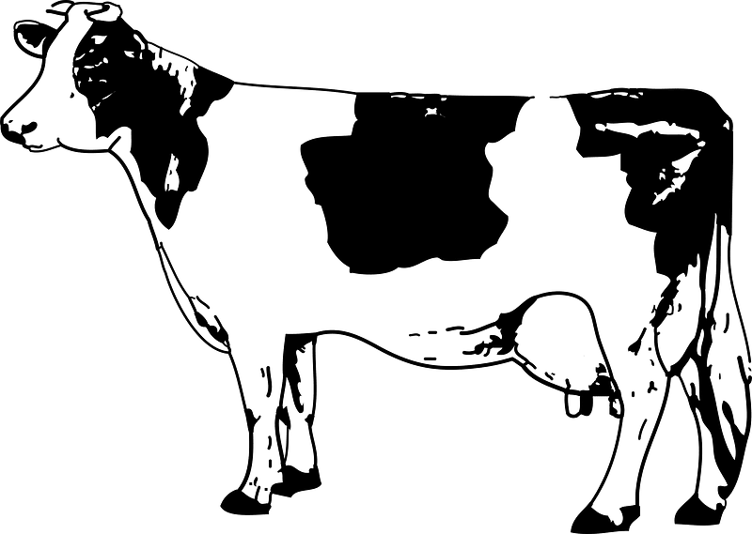

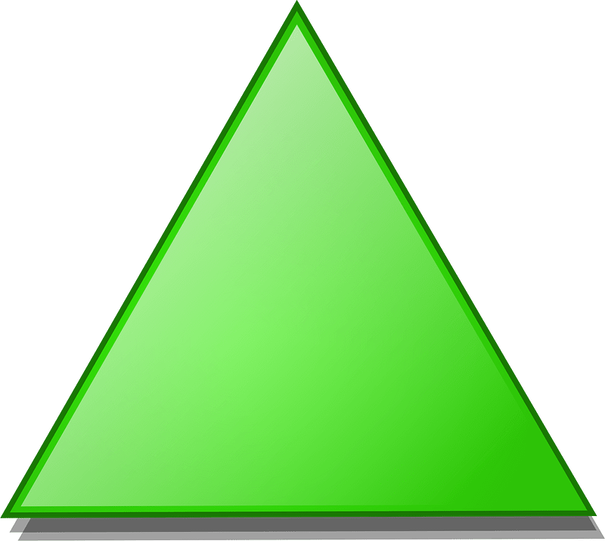

a- it's black and white.

b- it's red and pink.

a- Triangle

b- Square

**C- Complete.**

1 , 2 , …….… , ………, 5 , 6 , 7 , 8 , ………. , 10.

2- A , B , ……… , D , E , …….. , ……….. , H

**D- Complete the missing letters**

f d g b

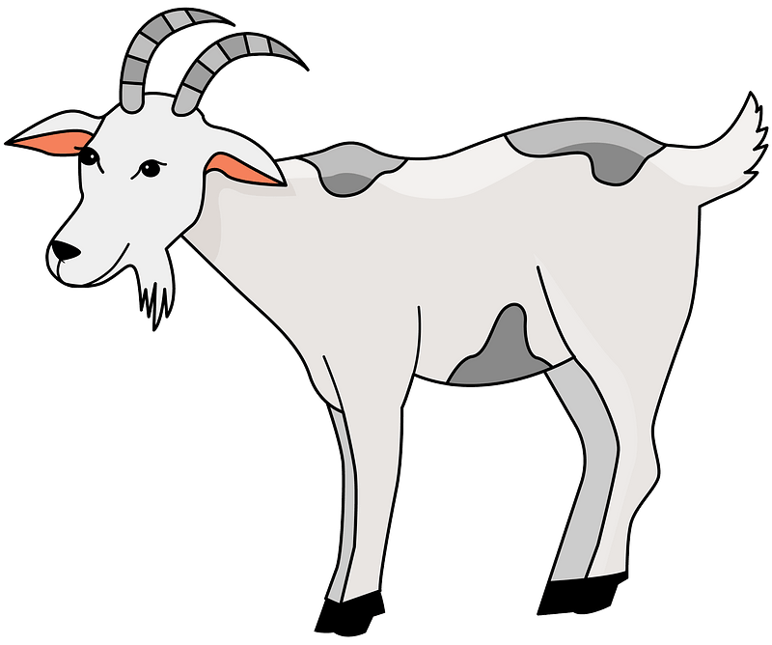

1-….ish 2- ……oat 3- …..ad 4- ……ear

Good luck

Your Teacher ………………..