Mega Goal 1.1 – Unit 1 Quiz
 | الشعبة |  | اسم الطالب (عربي)

Q1- Global issue: Use the words in the box.
Security – economy – pollution
 | 

Q2- Choose the correct answer:
1 – John ……… in New York .
a- live b- lives c- is living
2 – Omar ………… his father now .
a- calling b- calls c- is calling
3 – They ………. shopping last week .
a - go b- went c- gone
4- The people ………… when the earthquake happened.
- sleeps b- sleeping c- were sleeping
Q3- Choose the meaning of each word as it is used in the text:
Vision 2030 is built around three themes: A vibrant society, a thriving economy and an ambitious nation. | 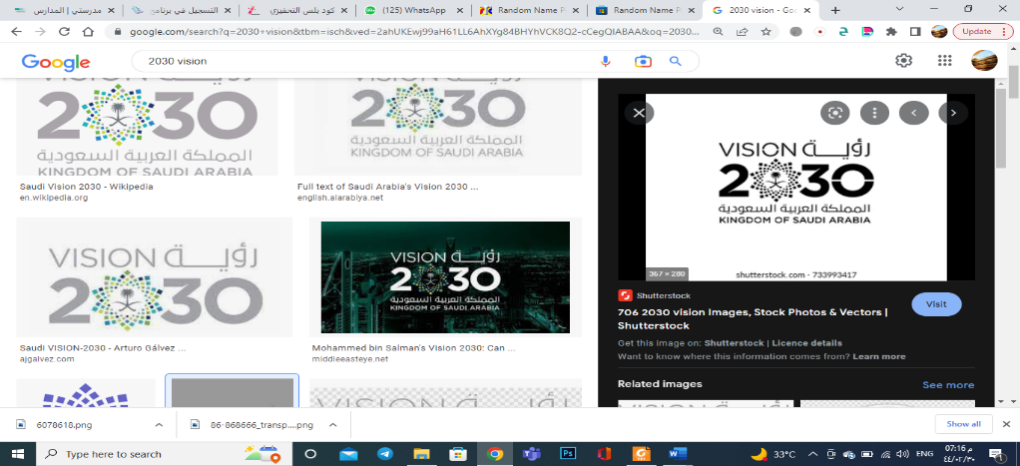

1. vibrant a. strong and active b. awake c. quiet
2. Thriving a. happy b. prosperous and strong c. poor
3. Ambitious a. determined to succeed b. greedy c. glorious
Q4- Do as shown between brackets :
1 – I get up at 7:00 everyday . ( Negative )
...........................................................................................................................
2- my brother has never been to dubai. (Rewrite using capitals )
...........................................................................................................................

