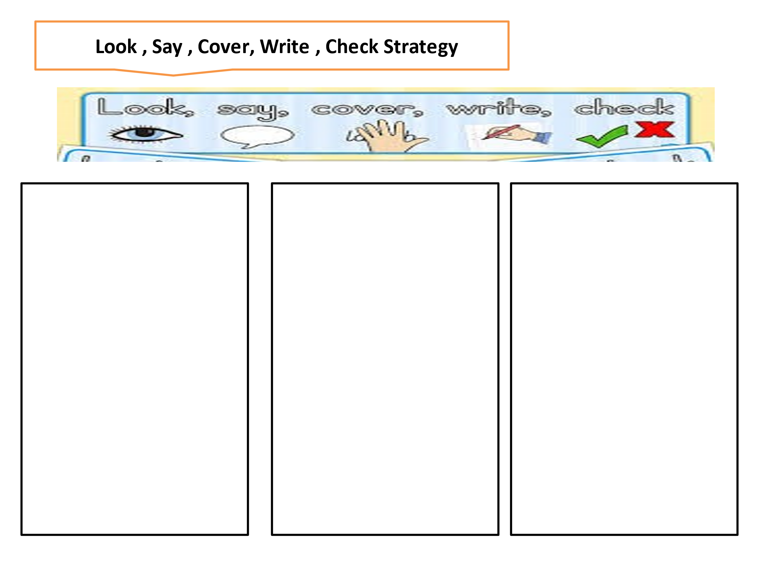

Sheep

Pie

Rain

Day

Sheep

Pie

Rain

Day

Meat

Sheep

Rice

Tie

Train

play

Meat

Sheep

Rice

Tie

Train

play