

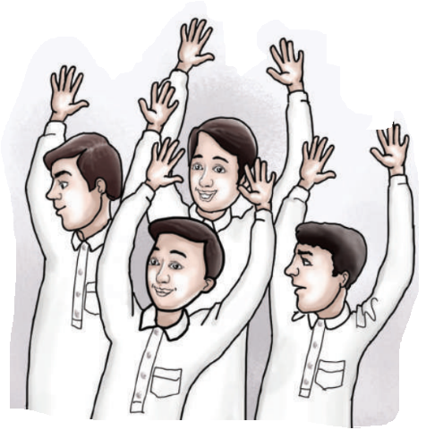

**Unit: 2 Lesson: 1 Page: 12**

Objective: I can match instructions correctly with pictures.

Match:



⃝ ⃝ ⃝ ⃝

⃝ ⃝ ⃝ ⃝

