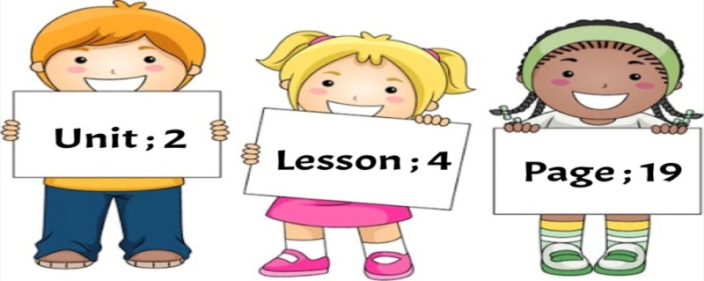

**Objective**: **I can determine if the small letter is tall, short or tail.**

**Drag each letter to its column :**

n

**x**

**c**

**z**

**v**

**b**

**m**

**h**

**k**

**g**

**l**

**j**

**f**

**q**

**w**

**e**

**r**

**t**

**y**

**u**

**o**

**i**

**d**

**s**

**a**

**p**

|  |  |  |  |
| --- | --- | --- | --- |
| Tail Letters | Short Letters | | Tall Letters |
|  |  |  |  |
|  |  |  |  |
|  |  |  |  |
|  |  |  |  |
|  |  |  |  |
|  |  |  |  |
|  |  |  |  |

**Teacher / Reefa Alotaibi**