**M.G. 2.1 Unit-2- Test**

**Crime Doesn't Pay**

Name; …………………………………..Class………………..

Grammar

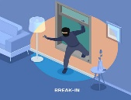**A- Choose the correct answers:**

**A**

1- Alan had [ install-installs-installed] the program.

2- A burglar had been [ attacking-attack-attacked] the house.

3-[ Was-Were-Are] she insuring her car?

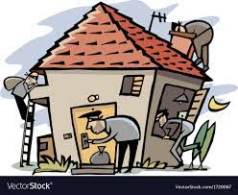4- When did the plane [ hijack-hijacked-hijacking]?

**B- Do as shown between brackets:**

1- Were the criminals breaking into the house? [Complete with a correct answer]

Yes, ………………………………………………………………………………………………………………..

C- Classify the words:

|  |  |
| --- | --- |
| Past Perfect | Past Progressive |
|  |  |

Was arresting -had abandon-charged- installed-

Vocabulary

1-Match words with their pictures:

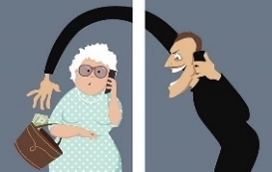

|  |  |  |
| --- | --- | --- |
| 3- fraud | 2-pickpoet | 1-pavement |

3- Fill in the blanks with correct words:

precaution- grim-To begin with

1- He had taken the …………………………………………of seeking legal advice.

2-……………………………………success needs more effort.

5- Circle the od d words'

a-burglar- victim -robber -inmate

4- Give the antonym's

a- unauthorized #----------------------

**Comprehension**

Read the following passage and answer the questions in complete sentences:

When I got to the airport, I learnt the plane from Paris, on which my brother was coming, had been delayed with engine trouble . It was supposed to arrive at 11 a.m. but it would be late for about two hours. As a rule, I can pass the time quite happily watching the planes land and take off, but that evening I had a headache which I thought the noise of the engines might make worse . I decided, therefore , to walk around to make the time pass quickly .

First of all I went back to the place where I had left my car to make sure that all the doors were locked. The walk in the fresh air did me good and felt better as I entered the main airport building again . I made my way to the café where I ordered a cup of coffee . Suddenly, I heard someone calling me . To my surprise, it was my brother ! He told me he had come on an earlier plane which had arrived at a.m before its appointed time. 10

What was wrong with the plane which was expected to come from Paris ?

**---------------------------------------------------------------------------------------------------------------------------**

**Put [ T ] or [ F ]**

1- The plane was supposed to receive at 12 p.m [ ]

2-He had a headache [ ]

Name; …………………………………..Class………………..

**M.G. 2.1 Unit-2- Test**

**Crime Doesn't Pay**

**Grammar**

**A- Choose the correct answers:**

**B**

1- Wife had [ be-been-being] abandoning herself to despair.

2- Shops [declined-decline-declines] the offers

3 -It used to be[a vicitm- inmate-swarm]

4- I would [declined-decline-declines] my appointment.

**B- Do as shown between brackets:**

1- Were the criminals breaking into the house? [Complete with a correct answer]

Yes, ………………………………………………………………………………………………………………..

C- Classify the words:

|  |  |
| --- | --- |
| Past Perfect | Past Progressive |
|  |  |

charged - were breaking into - had assumed

**Vocabulary**

1-Match words with their pictures:

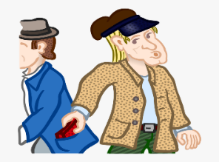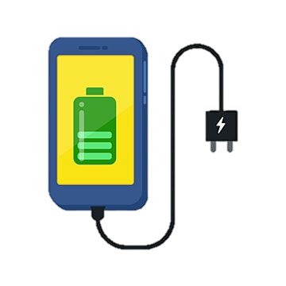

|  |  |  |
| --- | --- | --- |
| 3- fraud | 2-pickpoet | 1 -charge |

2- Match words with their meanings:

|  |  |
| --- | --- |
| ( ) without permission | 1- decline |
| ( ) to refuse | 2- unauthorized |

4- Circle the od d words'

a-pickpocket-rob-murder-display

3- Give the synonyms

a- inmate =……………………

**Comprehension**

**Read the following passage and answer the questions in complete sentences:**

When I got to the airport, I learnt the plane from Paris, on which my brother was coming, had been delayed with engine trouble . It was supposed to arrive at 11 a.m. but it would be late for about two hours. As a rule, I can pass the time quite happily watching the planes land and take off, but that evening I had a headache which I thought the noise of the engines might make worse . I decided, therefore , to walk around to make the time pass quickly .

First of all I went back to the place where I had left my car to make sure that all the doors were locked. The walk in the fresh air did me good and felt better as I entered the main airport building again . I made my way to the café where I ordered a cup of coffee . Suddenly, I heard someone calling me . To my surprise, it was my brother ! He told me he had come on an earlier plane which had arrived at a.m before its appointed time. 10

**1- What did he decide ?**

---------------------------------------------------------------------------------------------------------------------------

2-**Put [ T ] or [ F ]**

1- The plane was supposed to receive at 10 a.m [ ]

2-He ordered a cup of coffee [ ]