Unit 3 WHEN ARE YOU TRAVELLING?

Name _______________________________________ class _____

1. List items that you need for a trip to Spain

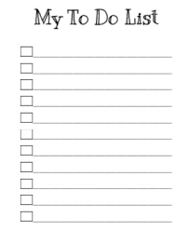

**To take list**

1. What are going to need?

Ex. I am going to need a passport.

 __________________________________________________

__________________________________________________

 __________________________________________________