|  |  |  |  |
| --- | --- | --- | --- |
| **متفوق** | **متقدم** | **متمكن** | **غير مجتاز** |
|  |  |  |  |

**المهارة**

**التقييم**

**. giving and receiving commands and instructions** 6

**listen to the teacher and do the body actions**

|  |
| --- |
| 1-Close your eyes! . |
| 2-Raise your hands! |
| 3- Clap your hands!  4-Open your eyes! |

**المهارة**

**. giving and receiving commands and instructions** 6

|  |  |  |  |
| --- | --- | --- | --- |
| **متفوق** | **متقدم**  **التقييم** | **متمكن** | **غير مجتاز** |
|  |  |  |  |

25 **. Read and comprehend simple sentences**

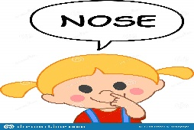

|  |  |  |
| --- | --- | --- |
| **1.Touch your nose!.** | 🗸 | 🗴 |
| **2 - Please stand up.** | 🗸 | 🗴 |
| **3-Please make a circle.** | 🗸 | 🗴 |

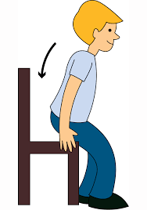

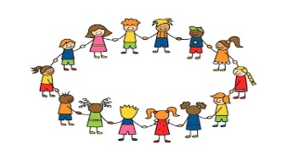

**المهارة**

**التقييم**

|  |  |  |  |
| --- | --- | --- | --- |
| **متفوق** | **متقدم** | **متمكن** | **غير مجتاز** |
|  |  |  |  |

31 **. Write upper/lower case letters correctly .**

|  |  |
| --- | --- |
|  | **K** |
|  | **L** |

|  |  |
| --- | --- |
| **m** |  |
| **n** |  |

|  |  |
| --- | --- |
|  | **O** |
| **p** |  |

**Rewrite the letters**

-------------------------------------------------------------------------------------------------------------------------------------------------------------------------------------------------------------------------------------------------------------------------------------------------------------------------------------------------------------------------------------------------------------------------------------------------------------------------------------

**_____________________________________________________________________________________________________________________________________________________________________________________________**

**المهارة**

|  |  |  |  |
| --- | --- | --- | --- |
| **متفوق** | **متقدم** | **متمكن** | **غير مجتاز** |
|  |  |  |  |

**28.Recognize and apply directionality in writing English**

**التقييم**

**30.Copy words, numbers and simple short sentences**

**Stand up**

------------------------------------------------------------------------------------------------------------------------------------------------------------------------------------------------------------------------------------------------------------

------------------------------------------------------------------------------------------------------------------------------------------------------------------------------------------------------------------------------------------------------------

_______________________________________________________________________________________________________________________________________________________________________________________________________

**التقييم**

|  |  |  |  |
| --- | --- | --- | --- |
| **متفوق** | **متقدم** | **متمكن** | **غير مجتاز** |
|  |  |  |  |

**المهارة**

**5.Recognise and match sounds to letters**

**Listen to the word and match with letters :**

|  |  |  |  |
| --- | --- | --- | --- |
| **n** | **m** | **o** | **Human Nose Animation, PNG, 512x512px, Watercolor, Cartoon, Flower, Frame,  Heart Download Free**  **1 –** |
| **k** | **l** | **p** | Colorful cartoon outlined kite vector illustration with red bow tie  decoration on the thread isolated on horizontal white background.  Traditional old international outdoor games. 24085242 Vector Art at Vecteezy  **2-** |
| **m** | **n** | **o** | **Orange Cartoon, A Hand Drawn Vector Illustration Of A Cartoon Orange With  Happy Face. Royalty Free SVG, Cliparts, Vectors, and Stock Illustration.  Image 49392823.**  **2-** |

_____________________________________________________________________________________________________________________________________________________________________________________________________

Good luck T.

_____________________________________________________________________________________

Controlled writing

Good luck T.

|  |  |
| --- | --- |
| المهارة / رقمها | ترجمتها |
| giving and receiving commands and instructions  6 | **إعطاء وتلقي الأوامر والتعليمات** |
| Read and comprehend simple sentences  25 | **قراءة وفهم الجمل البسيطة** |
| Write upper/lower case letters correctly.  31 | **كتابة الحروف الكبيرة والصغيرة** |
| Copy words, numbers and simple short sentences  30 | **نسخ كلمات / ارقام / جمل بسيطة** |
| Recognize and apply directionality in writing English  28 | **معرفة وتطبيق التجاه المناسب عند الكتابة باللغة الانجليزية _ (من اليسار لليمين , أعلى , أسفل )** |
| Recognise and match sounds to letters  5 | **التعرف على الأصوات ومطابقتها مع الحروف** |

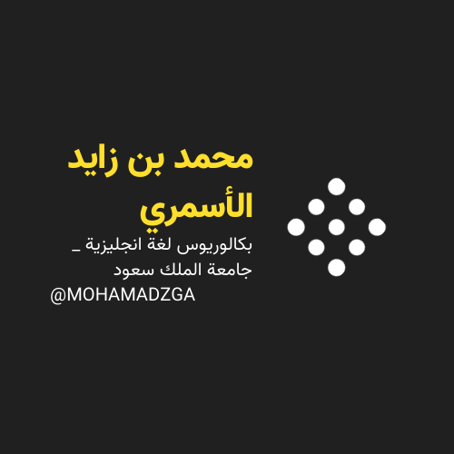

**لا تنسوني من صالح دعائكم**





M_zaid0